Feed intake, nutrient digestibility and nitrogen retention by Moo Lath pigs fed ensiled banana pseudo-stem (Musa spp) and ensiled taro foliage (Colocasia esculenta)
Bounlerth Sivilai, T R Preston1 and Lamphuey Kaensombath
Faculty of Agriculture, National University of Laos, Vientiane Capital Lao PDR Lerth_si@yahoo.com ¹ Centro para la Investigación en Sistemas Sostenibles de Producción Agropecuaria (CIPAV), Carrera 25 No 6-62 Cali, Colombia
Abstract
Four diets with different proportions of ensiled banana pseudo stem (BS) and ensiled taro foliage (TF) were fed to Moo Lath pigs (26.3±0.31 kg live weight) according to a 4*4 Latin square design. Protein levels which were higher in taro foliage were balanced by adding soybean meal in decreasing quantities as taro foliage replaced banana pseudo-stem in the diets. Corresponding proportions of banana pseudo-stem and taro foliage in the ensiled mixture were (% as DM): BS0: 0-75, BS25: 25-72, BS45: 45-35 and BS65: 65-20. By error of judgment, broken rice was included in diet BS45 at 9% and in diet BS0 at 25%, when it should have been a common level in all diets.
There were increases in apparent digestibility of DM and crude protein (CP), and in N retention, when taro foliage rather than banana pseudo-stem was the basis of the diet. Apparent DM digestibility and N retention were improved (the latter was increased by 40%) when 25% broken rice was added to the diet composed mainly of ensiled taro foliage. The variable quantities of broken rice in the diets are not considered to have influenced the overall conclusion that taro foliage was much superior to banana pseudo-stem as the basal diet for Moo Lath pigs.
Key words: Colocasia esculenta, indigenous, local resources, native
Introduction
Small-holder pig farming systems play an important role in food security and improving the livelihood of rural families. They contribute a source of income, of food and access to markets. The traditional production system in Lao PDR is by foraging and scavenging for left-over food with limited supplementation from crop byproducts, mainly rice bran. In mountain areas, most smallholder farmers prefer to keep native (Moo Lath) pigs as they adapt well to the foraging system (Phengsavanh et al 2010). Scarcity and poor quality of feeds, especially with respect to protein, appear to be the major cause of the low productivity (Stür et al 2010). Conventional protein-rich supplements such as fish and soybean meals are too expensive for poor farmers. The solution therefore is to identify locally available resources, which could serve as sources of protein (Kaensombath and Lindberg 2012). Perennial forages such as stylosanthes have been shown to be well utilized by Moo Lath pigs with resultant improvements in growth rates (Phengsavanh and Stür 2006; Chittavong et al 2012).
Bananas are cultivated in most smallholder farms in rural areas of Lao PDR, providing fruits, flowers, leaves and roots that are consumed by the people. After harvesting the fruit, the residual biomass yield has been shown to be high, equivalent to some 13-20 tonnes DM/ha/year (Ffoulkes and Preston 1978). In fact, many rural households traditionally use banana pseudo-stems for pigs, chopping and cooking them, then mixing them with other feeds such as rice bran, vegetables and kitchen wastes. Banana pseudo-stem contains from 85 to 92% of water, and is very low in protein (2-3% in DM) (www.feedipedia.org). However, it has been shown that sugars are present in the aqueous fraction which makes it feasible to ensile the chopped pseudo-stem without the need for other silage-enhancing additives such as molasses (Dao Thi My Tien et al 2010; Duyet and Preston 2013; Hang et al 2014).
The taro plant (Colocasia esculenta (L.) Schott) is native to Asia and the Pacific islands and widely distributed in tropical areas (Onwueme 1999). In Lao PDR, taro is largely found in natural resources near river banks, streams and ponds, and is often cultivated as feed for livestock and people. Taro leaves are rich in protein with a balanced amino acid profile and have been shown to be a potential source of protein for native pigs (Chittavong et al 2012; Kaensombath and Lindberg 2012).
A limiting factor in taro foliage is the presence of oxalate salts, which are a problem for pigs and humans as they cause itchiness of mucosal surfaces in the mouth and throat. Traditionally farmers boil the leaves and petioles before feeding them. However, a simpler way is to ensile them Rodriguez and Preston (2007). Ensiling has been shown to be an effective way of reducing the content of oxalates (Hang and Preston 2010; Hang et al 2011). It was shown by Manivanh and Preston (2015) that a combination of ensiled banana-pseudo stem and taro forage could constitute the basal diet of Moo Lath pigs, supporting live weight gains of 115 g/day. A similar diet supported normal reproduction and lactation performance in Mong Cai sows (Duyet and Preston 2013).
The aims of this study were to provide more information on the nutritive value of different combinations of ensiled banana pseudo-stem and taro foliage, by determining feed intake, digestibility and nitrogen retention in growing Moo Lath pigs.
Materials and Methods
Location and duration
The experiment was conducted in the livestock farm, Faculty of Agriculture, National University of Laos, Vientiane capital, Lao PDR, from January to April 2015.
Treatments and experimental design
The treatments were four diets with different proportions of ensiled banana pseudo-stem (BS), ensiled taro foliage (TF), soybean meal and broken rice (Table 1) arranged according to a 4x4 Latin square design:
- BS0: 0% banana pseudo-stem silage, 75% taro foliage silage and 25% broken rice
- BS25: 25% banana pseudo-stem silage, 72% taro foliage silage and 3% soybean meal
- BS45: 45% banana pseudo-stem silage, 35% taro foliage silage, 9% soybean meal and 11% broken rice
- BS65: 65% banana pseudo-stem silage, 20% taro foliage silage and 15% soybean meal
Four castrated male pigs (Moo Lath breed) with initial live weight of 26.3±0.31 kg were housed individually in cages (Photo 1) that allowed separate collection of urine and feces. Experimental periods were of 10 days: 5 days for adaptation to the change of diet and 5 days for collection of feces and urine.
Feed resources and silage management
The banana pseudo-stem was collected in the gardens of farmers near the university. Taro foliage was collected from the banks of ponds in the university. The broken rice was purchased from the local rice mill and soybean meal in the general agricultural shop in Vientiane.
Banana pseudo-stem and taro foliage were chopped by hand into small pieces of 1-2 cm of length and then dried under shade for a day to reduce the moisture content. Both forages were ensiled separately in polyethylene bags (capacity 20 liters) which were sealed to ensure an anaerobic condition.
Data collection and measurements
The ingredients of each diet were mixed prior to offering the mixture to the pigs at the daily rate of 40 g DM/kg live weight. Amounts offered and refused were recorded daily. Urine and feces of each pig were collected separately, weighed and stored at -20 ºC. The urine was collected in a bucket via a funnel below the metabolism cage, with 50 ml of 25% H₂SO₄ put in the bucket each day to maintain the pH below 4. At the end of each experimental period, the daily collections of urine were mixed and representative samples stored at -20ºC; feces collections were also mixed and representative samples dried at 60-65 ºC for 24h.
Chemical analysis
AOAC (1990) procedures were followed for analysis of: DM, ash, crude fiber (CF) and N in feed ingredients, feeds offered, feeds refused and feces; and for N in urine.
Statistical analysis
The data were analyzed using the general linear model in the ANOVA program of the MINITAB software (Minitab 2014). Sources of variation were: pigs, periods, treatments and error.
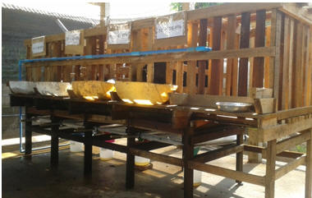 |  | 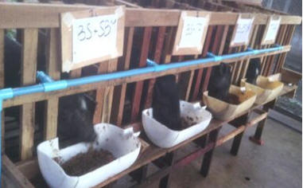
Photo 1. Metabolic cage and individual feeding pens for Moo Lath pigs

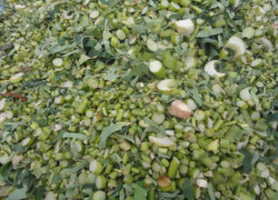 |  | 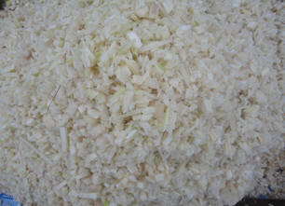
Photo 2. Chopped banana psuedo-stem and taro foliage to make silage for the experimental diets
Results and Discussion
Chemical composition of ingredients and experimental diets
The crude fiber (DM basis) was about 25% lower in taro silage than in silage of banana pseudo-stem (Table 1), but the ash was much higher in taro silage.
Table 1. Composition of the ingredients in the diets
Diets |  |  |  |  |  |  | % in DM
 |  |  |  |  |  | DM, % | CP |  |  |  | Ash | EE | CF
Banana pseudo-stem silage |  |  |  |  |  | 8.7 | 4.5 |  |  |  | 7.5 | 2.2 | 23.3
Taro foliage silage |  |  |  |  |  | 9.3 | 18.6 |  |  |  | 15.1 | 2.7 | 18.7
Soybean meal |  |  |  |  |  | 86.8 | 48.0 |  |  |  | 7.7 | 3.2 | 7.2
Broken rice |  |  |  |  |  | 87.8 | 7.4 |  |  |  | 1.3 | 0.9 | 1.4
pH of BS silage was 3.91 and of TS silage was 4.23
The experimental diets were formulated to contain similar levels of crude protein (Table 2). The levels of crude fiber reflected the relative proportions of taro silage and supplementary soybean/broken rice in the diets. pH was similar for all diets after mixing the ingredients prior to feeding.
Table 2. Chemical composition of the diets
 |  |  |  |  | BS65 |  |  |  | BS45 | BS25 | BS0
Banana pseudo-stem |  |  |  |  | 65 |  |  |  | 45 | 25 | 0
Taro foliage |  |  |  |  | 20 |  |  |  | 35 | 72 | 75
Soybean meal |  |  |  |  | 15 |  |  |  | 11 | 3 | 0
Broken rice |  |  |  |  | 0 |  |  |  | 9 | 0 | 25
DM as fed, % |  |  |  |  | 10.1 |  |  |  | 11.0 | 9.20 | 11.0
 |  |  |  |  | ----------------% in DM of feed offered--------------
Crude protein |  |  |  |  | 13.8 |  |  |  | 14.5 | 16 | 15.8
Crude fiber |  |  |  |  | 20 |  |  |  | 17.9 | 19.5 | 14.4
Ash |  |  |  |  | 9.05 |  |  |  | 9.62 | 13 | 11.7
Ether extract |  |  |  |  | 2.5 |  |  |  | 2.4 | 2.6 | 2.3
pH |  |  |  |  | 4.04 |  |  |  | 4.22 | 4.19 | 4.03
Feed intake, apparent digestibility and nitrogen retention
There was a negative trend in DM intake (Y = -1.05X + 700; R² = 0.99) as the ensiled banana pseudo-stem replaced the ensiled taro foliage (Table 3). Hang et al (2014) also reported that intake of mixed silage by crossbreed Mong Cai x Large White pigs was decreased when the banana pseudo-stem component of silage was increased at the expense of taro foliage.
Table 3. Mean values of DM intake and CP in consumed DM by Moo Lath pigs (BS = percent of ensiled banana pseudo-stem in diet DM)
 |  |  |  |  |  |  | BS0 | BS25 | BS45 | BS65 | SEM | p
DM intake, g/d |  |  |  |  |  |  | 696 | 680 | 651 | 630 | 39 | 0.67
DM intake, g/kg LW |  |  |  |  |  |  | 26.3 | 26.3 | 24.9 | 23.3 | 0.48 | 0.47
CP in DM consumed, % |  |  |  |  |  |  | 15.8 | 16.3 | 17.6 | 15.8 | 0.50 | 0.12
Apparent digestibility coefficients for DM and CP were increased as the bananpseudo-stem was replaced by taro foliage in the silage component of the diet (Table 4; Figures 1 and 2). The data for N retention showed even more marked trends with a major improvement when the combination of ensiled banana pseudo-stem (25%), ensiled taro foliage (72%) and soybean meal (3%) was replaced by ensiled taro foliage (75%) and broken rice (25%) (Figues 3 and 4).
Table 4. Mean values for apparent digestibility and N retention by Moo Lath pigs fed mixed silages of banana pseudo-stem (BS) and taro foliage (leaf + petiole) (BS = percent of ensiled banana pseudo-stem in diet DM)
 |  |  |  |  |  |  | BS0 | BS25 | BS45 | BS65 | SEM | p
Apparent digestibility, %
DM |  |  |  |  |  |  | 89.7 ª | 80.4 ^{ab} | 73.8 ^{ab} | 66.7 ^{b} | 3.7 | 0.021
CP |  |  |  |  |  |  | 90.0 ª | 81.8 ^{ab} | 78.8 ^{ab} | 71.5 ^{b} | 2.9 | 0.022
Nitrogen balance, g/d
Intake |  |  |  |  |  |  | 17.8 | 18.1 | 20.6 | 18.7 | 1.3 | 0.48
Feces |  |  |  |  |  |  | 1.73 ª | 3.26 ^{ab} | 4.57 ^{ab} | 5.05 ^{b} | 0.67 | 0.007
Urine |  |  |  |  |  |  | 4.15 | 6.04 | 8.29 | 7.34 | 1.3 | 0.23
Retention of N
g/d |  |  |  |  |  |  | 11.9ª | 8.84 ª | 7.71 ^{ab} | 6.27^{b} | 0.70 | 0.006
% of N intake |  |  |  |  |  |  | 66.3 ª | 48.8^{b} | 37.9^{b} | 29.2^{c} | 2.4 | 0.001
% of N digested |  |  |  |  |  |  | 73.5 ª | 59.0 ^{ab} | 48.4 ^{b} | 39.8 ^{c} | 3.8 | 0.003
abc: Means in the same row without common letter are different at p<0.05

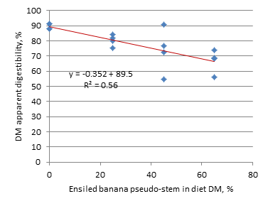 | 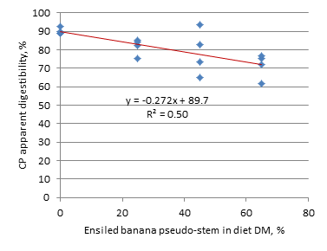
Figure 1. Effect of ensiled banana pseudo-stem replacing ensiled taro  foliage on apparent DM digestibility by Moo Lath pigs | Figure 2. Effect of ensiled banana pseudo-stem replacing ensiled taro  foliage on apparent CP digestibility by Moo Lath pigs

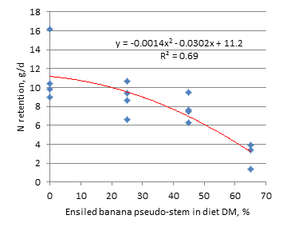 | 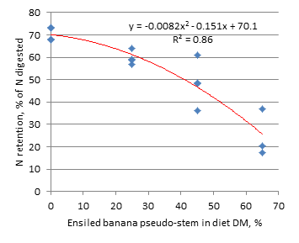
Figure 3. Effect of ensiled banana pseudo-stem replacing ensiled  taro foliage on N retention by Moo Lath pigs | Figure 4. Effect of ensiled banana pseudo-stem replacing ensiled taro foliage  on N retention as percent of N digested by Moo Lath pigs
The effect of replacing ensiled banana pseudo-stem with ensiled taro foliage (leaves + petioles) was slightly confounded by incorporating broken rice at different levels in diets BS45 (9% broken rice) and BS0 (25% broken rice). The increased availability of highly digestible carbhydrate, in the form of broken rice, probably was the cause of the 50% increase in N retention on diet BS0 compared with BS25. Despite the confounding caused by the incorporaton of broken rice in diets BS45 and BS0, the superior nutritional value of taro silage over the banana pseudo-stem silage is quite clear. It is also noteworthy that the highest values of apparent digestibility of dietary DM and crude protein, and of N retention, were a function of the level of ensiled taro silage in the diet and not the source of the protein, as the addition of soybean meal to make the diets iso-nitrogenous conferred no nutritional benefit when the energy source was ensiled banana pseudo-stem as opposed to ensiled taro foliage.
The major increase is N retention when broken rice was added to ensiled taro foliage highlights the benefits that can be gained when ensiled taro foolage is supplemented with a highky digestible source of carbohydrates
Conclusions
- The major findings from the experiment were: (i) the increase in digestibility and N retention when taro foliage rather than banana pseudo-stem was the basis of the diet; and (ii) the improvement in digestibility and N retention when 25% broken rice was added to the diet composed mainly of ensiled taro foliage.
Acknowledgements
This research was done by the senior author as part of the requirements for the PhD degree in Animal Production "Improving Livelihood and Food Security of the people in Lower Mekong Basin through Climate Change Mitigation" of Nong Lam University. The authors acknowledge support for this research from the MEKARN II project financed by Sida/MEKARN II and the help from Animal Science students (Mr Vanh Sysouphanh, Mr Soulasay Phimmasan, Mr Khamdy Sansayyang and Ms Khambang Inthavone) in the the farm and laboratory. The Faculty of Agriculture, National University of Laos is acknowledged for providing the facilities to carry out this research.
References
AOAC 1990 Official Methods of Analysis. Association of Official Analytical Chemists.15th edition (K Helrick editor). Arlington pp 1230
Chittavong M, Lindberg J E and JanssonA 2012 Feeding regime and management of local Lao pigs in central Lao PDR. Tropical Animal Health and Production doi: 10.1007/s11250-021-0186-1.
Dao Thi My Tien, Ngo ThuyBaoTran, Bui Phan Thu Hang and Preston T R 2010 A note on ensiling banana pseudo-stem with Taro (Colocasia esculenta) leaves and petioles. (Editor: Reg Preston) International Conference on Livestock, Climate Change and Resource Depletion, Champasack University, Pakse, LAO PDR, 9-11 November 2010 . http://www.mekarn.org/workshops/pakse/abstracts/tien_agu2.htm.
Duyet H N and Preston T R 2013 Ensiled mixed foliage of taro leaves + petioles and banana pseudo-stems as replacement of rice bran for MongCai sows in small-holder farms in Vietnam. Livestock Research for Rural Development.Volume 25, Article #54. http://www.lrrd.org/lrrd25/4/duye25054.htm
Ffoulkes D and Preston T R 1978 The banana plant as cattle feed: digestibility and voluntary intake of different proportions of leaf and pseudo-stem. Tropical Animal Production. Volume 3, Number 2, 114-117. http://www.utafoundation.org/UTAINFO1/TAP/TAP32/3_2_4.pdf
Hang D T and Preston T R 2010 Effect of processing Taro leaves on oxalate concentrations and using the ensiled leaves as a protein source in pig diets in central Vietnam.Livestock Research for Rural Development.Volume 22, Article #68. Retrieved February 18, 2015, from http://www.lrrd.org/lrrd22/4/hang22068.htm
Hang D T, Binh L V, Preston T R and Savage G P 2011 Oxalate content of different taro cultivars grown in central Viet Nam and the effect of simple processing methods on the oxalate concentration of the processed forages. Livestock Research for Rural Development. Volume 23, Article #122. http://www.lrrd.org/lrrd23/6/hang23122.htm
Hang D T, ThanhTra T T, Loc N T, Hai P V, Qui N D, Ngoc Linh H L and Ngoan L D 2014 Taro (Colocasia esculenta (L) Schott) and banana pseudo-stem as energy sources for pigs in Central Vietnam. Livestock Research for Rural Development.Volume 26, Article #109. Retrieved October 16, 2015, from http://www.lrrd.org/lrrd26/6/hang26109.html
Kaensombath L and Lindberg J E 2012 Effect of replacing soybean protein by taro leaf (Colocasia esculenta (L.)Schott) protein on growth performance of exotic (Landrace x Yorkshire) and native (Moo Lath) Lao pigs. Tropical Animal Health and Production, p. 1-7
Manivanh N and Preston T R 2015 Protein-enriched cassava root meal improves the growth performance of Moo Lat pigs fed ensiled taro (Colocacia esculenta) foliage and banana stem. Livestock Research for Rural Development.Volume 27, Article #44. Retrieved October 16, 2015, from http://www.lrrd.org/lrrd27/3/noup27044.html
Minitab 2014 Minitab reference Manual release 16. User’s guide to statistics. Minitab Inc. USA
Onwueme I 1999 Taro cultivation in Asia and the Pacific.Food and agriculture organization of the unitednation.Regional Office for Asia and the Pacific. Bangkok, Thailand, p. 48.
Phengsavanh P and Stür W 2006 The use and potential of supplementing village pigs with Stylosanthesguianensis in Lao PDR. Workshop-seminar "Forages for Pigs and Rabbits" MEKARN-CelAgrid, Phnom Penh, Cambodia, 22-24 August, 2006. Article # 14. RetrievedNovember 8, 115, from http://www.mekarn.org/proprf/wern.htm
Phengsavanh P, Ogle B, Stür W, Frankow-Lindberg B E and Lindberg J K 2010 Feeding and performance of pigs in smallholder production systems in Northern Lao PDR. http://lad.nafri.org.la/fulltext/2722-0.pdf
Rodríguez L and Preston T R 2009 A note on ensiling the foliage of New Cocoyam (Xanthosoma sagittifolium). Livestock Research for Rural Development. Volume 21, Article #183. http://www.lrrd.org/lrrd21/11/rodr21183.htm
Stür W, Phengsavanh P, Keonouchanh S, Phimphachanvongsod V, PhengvilaysoukA and Kopinski J 2010 Forage legumes for supplementing village pigs in Lao PDR.Australian Center for International Agricultural Research (ACIAR).

Received 8 November 2015; Accepted 5 December 2015; Published 2 January 2016

