THE REALITY OF TEACHER COLLABORATION AT FACULTY OF ESP DEPARTMENT, UNIVERSITY OF FOREIGN LANGUAGES, HUE UNIVERSITY
Duong Phuoc Quy Chau
University of Foreign Languages, Hue University
Abstract: Ongoing professional development is extremely important, especially for teachers. As teachers are their own most valued resource in the teaching profession, teacher collaboration, which is considered a critical part of teacher professional development, needs to be practiced more frequently in order that teachers’ valuable resources can be shared with their colleagues. Many educators and researchers argue that collaboration helps teachers learn from one another as well as share and develop their experience together. As a result, teacher collaboration should be promoted to benefit both student achievements and school success. This paper presents an investigation into collaborative professional development activities applied by teachers at ESP department, Hue University of Foreign Languages. The findings of the study indicate that teachers at ESP department tended to do their own things in the classroom with little collaboration with their colleagues. By exploring the reality of teacher collaboration, the author also comes to implications for teachers and administrators about this issue.
Key words: EFL teaching, professional development, teacher collaboration
1. Introduction
Along with the continuing development of human society, there have been changes for the better in education systems around the world. In the early years of the new millennium, many countries are carrying out serious and promising innovations in education. One of the very essential factors in most of these reforms is teacher professional development. Castellano and Datnow (2000) assert that teachers are becoming recognized as the centerpiece of educational change. Of upmost importance is that teachers are finally acknowledged to be both subjects and objects of educational improvement. Teachers are not only one of the key elements that need to be changed, but also the most vital change agents in these reforms. This “double role” of teachers makes teacher professional development a growing and challenging area and also a field that has received major attention during the past few years. Teacher professional development can no longer be viewed as an event that occurs on a particular day of the school year. It must become part of the daily working life of educators.
Among a wide range of activities for teacher professional development, collaboration activities have proved to be much more effective than individual ones. Many studies show that teachers, students, and schools benefit in a variety of ways when teachers work together (McClure, 2008). Bailey, Curtis and Nunan (2001) argue that even self-development activities will “become more powerful … when their results are shared or when [teachers] practice collaboratively with trusted colleagues” (p.11). Similarly, Richardson (2001) believes that even excellent teachers need to work with other teachers and continue to learn about their practice. What is more, collaboration helps to establish long-lasting and trusting professional relationships. “Ultimately, the beauty of teacher collaboration is as a professional development tool empowering teachers to close in ranks and tackle professional challenges they deem important, together” (De Lay, 2009, p.7).
2. Theoretical background
Bailey, Curtis, and Nunan (2001) claim that teachers can pursue professional development as individuals or as members of a group. They also suggest many activities for teacher professional development. “Some [activities] are inherently personal in nature. These include self-awareness and self-observation, reflective teaching, teaching journals, and teaching portfolios. Other [activities] can be done either individually or as a joint effort. These include action research, case studies, language learning experience, and video. Still other [activities] are inherently collaborative in nature from the outset. These include peer observation, mentoring, peer coaching, and team teaching” (p.11). In addition, Diaz-Maggioli (2003) adds collaborative study groups to common teacher collaboration activities.
2.1. Peer observation
Peer observation is one way teaching staff can share ideas about learning, teaching and assessment. It is “an excellent way to break down barriers and begin conversations that lead to professional development” (Bailey, Curtis, and Nunan, 2001, p.157). However, it is important to stress that peer observation is not about monitoring or judging teaching staff, but about learning from each other. It is essentially a support system, which encourages staff to talk about their teaching with colleagues and to learn from each other's practices. Therefore, it should be supportive rather than evaluative. It means that teacher observation needs to be carried out as a vehicle for professional growth rather than performance evaluation. If peer observation is applied as a form of collaborative professional development, it can yield its greatest benefits as a means of sharing instructional techniques and ideologies between and among teachers. “The growth in trust and respect that comes from sharing ideas and skills in this way can really help all involved move forward, as well as having a markedly positive effect on the whole atmosphere of a school” (Scrivener, 1994, p.196).
2.2. Mentoring
Teacher mentoring is typically performed by veteran teachers, who have experienced the problems of the teaching profession and the challenges faced by new teachers. Veteran teachers develop a mutual trust relationship with novice teachers and transfer their professional skills and experience. New teachers acquire both technical and professional skills to survive daily experiences and advance their career development.
Kochan & Trimble (2000) define mentoring as a mutually transformative relationship with the potential to foster collaboration among teachers. They assert that all participants can benefit from actively engaging in collaborative mentoring, and that "mentoring relationships are important avenues for acquiring the professional and personal skills necessary for succeeding in collaborative workplaces" (p. 27). More specifically, Bailey, Curtis, and Nunan (2001) say that “in the professional development of teachers, mentors should not serve the supervisorial function of evaluation on behalf of the management of a school or program” (p.207). In this sense, teacher mentoring should be implemented not only for the smooth induction of new teachers in the education system, but also for continuing staff development.
2.3. Peer coaching
Peer coaching is a professional development strategy for teachers to consult with one another, to discuss and share teaching practices, to observe one another's classrooms, to promote collegiality and support, and to help ensure quality teaching for all students. Joyce and Showers (1982) define peer coaching as a developmental process in which teachers meet regularly to focus on a particular skill. This definition of peer coaching seems similar to the definition of mentoring. However, the difference is that “the equal power basis of the coaching partners is significant” (Bailey, Curtis, and Nunan, 2001, p.215). The relationship between or among coaching partners is built on confidentiality and trust in a non-threatening, secure environment in which they learn and grow together. “A key characteristic of all types of coaching is that coaching is not supervisorial in nature. Coaching partners can work candidly on developing their teaching skills and not feel awkward or threatened by revealing their weaknesses to someone who conducts their official evaluations” (Bailey, Curtis, and Nunan, 2001, p.216). Therefore, peer coaching is usually not part of an evaluative system. It can be used by teachers throughout their careers and applied to any teaching and learning situation.
2.4. Team teaching
In team teaching, both teachers share the instruction of students. The teachers may take turns leading a discussion; one may speak while the other demonstrates a concept; one may speak while the other models note taking on the chalkboard, and so on. Teachers may role-play, simulate conflict, and model appropriate ways to ask questions. However, Bailey, Curtis and Nunan (2001) believe that teachers’ working together in classrooms is only a small part of team teaching. A great deal of the responsibility in team teaching occurs before and after lessons. In other word, “team teaching really consists of three phrases: pre-instructional planning, instructional in-class teamwork, and post-instructional follow-up work” (p.181).
Many advantages of team teaching in language classrooms are pointed out. Among them, the benefits associated with content-based instruction get much focus. Bailey, Curtis and Nunan (ibid) argue that “team teaching is a natural format for content-based instruction” (p.183). Nevertheless, “team teaching is not for everyone and it’s not ideal under all circumstances”. There exists some potential problems and it requires a great deal of coordination and communication for such cross-disciplinary teaching team to be successful. Bailey, Curtis, and Nunan (2001) suggest that the problems can be reduced if teachers “self-select into a team teaching situation, and get to choose their teaching partners” (p.183).
2.5. Study groups
“Study groups”, “learning teams”, or “collaborative teacher teams” are some of the common words used to talk about small, collaborative groups of teachers who work together in a very disciplined way to focus on a central issue all year long. Teachers participating in such ongoing teams meet on a regular basis for the purpose of learning, joint lesson planning, and problem solving (Jolly, 2005). Study groups may be of various sizes, but they should be small enough so that all group members can have substantial input during meetings. Diaz-Maggioli (2003) suggests that a study group includes not more than ten participants who meet at least once a month for an academic year.
Study groups are the most effective, cost-efficient way for teachers to learn what changes are needed in their practice and then to make those changes. They also have the added benefit of building rapport, trust, and support (Richardson, 2001). Teachers engaged in study groups are able to learn from one another, thus creating momentum for continuing improvement. Moreover, many study groups that share common goals can create the basic structure of schools as a professional learning community (DuFour and Eaker, 2005).
However, study groups demand much teachers’ time and effort. The key to starting and sustaining a teacher study group is to find a group of teachers who share interests around issues or problems in their own classroom practices, to set up a supportive environment for these teachers to communicate and collaborate, and to help each teacher benefit from participation in the group. Lambert (2003) indicates that teachers will willingly participate in collaborative teams if they find the effort interesting, meaningful, and rewarding to do.
2.6. Related studies on teacher collaboration abroad and in Vietnam
Recently, there have been a wide range of studies on teacher collaboration all over the world. Most of them focus on the impacts of teacher collaboration on teachers, students, and schools (Leonard & Leonard, 2003; Ronfeldt, Farmer, McQueen, and Grissom, 2015; Tar, Varga, and Wiwczaroski, 2009; Atay, 2006; Berry, Daughtrey, and Wieder, 2009), and the reality of teacher collaboration application in particular contexts (Stanley, 2011; Gajda and Koliba, 2008; Musanti, 2004; Savonmaki, 2005; Sargent and Hannum, 2009). Besides, some researchers investigate the collaboration between language teachers and colleagues in the subject-area disciplines (Esteban and Vallejo Marios, 2002; Stewart and Perry, 2005).
In Vietnam, however, the number of research on teacher collaboration is not much. What is more, most of the studies on teacher collaboration in Vietnam focus on a specific collaborative activity such as team-teaching (Ho, 2009; Nguyen and Le, 2015), mentoring (Nguyen, 2017), or critical friends groups (Vo and Nguyen, 2010). In 2011, Ogisu conducted a study to explore teacher collaboration as a means of development of in-service teachers in China, Cambodia, and Vietnam.
3. Methodology
This study aims to investigate the reality of teacher collaboration as a means of professional development at Faculty of ESP – University of Foreign Languages, Hue University.
The participants of this study were all EFL teachers at Faculty of ESP who are teaching General English and English for Specific Purposes to non-English major students at most colleges within Hue University. There were five male and thirty five female teachers with ages ranging from twenty four to fifty. Thirty three out of forty teachers held MA degrees, and the rest were BA graduates. Their teaching experience varied from two to twenty eight years. It means there were both novice and experienced teachers. However, the number of teachers who actually participated into the investigation was thirty eight.
This study applied questionnaires and interviews as instruments of data collection. Questionnaires were sent to all the participants. Besides, five teachers with different ages and teaching experiences were invited to five individual interviews. The interviews were conducted in Vietnamese so that the interviewees could feel more comfortable to express their opinions. Moreover, in order to ensure the confidentiality for the participants, their real names were not mentioned. Instead, they were referred to in this study as T1, T2, T3, T4, and T5.
The data collected from the questionnaires was processed quantitatively and presented in charts, while the information from the interviews was quoted and analyzed qualitatively.

4. Findings and discussion

4.1. Teacher interests in teacher collaboration (TC) opportunities
Chart 1 below is a demonstration of teacher interests in TC opportunities. As shown in the chart, informal TC gets much more teacher concern than formal TC. The percentage of participants who engaged “very often” in informal TC activities is 29%, while that of formal TC activities is 0%. A total of 26% of participants indicated that they “almost never” enjoyed formal TC, and up to 37% participants “seldom” enjoyed formal TC. On the contrary, no participants chose value 1 (Almost never) and value 2 (Seldom) with informal TC. The proportion of participants that “sometimes” joined informal TC is 1.5 times more than that of formal TC. The number of participants that often took part in informal TC is twice as much as in formal TC.
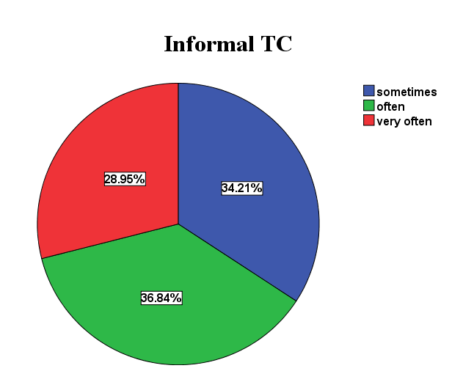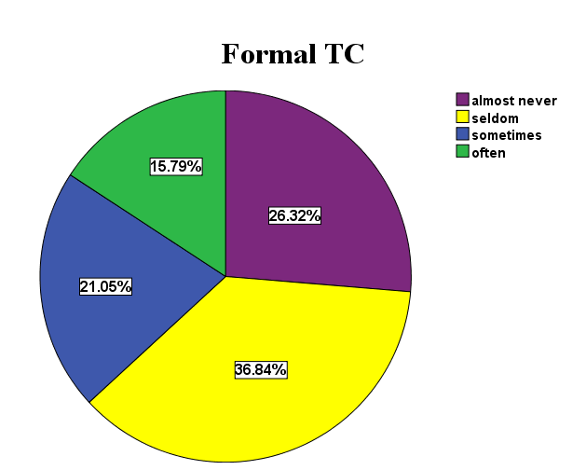
Chart 1: Informal vs. formal TC
The above finding could indicate that informal TC opportunities make teachers more comfortable and enjoyable than formal TC opportunities. This issue needs to be borne out in the interview data, where teachers had room for expressing ideas and giving comments in detail.
When being asked if there are formal TC opportunities offered to teachers of ESP department, all respondents said “yes” and listed many activities organized by the university or by the department such as workshops, seminars, classroom observations, and collaborative research.
However, all interviewees revealed that they rarely conduct research collaboratively. Three interviewees also stated that many teachers participate in workshops, seminars, and classroom observations mostly because these activities are compulsory. What is more, it can be concluded from what interviewees said that such activities do not have characteristics of TC activities because there is not a shared goal and not much interaction among teachers. For instance, in a seminar, “[teachers] listen to what the speaker says without interaction, some [teachers] even have private conversations while the speaker is presenting” (T2).
It seems that most of the interviewees are not very satisfied with these formal activities. On the other hand, all interviewees show an interest in informal TC opportunities which are conducted by teachers themselves. The reasons for their preference vary.
T4 talked about the harmony in collaborative relationships:

I have close relationships with some trusted colleagues who share common interest. We feel free to talk about any problems we meet in teaching. We discuss to find out the best solutions to the problems. This friendly and informal form of collaboration puts me at ease.
T1 compared the convenience of time arrangement between formal and informal TC activities:

I like informal [TC] activities with flexible time and pleasant atmosphere. Formal [TC] activities with fixed schedules make me feel serious and uncomfortable.
According to T3, some teachers do not enjoy formal TC activities very much because they are not really interested in the topics which are usually based on the common need of the majority. Those teachers, in contrast, prefer informal situations to exchange ideas about some problems they have or about something they are concerned about.
4.2. Employment of TC activities
The Means TC activities are displayed in Chart 2 in order to summarize the overall frequency of teacher participation in TC activities.
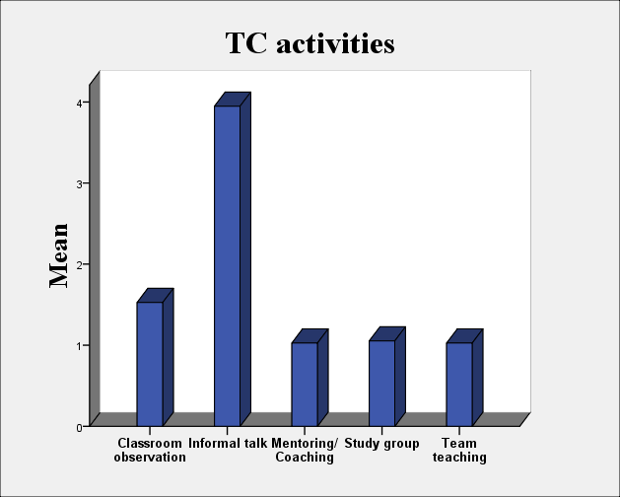
Chart 2: Teacher participation in TC activities
With reference to Chart 2 above, it can be seen that there is a disparity across the range of activities. Informal talk was very common among teachers (Mean = 3.95). Other activities, on the other hand, were employed very little. Such activities as mentoring/coaching, study groups, and team teaching have very low Means, slightly higher than value 1 (Almost never) of the 5-point scale. Classroom observation also received little concern (Mean = 1.53).
These numerical facts seem to correlate with the arithmetical findings in Chart 1 where most teachers expressed a greater interest in informal TC activities than formal ones. This may be due to the fact that formal TC activities such as classroom observation, mentoring/coaching, study groups, and team teaching require much time and effort. These activities also call for open minds and sympathetic hearts.
During the interviews, teachers’ answers to the questions on TC employment are closely connected to the facts drawn out from the questionnaires. It is the truth that teachers almost never join a study group or get involved in team teaching. Mentoring/coaching rarely happens and classroom observation is carried out only once a year. Only informal discussion is quite common among teachers. T5 declared:

We talk about issues relating to teaching anytime we meet. The most often is the break time between classes. We exchange experiences, learn from each other, and have fun together.
Disappointedly, “classroom observation is compulsory and not effective because both observers and observed teachers just do it for show. Observers rarely even give feedback. This kind of observation is not for the purpose of teacher professional development” (T1). Additionally, informal TC opportunities, in which teachers showed a great interest, are restricted to informal discussion only. No respondents can point out another form of informal TC when asked.
Again, the barriers to TC such as time constraints and lack of support were mentioned by the respondents as the reasons for teacher indifference to TC. However, some interviewees such as T2 and T4 honestly said it was teachers’ thinking that prevents them from participating in TC activities.

Some teachers are lazy and do not want to continuously study. Some others feel safer with individual [TPD] activities and are afraid of taking risks when collaborating with colleagues. (T2)

4.3. Focus of TC activities
As can be seen from Chart 3, classroom instruction is the main focus of TC with the Mean of 3.66. Assessment of student work holds the second position (Mean = 2.63). The Mean scores of lesson plan, material development/syllabus design, and research are very low, between value 1 (Almost never) and value 2 (Seldom).
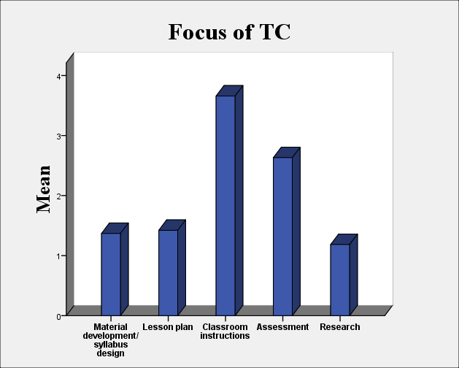

Chart 3: Focus of TC activities
From this result, it can be inferred that teachers seldom plan lessons, develop materials, and conduct research with collaborative efforts. Assessment of student work, though ranked second, is not discussed very often among teachers. Only classroom instruction is often taken into account by the majority of teachers.
Questions on the areas of teaching which receive most TC focus were raised in the interviews. Though interviewees have several ways to express their thoughts, there is not much difference among the answers. No respondents mentioned research as the main area of TC. Material development/syllabus design and lesson planning, similarly, are not taken into much consideration. Only T5 asserted that she developed curriculum and teaching material cooperatively with other teachers. On the contrary, classroom instruction and assessment of student work, received most attention from teachers.

We talk to each other about how we taught and the results we got. (T4)

I often apply alternative assessment in my classes. Sometimes I share and discuss student work with other teachers. (T3)

I sometimes share ideas on teaching techniques with other teachers, especially how to control large classes and motivate students. (T2)

We talk about new techniques in teaching and assessing students. (T1)

I share my teaching experiences, ideas, and student problems with other teachers. (T5)
T3 gave a comment that classroom instruction and student assessment were two major tasks of a teacher. Of course, these tasks became the main topics of all discussions among teachers. Other tasks such as material development/syllabus design and research were not often conducted by most teachers, so they could not be a common topic. However, T3 could not give an explanation for lesson planning.
Another likely explanation for this focus is that informal discussion is the major (and sometimes is the only) TC activity applied by teachers (as shown in Chart 2). Certainly, teachers cannot do research or develop material together only by discussing.

4.4. Teacher partnership in TC activities
Interestingly, Chart 4, which shows how frequently teachers collaborate with different partners, looks like a ladder of 5 steps. The height of each step is defined by the Mean of each item.
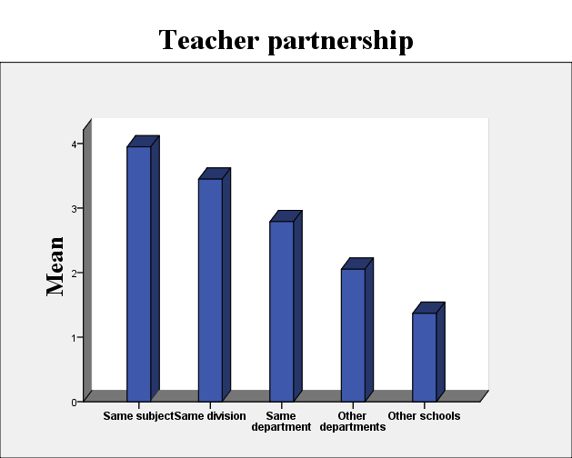

Chart 4: Teacher partnership in TC activities

The descriptive statistics suggest a tendency towards the partnership in teacher collaboration: the closer the professional relationship is, the more collaboration happens. As can be noticed from Chart 4, collaboration often occurs among teachers teaching the same subject (Mean = 3.95), takes place quite often among teachers in the same division (Mean = 3.45), sometimes happens among teachers in the same department (Mean = 2.79), seldom occurs among teachers from different departments (Mean = 2.05), and rarely takes place among teachers from different schools (Mean = 1.37).
This can be explained with the fact that most schools are organized by subject matter. Therefore, teachers affiliate with others in the same field through professional associations and informal networks. Thus, the capacity for teachers to pursue new curricular and organizational forms is limited not only by their relative isolation from one another in the school day, but also by the insularity of subject and departmental boundaries. These barriers lessen teachers’ opportunities or reasons for meaningful collaboration with teachers in other departments.
When being asked about the partnership in TC activities, all interviewees agreed that teachers tend to have more conversations with colleagues in the same division than with other teachers from other divisions, other departments or schools. With those who teach ESP, they often exchange information with those teaching the same subject.

I often share my experiences and teaching materials with other teachers who teach the same subject. (T2)

Teachers in my division often talk to each other about their classroom situations and the specific challenges they face. They also discuss what they learned at a workshop or conference together. (T4)

I share teaching materials and other professional resources with other teachers in my division. (T5)
Interviewees’ explanations for their partnership concentrate on three main reasons: time, commonality, and personal relationships.
Concerning time, T4 said that teachers in the same division often teach in the same school with similar teaching schedules. Therefore, they have opportunities to meet frequently at school, especially during the break time. In contrast, teachers in different divisions teach in different schools with different schedules. As a result, it is very difficult for teachers to find time together.
Regarding commonality, T1 asserted that teachers who teach the same subject or work with the same group of students often share common interests as well as common problems. Accordingly, they tend to have more contact with each other.
About personal relationships, T3 commented that it is the interpersonal bonds between teachers that decide how much TC they have.

4.5. Suggestions for promoting TC
Four suggestions for promoting TC were selected and presented in the questionnaires. Data collected was shown in Chart 5 below.

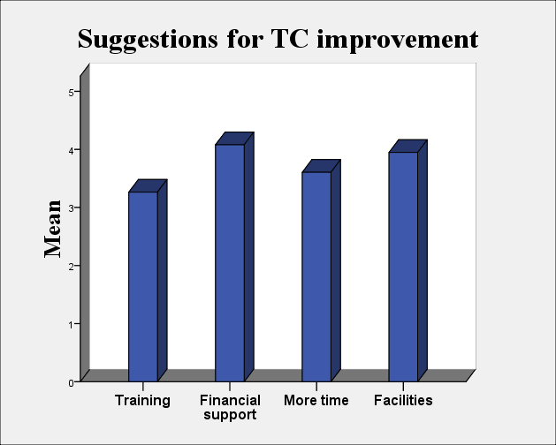
Chart 5: Suggestions for TC improvement
Of the four supporting elements, financial support gets the most agreement with Mean = 4.08. Facilities for TC activities also receive much attention from participants with Mean = 3.95. Time is not the most demanding for TC improvement (M= 3.61) and training on TC skills is the least required (M = 3.26).
To get more suggestions, the interviewer encouraged participants to freely express their ideas. However, no recommendations for teachers were provided. All suggestions that interviewees made were for institutional administrators. The surprise is that time was mentioned very little through interviewees’ suggestions. This seems controversial as compared to what interviewees said about TC obstacles when they explained the reason why they did not participate in formal TC activities.
Among several suggestions, financial support is considered by 4 out of 5 respondents. For example, T5 insisted that teachers would actively take part in TC activities if they received payment. Similarly, T3 believed that financial support would encourage teachers to spend more time and put more effort into TC. Furthermore, T3 suggested that teachers should be provided with sufficient facilities to promote TC:

We need common spaces, rooms, or areas for discussion. We also need facilities such as computer and projector to make TC more effective.
Only T2 thought that it is necessary for the institutional or departmental administrators to make policies or regulations on teacher participation in TC. T1 and T4 shared the same idea that workshops and seminars should be given in a different ways with a variety of topics in need. They also claimed that teachers should be encouraged to organize some of their own TC activities, provided that these activities are helpful for their professional development.
5. Conclusion and implications
Data collected from the questionnaires and interviews show that teachers at ESP Department – HUFL tend to do their own things in the classroom with little collaboration with their colleagues. It is depressing to know that many teachers joined formal TC activities just because these activities were compulsory. On the contrary, most participants revealed that they feel more comfortable and receive enjoyment with informal TC activities.
5.1. Implications for teachers
The findings of this study imply that teacher collaboration cannot be effective unless teachers think about themselves as change agents.
Firstly, many teachers argued that they could not find common time for TC because teachers at ESP Department had to teach in different schools with different schedules and time slots. However, TC does not require the participation of all teachers at the same time. On the contrary, all TC activities provided in this study (peer observation, mentoring, peer coaching, team teaching, and study group) can be carried out in pairs or small groups. It is unlikely to be true that two teachers cannot have at least one hour in common during a busy week.
Secondly, a lot of teachers worried about controversy occurring during TC. It is not a problem if teachers try to look at things from a different point of view. Teachers should always bear in mind that personality differences and conflicting opinions are normal and inevitable in any collaborative task, as an old saying goes “many men, many minds”. It will only be a problem if teachers make TC arguments become personal conflicts. It cannot be a problem if teachers choose to see the positive side of the matter. Actually, it is this diversity that benefits teachers a lot since it gives teachers opportunities to learn new ideas.
Finally, most teachers suggested financial support as the strongest motivation for teacher participation in TC. When asked whether teachers would participate more often in TC if they were provided with favorable conditions such as time and facilities, 3 out of 5 interviewees hesitated to give answers and finally said “It depends …”. Meanwhile, all interviewees said “I think so” without hesitation to the question “If teachers are paid for their participation in TC, do you think they will do it more often?” This opinion may be an explanation for the big gap between what teachers think and what teachers actually do with TC.
It can also be drawn out from teachers’ suggestions that they are waiting for changes from the school leaders. However, “Ongoing professional development is the responsibility of individual language teachers, rather than the schools, programs, or universities for which they work” (Bailey, Curtis, and Nunan, 2001, p.238).
5.2. Implications for administrators
It can also be seen from the findings of this study, especially from teachers’ suggestions, that teacher collaboration is hard to be successful without administrators, support.
Brown (1994) says that one of the most interesting things about teaching is that teachers never stop learning. Teaching is considered a lifelong journey of learning rather than a final destination of “knowing” how to teach. To promote the idea that teachers should join TC – a difficult but essential part of the journey, administrators should have policies to ensure that teachers have the needed support to go through this journey. What is more, teachers enthusiastically participating in TC activities should be provided with financial support (if it is possible). Though “voluntary” is the first principal quality of TC (Cook & Friend, 1991), some financial support can make teachers more serious and more responsible for TC. Moreover, sufficient financial support can reduce teacher time for additional jobs and, as a result, create more time for TC. In case the school cannot afford to do this, there should exist some forms of praise or encouragement for teachers to conduct more TC activities.
Among a wide range of TC activities that teacher may apply, study groups should be taken into great consideration by the administrators with the purpose of building a learning community and creating a collaborative culture for the college. Richardson (2001) claims that study groups are the most effective, cost-efficient way for teachers to learn what changes are needed in their practice and then to make those changes. They also have the added benefit of building rapport, trust, and support. According to DuFour and Eaker (2005), teachers engaged in study groups are able to learn from one another, thus creating momentum for continuing improvement. Moreover, many study groups that share common goals can create the basic structure of schools as a professional learning community.

References
Atay, D. (2006). Teachers' professional development: Partnerships in research. Y'stanbul: Marmara University.
Bailey, K. M., Curtis, A., & Nunan, D. (2001). Pursuing Professional Development: The Self as Source. Boston: Heinle & Heinle.
Berry, B., Daughtrey, A., & Wieder, A. (2009). Collaboration: closing the effective teaching gap. Center for Teaching Quality. Retrieved from https://www.teachingquality.org/sites/default
Brown, H. D. (1994). Teaching by principles: An interactive approach to language pedagogy. Englewood Cliffs, NJ: Prentice Hall Regents.
Castellano, M., & Datnow, A. (2000). Teachers’ responses to success for all: How beliefs, experiences, and adaptations shape implementation. American Educational Research Journal, 37(3), 775-799.
Cook, L., & Friend, M. (1991). Principles for the practice of collaboration in schools. Preventing School Failure, 35(4), 6-9.
De Lay, A. M. (2009). Behold! The power of teacher collaboration. The Agricultural Education Magazine, 82(July/August), 7-8.
Diaz-Maggioli, G. (2003). Options for teacher professional development. English Teaching Forum, 41(2), 2-10.
DuFour, R., Eaker, R. (2005). On common ground. Bloomington, Indiana: National Education Service.
Esteban, A. A., & Vallejo Martos, M. C. (2002). A case study of collaboration among the ESP practitioner, the content teacher, and the students. Revista Alicantina de Estudios Ingleses, 15, 7-21.
Gajda, R., & Koliba, C. J. (2008). Evaluating and improving the quality of teacher collaboration: A field-tested framework for secondary school leaders. NASSP Bulletin, 92(June), 133-153.
Ho, T. H. H. (2009). Attitude towards team-teaching: A study at the elementary level of teachers and learners at Vietnam USA society English Training Service Center. (Unpublished M.A. dissertation). CTU, Can Tho, Vietnam.
Jolly, A. (2005). A facilitator’s guide to professional learning teams: Creating on-the-job opportunities for teachers to learn and grow. Greensboso: SERVE.
Joyce, B., & Showers, B. (1982). The coaching of teaching. Educational Leadership, 40(1), 4-8.
Kochan, F. K., & Trimble, S. B. (2000). From mentoring to co-mentoring: Establishing collaborative relationships. Theory into Practice, 30(1), 20-28.
Lambert, L. (2003). Leadership capacity for leading school improvement. Alexandria, Virginia: ASCD.
Leonard, L., & Leonard, P. (2003). The continuing trouble with collaboration: Teachers talk. Current Issues in Education, 6(15). Retrieved from http://cie.ed.asu.edu/volume6/number15/
McClure, C. T. (2008, September). The benefits of teacher collaboration. District Administration. Retrieved from http://www.districtadministration.com/viewarticle.aspx?articleid=1682
Musanti, S. I. (2004). Balancing, mentoring and collaboration: Midcareer teachers constructing a new role. Curriculum and Teaching Dialogue, 6(1), 13-23.
Nguyen, T. M. H. (2017). Models of mentoring in language teacher education. Switzeland: Springer.
Ogisu, T. (2011). Learning to teach through teacher collaboration: Lessons from Chinese, Cambodian, and Vietnamese experience. Paper presented at the annual meeting of the 55th Annual Conference of the Comparative and International Education Society, Fairmont Le Reine Elizabeth, Montreal, Quebec, Canada.
Richardson, J. (2001). Learning Teams: When teachers work together, knowledge and rapport grow. Tools for School, Aug/Sep volume, 1-8.
Ronfeldt, M., Farmer, S., McQueen, K., & Grissom, J. (2015). Teacher collaboration in instructional teams and student achievement. American Educational Research Journal, 52 (3), 475-514.
Sargent, T. C., & Hannum, E. C. (2009). Doing more with less: Teacher professional learning communities in resource-constrained primary schools in Rural China. Journal of Teacher Education, 60(3), 258-276.
Savonmaki, P. (2005). Collaboration among teachers in Polytechnics. New Zealand Journal of Teachers’ Work, 2(2), 152-155.
Scrivener, J. (1994). Learning Teaching. In A. Underhill (Ed.), The Teacher Development Series. Oxford: Macmillan Heinemann.
Stanley, A. M. (2011). Professional development within collaborative teacher study groups: Pitfalls and Promises. Arts Education Policy Review, 112, 71-78.
Stewart, T., & Perry, B. (2005). Interdisciplinary team teaching as a model for teacher development. TESL-EJ, 9(2), 1-17.
Tar, I., Varga, K. C., & Wiwcraroski, T. B. (2009). Improving ESP teaching through collaboration: the situation in Hungary. ESP World, 8(1).
THỰC TẾ HỢP TÁC GIÁO VIÊN TẠI KHOA TIẾNG ANH CHUYÊN NGÀNH, ĐẠI HỌC NGOẠI NGỮ, ĐẠI HỌC HUẾ
Tóm tắt: Phát triển chuyên môn nghiệp vụ cho giáo viên được xem là việc làm vô cùng quan trọng và cần được tiến hành thường xuyên nhằm nâng cao chất lượng dạy và học. Trong đó, các hoạt động hợp tác giữa các giáo viên là một phần vô cùng ý nghĩa, bởi bản thân mỗi giáo viên đã là một nguồn tài nguyên vô cùng quý giá cần được chia sẻ để phát huy và học hỏi lẫn nhau. Bài báo này trình bày khái quát cơ sở lý luận về các hoạt động hợp tác giữa các giáo viên nhằm mục đích phát triển nghề nghiệp, đồng thời trình bày kết quả nghiên cứu về thực tế hợp tác giáo viên tại khoa Tiếng Anh chuyên ngành của Đại học Ngoại ngữ, Đại học Huế. Thông qua việc bàn luận về kết quả nghiên cứu, tác giả cũng đưa ra các đề xuất nhằm tăng cường và đẩy mạnh hơn nữa việc hợp tác giữa các giáo viên.
Từ khóa: giảng dạy ngoại ngữ, hợp tác giáo viên, phát triển nghiệp vụ

