Effect of leaves from sweet or bitter cassava and brewers’ grains on methane production in an in vitro rumen incubation of cassava root pulp-urea

Phanthavong Vongsamphanh, Sangkhom Inthapanya¹, T R Preston², Dinh Van Dung³ and Nguyen Xuan Ba³

Department of Livestock and Fisheries, Ministry of Agriculture and Forestry PO Box 6644 Vientiane, Lao PDR
vongsamphanh2015@gmail.com
¹ Animal Science Department, Faculty of Agriculture and Forest Resource Souphanouvong University Lao PDR
² Centro para la Investigación en Sistemas Sostenibles de Producción Agropecuaria (CIPAV), Carrera 25 No 6-62 Cali, Colombia
³ Faculty of Animal Husbandry and Veterinary Medicine, Hue University of Agriculture and Forestry, Hue University, Hue City, Vietnam

Abstract
The aim of this study was to evaluate the effect of cassava leaves (from sweet and bitter varieties) and supplementation with brewers’ grains (0 or 4%) on methane production in an in vitro rumen incubation of cassava pulp-urea as the main substrate. The design was a 2*2 factorial of 4 treatments with 4 replications. The two factors were: source of cassava leaves: sweet or bitter variety; and 4% brewers’ grains or none. The incubation was for 24h with measurements of total gas production and methane percentage at 6h intervals and determination of residual undigested substrate at the end.
The rate of gas production was higher when leaves of sweet rather than bitter cassava were the source of protein; and when brewers’ grains were added to the substrate. For all incubation intervals the methane content in the gas was lower for bitter than for sweet cassava leaves and lower when brewers’ grains were added to the substrate. The proportion of substrate DM that was digested, and the methane produced per unit DM digested, were reduced when the leaves of bitter rather than sweet cassava were the source of protein. The effect of the brewers’ grains was to increase the proportion of DM digested and to reduce the methane production per unit of substrate digested.
Key words: fermentation, secondary plant compounds, soluble protein, tannins

Introduction
Cassava in Lao PDR is mainly planted as an industrial tuber crop for starch production. It is the third most important food crop after rice and maize, the planting area having increased from 6,765 ha in 2005 to 63,260 ha in 2017 (MAF 2017). In the processing of the roots some 15% remains in the form of cassava pulp (Sriroth et al 2000). The pulp is high in fermentable carbohydrates and can contaminate the environment if not well managed. However, we have shown that when adequately supplemented the pulp can be the basis of an intensive cattle fattening system to produce quality beef for export (Phanthavong et al 2015).
The cassava varieties used for industrial starch production have been selected for high yield and are known as “bitter” varieties due to the high content of cyanogenic glucosides that are converted into the highly toxic hydrocyanic acid when consumed by animals and people. However, research by Phuong et al (2012) showed that from the point of view of the environment, and especially the problem of global warming, the presence of the cyanogenic glucosides in cassava could be an advantage as methane production in an in vitro rumen fermentation was found to be lower when the cassava leaves in the fermentation substrate were from “bitter” rather than from “sweet “varieties”. A related finding was that enteric methane production from a cassava-based feeding system could also be reduced by adding small amounts (4% of diet DM) of brewers’ grains to a cassava root-urea feeding system (Binh et al 2017).
The objective of this research was to provide further information on methane production when brewers’ grains were used as an additive in a rumen fermentation of cassava pulp-urea with either sweet or bitter cassava leaves as the protein supplement.

Materials and methods

Location
The experiment was conducted in the laboratory of the Faculty of Agriculture and Forest Resource, Souphanouvong University, Lao PDR.

Treatments and experimental design
Two factors were studied in an in vitro rumen incubation according to a 2*2 factorial design with 4 replications. The factors were:
- Source of cassava leaves: Sweet or Bitter variety
- With or without addition of 4% brewers’ grains in the fermentation substrate.
The basal substrate was ensiled cassava pulp supplemented with urea (Table 4.1) and with additions of rice straw and rice bran.

Table 1. Ingredients in the substrate, g DM
 | BCF |  | SCF
 | 0%BG | 4%BG | 0%BG | 4%BG
CP | 46 | 46 | 46 | 46
BCF | - | - | - | -
SCF | 30 | 26 | 30 | 26
BW | - | 4 | - | 4
RS | 16 | 16 | 16 | 16
Rice bran | 5 | 5 | 5 | 5
Urea | 2.5 | 2.5 | 2.5 | 2.5
Mineral # | 0.5 | 0.5 | 0.5 | 0.5
Total | 100 | 100 | 100 | 100
Contains P and S to provide 0.3 % P and 0.2% S in the substrate DM:
CP: Cassava pulp; BCF bitter cassava foliage; SCF sweet cassava foliage, BW brewers ‘grain; RS rice straw

In vitro rumen fermentation system
The in vitro rumen fermentation system was that described by Inthapanya et al (2011; Diagram 1). Recycled water bottles (capacity 1500ml) were used for the fermentation and collection of the gas. A hole was made in the lid of each of the bottles, which were interconnected with a plastic tube (id 4mm). The bottle receiving the gas had the bottom removed and was suspended in a larger bottle (5 liter capacity) partially filled with water, to collect the gas by water displacement. The bottle that was suspended in water was calibrated at 50ml intervals to indicate the volume of gas.
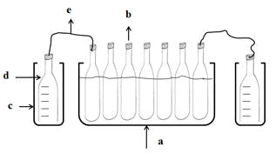

Figure 4.1. A schematic view of measuring gas production in the in vitro rumen fermentation

Experimental procedure
Leaves from sweet and bitter cassava varieties were collected in the morning from plots in the campus of Souphanouvong University. They were immediately chopped into small pieces (0.5-1.0 cm) and then ground (1mm sieve). Cassava pulp was collected from the storage pit at the Cassava Starch Factory in Nashaw village (Phanthavong et al 2014). Urea, rice bran, rice straw (chopped and ground), sulphur-rich minerals and brewers’ grains were mixed with the cassava pulp and cassava leaves and put in the fermentation bottle prior to adding 960 ml of buffer solution (Table 4.2) and 240 ml of rumen fluid (obtained from a newly slaughtered animal of the local “Yellow” breed in the Luang Prabang District abattoir). The residual air in the fermentation bottle was flushed with carbon dioxide. The bottles were incubated at 38ºC in a water bath for 24h.

Table 4.2. Ingredients of the buffer solution
 | CaCl₂ | NaHPO₄.12H₂O | NaCl | KCl | MgSO₄.7H₂O | NaHCO₃ | Cysteine
(g/liter) | 0.04 | 9.30 | 0.47 | 0.57 | 0.12 | 9.80 | 0.25
Source : Tilly and Terry (1963)

Data collection and measurements
The volume of gas was measured at 6, 12, 18 and 24h of the incubation, and the methane concentration recorded by passing the gas through a Crowcon infra-red analyser (Crowcon Instruments Ltd, UK). The residual DM in the incubation bottle was determined by filtering the residue through cloth and drying at 65°C for 72h. Solubility of the protein in the cassava leaves was determined by shaking 3g of dry leaf meal in 100 ml of M NaCl for 3h then filtering through Whatman No.4 filter paper and determining the N content of the filtrate (Whitelaw and Preston 1963). The ingredients in the substrate and the residue were analysed for DM, ash and N according to AOAC (1990) methods

Statistical analysis
The data were analyzed by the general linear model option of the ANOVA program in the Minitab software (Minitab 2014). The statistical model used was:
Y_{ijk} = μ + P_{i} + A_{j} + P_{i}*A _{j}+ e_{ijk}
μ = Overall mean
P_{i} = Source of cassava leaves
A_{j} = With or without brewers’ grains
P_{i}*A_{j} = Interaction between source of cassava leaves and brewers’ grains
e_{ijk} = random error

Results and discussion

Chemical composition
The solubility of the protein was lower in bitter than in sweet cassava leaves (Table 4.3) presumably due to higher levels of condensed tannins as reported by Sarkiyayi Agar (2010).

Table 4.3. The chemical composition of substrate ingredients (% in DM, except DM which is on fresh basis)
 | DM | CP | Ash | Protein  solubility, %
Cassava pulp | 24.3 | 1.8 | 5.6 | -
Sweet cassava leaves | 27.2 | 25.0 | 9.2 | 32.2
Bitter cassava leaves | 26.9 | 26.1 | 9.5 | 30.8
Rice straw | 90.4 | 2.1 | 13.4 | -
Rice bran | 90.1 | 100 | 23

Gas and methane production
The rate of gas production was highest in the incubation interval 12-18h, and over 24h was higher for leaves of sweet compared with bitter cassava variety, and higher when brewers’ grains were added to the substrate (Table 4.4; Figures 4.2-5). For all incubation intervals the methane content in the gas was lower for bitter than for sweet cassava leaves and lower when brewers’ grains were added to the substrate (Figures 4.6-8). The percent of substrate that was digested was reduced by presence of bitter compared with sweet cassava leaves and was increased when brewers’ grains were added to the substrate (Figure 4.10). Methane produced per unit DM digested was reduced by bitter cassava leaves and by adding brewers’ grain to the substrate (Figure 4.1).

Table 4.4. Mean values for gas production, methane in the gas, DM digestibility and methane per units substrate
 | Variety cassava leaves |  | p | Brewers’ grains |  | SEM | p
 | Bitter | Sweet |  | None | 4%
Gas production, ml
0-6h | 715 | 788 | 0.002 | 721 | 781 | 12.7 | 0.006
6-12h | 1006 | 1075 | 0.036 | 994 | 1088 | 20.6 | 0.007
12-18h | 1081 | 1213 | <0.001 | 1088 | 1206 | 15.5 | <0.001
18-24h | 625 | 838 | <.001 | 706 | 756 | 34.4 | 0.325
Methane in the gas, %
0-6h | 9.3 | 10.3 | 0.04 | 10 | 9.5 | 0.306 | 0.271
6-12h | 13.6 | 16.1 | 0.002 | 15.4 | 14.4 | 0.439 | 0.133
12-18h | 20.1 | 21.9 | <0.001 | 21.6 | 20.4 | 0.280 | 0.008
18-24h | 26.1 | 29.3 | 0.001 | 28.4 | 27 | 0.528 | 0.09
Total gas, ml | 3428 | 3913 | <0.001 | 3509 | 3831 | 36.52 | <0.001
Total methane, ml | 583 | 763 | <0.001 | 662 | 684 | 9.228 | 0.129
DM digested, % | 67.1 | 71.2 | 0.003 | 65.7 | 72.5 | 0.772 | <0.001
CH₄, ml/g DM digested | 69.4 | 86.5 | <0.001 | 81.0 | 74.9 | 1.613 | 0.002

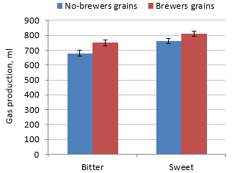 | 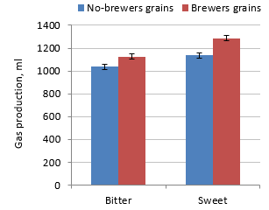
Figure 4.2. Effect of sweet or bitter cassava leaves with or without brewers’ grains on gas production 0-6h | Figure 4.3. Effect of sweet or bitter cassava leaves with or without brewers’ grains on gas production 6-12h
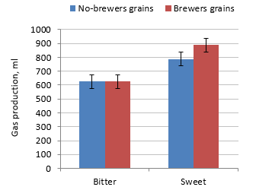 |  | 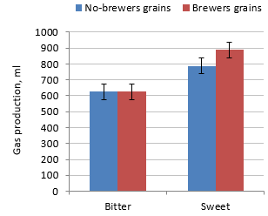
Figure 4.4. Effect of sweet or bitter cassava leaves with or without brewers’ grains on gas production 12-18h |  | Figure 4.5. Effect of sweet or bitter cassava leaves with or without brewers’ grains on gas production 18-24h
The methane content of the gas increased as the fermentation advanced and was reduced when bitter cassava leaves replaced leaves of sweet cassava, and when 4% brewers’ grains was included in the substrate (Table 4.4; Figures 4.5-4.8).
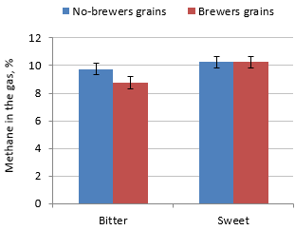 | 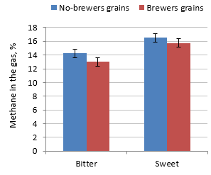
Figure 4.6. Effect of sweet or bitter cassava leaves with or without brewers’ grains on percent methane in the gas 0-6h | Figure 4.7. Effect of sweet or bitter cassava leaves with or without brewers’ grains on percent methane in the gas 6-12h

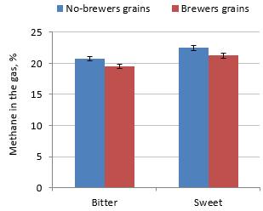 | 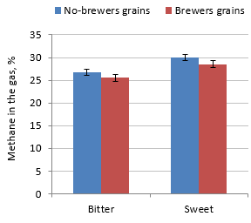
Figure 4.8. Effect of sweet or bitter cassava leaves with or without brewers’ grains on percent methane in the gas 12-18h | Figure 4.9. Effect of sweet or bitter cassava leaves with or without brewers’ grains on percent methane in the gas 18-24h
The proportion of the substrate DM that was digested during the incubation was increased when brewers’ grains were included in the substrate and was reduced when the protein supplement was from bitter compared with sweet cassava leaves (Table 4.4; Figure 10).
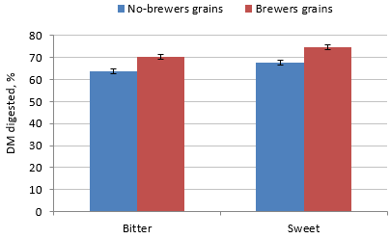

Figure 4.10. Effect of sweet or bitter cassava leaves with or without brewers’ grains on percent DM digested

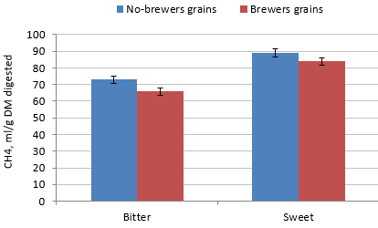

Figure 4.11. Effect of sweet or bitter cassava leaves with or without brewers’ grains on methane per unit substrate digested

Discussion
There is now abundant evidence confirming the reduction in methane production when leaves from bitter cassava replace leaves from the sweet variety in in vitro rumen incubations of: molasses (Phuong et al 2012), cassava root pulp (Phanthavong et al 2015; Binh et al 2018) and Bauhinia acuminata (Silivong et al 2018). This effect in reducing methane productionwould seem to be the direct consequence of the higher concentrations in bitter versus sweet cassava leaves of a range of anti-nutritional compounds (cyanogenic glycosides, trypsin inhibitors, oxalates, phytate and tannin) reported by Sarkiyayi and Agar (2010). The research of Smith et al (1985) supports the concept that cyanide is toxic to methanogens, and/or reduces their potential growth by lowering the availability of sulphur by formation of thiocyanates (Majak and Cheng 1984). Additions of 5, 10, and 25 mg 1itre^{-l} cyanide (from KCN or linamarin) temporarily inhibited methanogenesis in biodigesters charged with cassava root waste, but when the concentration of cyanide returned to lower levels (as it was before KCN or linamarin addition), methane production recovered (Cuzin and Labat 1992). It was concluded that the biodigester methanogenic microflora were sensitive to the added cyanide.
The reduction in DM digestibility when the cassava leaves were from bitter rather than sweet varieties suggests that the higher concentration of cyanogenic glucosides (and perhaps other secondary plant compounds) in the bitter varieties were having an inhibitory effect on the rumen microbiota in general as well as on methanogens.
There is also supporting evidence that the addition of small amounts (4% as DM) of brewers’ grains to an in vitro incubation of cassava pulp reduces methane production (Binh et al 2018), and that a byproduct from rice fermentation and distillation (rice distillers’ byproduct) has similar effects (Sangkhom and Preston 2016; Inthapanya et al 2017).
It is suggested that the increased rumen DM digestibility due to both these additives may reflect the improvement in habitat and consequent support for formation of biofilms that facilitate the activities of the overall rumen microbiota, as postulated by Leng (2017). The “prebiotic” effect of the beta-glucan present in the cell walls of barley, rice and yeast, which appears to be released by the process of fermentation and distillation in the manufacture of beer and rice wine, is another factor that could have contributed to the beneficial effects on rumen fermentation, and hence on digestibility, due to these additives.

Conclusions
In an in vitro incubation of cassava root pulp the rate of gas production was higher, when leaves of sweet rather than bitter cassava were the source of protein; and when 4% of brewers’ grains were added to the substrate.
For all incubation intervals the methane content in the gas was lower for bitter than for sweet cassava leaves and lower when brewers’ grain was added to the substrate.
The proportion of substrate DM that was digested, and the methane produced per unit DM digested, were reduced when leaves of bitter rather than sweet cassava were the source of protein. By contrast, the effect of the brewers’ grain was to increase the proportion of DM digested and to reduce the methane production per unit of substrate digested.

References
AOAC 1990 Official Methods of Analysis.Association of Official Analytical Chemists.15th Edition (K Helrick editor). Arlington pp 1230.
Binh P L T, Preston T R, Duong K N and Leng R A 2017 A low concentration (4% in diet dry matter) of brewers’ grains improves the growth rate and reduces thiocyanate excretion of cattle fed cassava pulp-urea and “bitter” cassava foliage. Livestock Research for Rural Development. Volume 29, Article #104. http://www.lrrd.org/lrrd29/5/phuo29104.html
Binh P L T, Preston T R, Van H N and Dinh V D 2018 Methane production in an in vitro rumen incubation of cassava pulp-urea with additives of brewers’ grain, rice wine yeast culture, yeast-fermented cassava pulp and leaves of sweet or bitter cassava variety. Livestock Research for Rural Development. Volume 30, Article #77. http://www.lrrd.org/lrrd30/4/binh30077.html
Cuzin N and Labat M 1992 Reduction of cyanide levels during anaerobic digestion of cassava. International Journal of Food Science 27 329-326
Inthapanya S, Preston T R and Leng R A 2011 Mitigating methane production from ruminants; effect of calcium nitrate as modifier of the fermentation in an in vitro incubation using cassava root as the energy source and leaves of cassava or Mimosa pigra as source of protein. Livestock Research for Rural Development. Volume 23, Article #21. http://www.lrrd.org/lrrd23/2/sang23021.htm
Inthapanya S, Preston T R, Phung L D and Ngoan L D 2017 Effect of supplements of yeast (Saccharomyces cerevisiae), rice distillers’ by-product and fermented cassava root on methane production in an in vitro rumen incubation of ensiled cassava root, urea and cassava leaf meal. Livestock Research for Rural Development. Volume 29, Article #220. http://www.lrrd.org/lrrd29/12/sang29220.html
Leng R A 2017 Biofilm compartmentalisation of the rumen microbiome: modification of fermentation and degradation of dietary toxins. Animal Production Science. 57(11) 2188-2203. https://doi.org/10.1071/AN17382
MAF 2017 Agricultural statistics year book 2017, Department of Planning and Finance, Ministry of Agriculture and Forestry, Lao PDR, 138 pp.
Majak W and Cheng K J 1984 Cyanogrnesis in bovine rumen contents and pure cultures of rumen bacteria Journal Animal Science 59, 784-790 http://www.journalofanimalscience.org/content/59/3/784.full.pdf
Minitab 2014 Statistical Software. Minitab Inc. Company. State College (Pennsylvania). http://www.minitab.com
Phanthavong V, Viengsakoun N, Sangkhom I and Preston T R 2014 Cassava pulp as livestock feed; effects of storage in an open pit. Livestock Research for Rural Development. Volume 26, Article #169. http://www.lrrd.org/lrrd26/9/phan26169.htm
Phanthavong V, Viengsakoun N, Sangkhom I and Preston T R 2015 Effect of biochar and leaves from sweet or bitter cassava on gas and methane production in an in vitro rumen incubation using cassava root pulp as source of energy. Livestock Research for Rural Development. Volume 27, Article #72. http://www.lrrd.org/lrrd27/4/-phan27072.html
Phuong L T B, Preston T R and Leng R A 2012 Effect of foliage from “sweet” and “bitter” cassava varieties on methane production in in vitro incubation with molasses supplemented with potassium nitrate or urea. Livestock Research for Rural Development. Volume 24, Article #189. http://www.lrrd.org/lrrd24/10/phuo24189.htm
Sarkiyayi S and Agar T M 2010 Comparative Analysis on the Nutritional and Anti-Nutritional Contents of the Sweet and Bitter Cassava Varieties. Advance Journal of Food Science and Technology 2(6): 328-334,
Silivong Phonevilay, Preston T R, Nguyen Huu Van and Duong Thanh Hai 2018 Effect of sweet or bitter cassava leaves and biochar on methane production in an in vitro incubation with substrates of Bauhinia acuminata and water spinach (Ipomoea aquatica). Livestock Research for Rural Development. Volume 30, Article #163. http://www.lrrd.org/lrrd30/9/psivil30163.html
Smith M R, Lequerica J L and Hart M R 1985 Inhibition of methanogenesis and carbon metabolism in Methanosarcina sp. by cyanide, Journal of Bacteriology, 162, 67-71.
Sriroth K, Chollakup R, Chotineeranat S, Piyachomkwan K and Oates C G 2000 Processing of cassava waste for improved biomass utilization. Bioresource Technology , Volume 71, pp 63-69
Tilley J M A and Terry R A 1963 A two stage technique for the in vitro digestion of forage crops. Journal of the British Grassland Society 18: 104
Whitelaw F G and Preston T R 1963 The nutrition of the early-weaned calf III. Protein solubility and amino acid composition as factors affecting protein utilization. Animal Science, Volume 5, Issue 2, pp. 131-145 Published online: 01 September 2010 https://doi.org/10.1017/S0003356100021620

