THE IMPACT OF RISK FACTORS ON BUSINESS RESULTS OF LIFE INSURANCE PRODUCTS IN THE INSURANCE COMPANIES IN HUE CITY
Duong Dac Quang Hao, Nguyen Thi Minh Hoa
University of Economics, Hue University

Abstract. Based on leveraging Monte Carlo simulation method and @Risk - the risk analysis software, this study aims to identify and analyse the impacts of the potential risk factors on business results of life insurance products in the insurance companies in Hue city. Both qualitative research method and quantitative one are applied. Based on the DELPHI technique, data was collected from interviewing the leaders, financial managers and senior consultants at four most representative life insurance companies in the area (including Bao Viet life insurance, Prudential, AIA and PCI Sun Life). Research results show that: Firstly, besides the identified events, it exists 10 other types of risks that could affect the business results of life insurers. Secondly, these types of risks have a very different frequency and level of impact on three measurement variables of the simulation model. Finally, risk of rumours and risk of new competitors appear to be the most significant risks to the expected profits of life insurance companies.
Keywords. Monte Carlo simulation, @Risk, business risks, life insurance.
1. INTRODUCTION
In Vietnam, the insurance industry has started since 1993, However, according to the Department of Insurance Supervisory and Authority, approximately only 9.7% of the Vietnamese population buys life insurance so far [3]. Along with the huge market development opportunities and the rapid growth of the economy in the coming time, Vietnam is recognised as one of the most lucrative markets for life insurers in the South East Asian region [5]. In terms of domestic enterprises, to exploit this opportunity, they need to make breakthrough changes. In fact, 62.5% of market share in the Vietnam life insurance industry is accounted by foreign insurers (such as AIA, Frudential), this is rooted from the weaknesses of domestic ones in risk management activities [17]. Weak ability to control business risks leads to severe effects on company reputation, customer relationship and profitability [12].
Regarding the academic aspect, after the world economic crisis, along with the increasing concerns of corporations about risk management issues, the topic of assessing risk factors affecting business results thus has been recognized as a field of growing interest worldwide [5]. Many research has been implemented to develop the evaluation scale of identified and unidentified risk events [1, 12, 13]. Some authors interest in clarifying the consequences of risks on business activities in the insurance companies [4]. Despite the increase in the number of related researches, there are still gaps in the knowledge base.
Namely, it is still lack of efficient quantitative model to measure the level of identified and unidentified risk events. Further, the relationship between these events and financial results of life insurers have not quantified clearly yet.
Besides, although numerous scholars in risk management have developed a quantitative scale to assess the business risks in developed countries [4]. The evaluation scale of these identified risks was not thoroughly tested in the practice of a developing country, such as Vietnam [13].
Stemming from the above urgent problems, the study was carried out with two main objectives:
- Analyse the risks affecting the selling process of life insurance products in some typical insurance companies in Hue city.
- Propose feasible solutions to help life insurers in Hue city identify, mitigate and overcome the above risks.
2. LITERATURE REVIEW
One of the first definitions of risk is attributed to Bernoulli, who in 1738 proposed measuring risk with the geometric mean and minimizing risk by spreading it across a set of independent events [21]. Accordingly, the traditional definition of risk is measured by two combined variables: a) frequency of occurrence (probability) of the “risky” event, i.e., the number of times the risky event is repeated in a predetermined period and b) extent of the consequences (magnitude) that the event generates, i.e., all the results of its occurrence [15].
Following Verbano and Venturini (2013), the risk is the possibility of an abnormal event with consequential consequences or results that are not expected. The risk may comprise positive and negative consequences of an event. Risk has four basic characteristics: randomness, objectivity, uncertainty (or unpredictable) and duality [20].
In business, risk can be caused by external factors, such as risks arising from the macro environment (such as economic status, political situation, social features, science and technology), micro-environments (such as competitors, customers, suppliers, alternative products), or may also come from internal factors (such as risks related personnel issues, strategies, products, company policies, ...) [20].
The International Organization for Standardization (ISO 31000, 2009) identifies the following principles of risk management that should: create value; be an integral part of the organizational processes; be part of decision making that explicitly addresses uncertainty; be systematic and structured; be based on the best available information; be tailored; take into account human factors; be transparent and inclusive; be dynamic, iterative and responsive to change; and be capable of continual improvement and enhancement.
The adoption of a risk management methodology can lead firms to reduce the uncertainty in enterprise management, to ensure continuity in production and trading in the market, to decrease the risk of failure, and to promote the enterprise’s external and internal image. Therefore, risk management creates business value, maximizing business profits by minimizing costs [10].
Regarding the studies on the topic of business risks in the life insurers and insurance companies in general, most of the studies only research on the risk identification [6], traced the source of risk [14] or analyzed the financial consequences when risks occur [2]. These studies have not considered the use of risk measurement tools, as well as compared to the random effects of business risks. This study thus will utilise the Monte Carlo simulation method to create a relatively distinct research platform.
Monte Carlo simulation method is a broad class of computational algorithms that rely on repeated random sampling (using pseudo-random random numbers), to obtain numerical results. Its essential idea is using randomness to solve problems that might be deterministic in principle. The result of this method is more accurate (asymptotic in the right result) when the number of iterations increases [3]. It is mainly used in three problem classes: optimization, numerical integration, and generating draws from a probability distribution [7].
In this study, based on using the @Risk - a risk analysis software, the Monte Carlo method is leveraged to evaluate the impact of defined variables (caused by negative causes) and undefined variables (caused by difficult-to-identify causes) to measurement variables and targeted ones. By this way, the fluctuation of these variables, under the impact of different types of risks could be analysed and evaluated clearly.
3. RESEARCH METHOD
In this study, the authors utilized both qualitative data and quantitative one. Namely, the secondary data were collected from the Department of Insurance Supervisory and Authority, Thua Thien Hue Statistical Office, and Association of Hue enterprises. These data sources provide an overview of business activities in life insurers in Hue city, general assessments on their performance and the financial results of these enterprises.
Primary data was then collected by using DELPHI technique. This is a structured communication technique, derived from symmetric prediction methods and interactive forecasts based on panel answers of experts' questions [16].
Regarding data collection techniques, the study applied. The sample size consists of 2 interviewed groups (more than 3 people/ group) and 12 individuals from 4 most typical selected life insurance companies. The interview sequence for collecting quantitative data will go through 3 steps:
- Step 1: Personal interview with 4 accountants from 4 selected companies.
- Step 2: Personal interview with 8 people (leaders, managers of the sales department and senior consultants from 4 selected companies).
- Step 3: Interview 2 research groups from 4 selected companies.
During this process, in each step, the interviewees will receive a summary of all predictions from the prior interviewees and the interpretation of these predictions. The interview results by the previous step thus were evaluated by the following steps, similar to the results from the following steps are also considered by the members in the previous step, in order to have a high consensus before the study obtained the final result.
Regarding analytical methods, @Risk analysis tool was selected to analyze risks in the selling process of life insurance products at selected insurance companies in Hue city.
4. RESEARCH FINDINGS

4.1. Building simulation model
As a prerequisite for risk analysis based on Monte Carlo simulation method, the study conducted a qualitative survey. The results are shown in Table 1 below. Namely, the interviewees propose three most important measurement variables representing for business results at Hue life insurer, including number of sold life insurance contracts, average costs and average revenue for each life insurance contract. Besides the defined events, there are 10 unknown events (see table 1).

Table 1. Simulation model
Unknown events | Number of contract |  | Cost/ contract |  | Revenue/ contract
 | Frequency | % impact | Frequency | % impact | Frequency | % impact
Risk of organizing unsuccessful workshops (finding customers) | 0.15 | -0.05 | 0.17 | 0.04 | - | -
Risk of unsuccessful cold canvassing | 0.18 | -0.05 | 0.25 | 0.05 | - | -
Risk of appearing new competitors | 0.12 | -0.06 | 0.16 | 0.05 | 0.11 | -0.11
Risk of rumors | 0.20 | -0.11 | - | - | 0.16 | -0.10
Risk of changing insurance policies | 0.11 | 0.04 | 0.12 | 0.03 | - | -
Risk of losing key personnels | 0.10 | -0.12 | - | - | - | -
Risk of sudden increase in the number of compensated contracts | - | - | 0.52 | 0.04 | - | -
Risks of canceling a large number of contracts | 0.13 | -0.04 | 0.26 | -0.04 | 0.04 | -0.04
Risk of temporarily invalidating a series of contracts | 0.11 | -0.14 | - | - | 0.06 | -0.06
Risk of suddenly adjusting a large number of contracts | - | - | - | - | 0.06 | -0.07
4.2. Analyze the impact of risks on measurement variables
After building simulated models for the research year and the base year, risks affecting the business results of life insurance products are evaluated through 4 steps. The number of random iterations during the simulation is 10000 times. The results are as follows:
4.2.1. Analyse risks affecting the number of sold life insurance contracts
The analysis results show that the identified events cause different in the number of sold contracts among different years. This number ranges from about 325 contracts/ year to 1357 contracts/ year. These identified events relate to changes in market demand; competitors; insurance companies' strategies and policies; skills of consulting staff, sales staff,... Besides, the number of sold life insurance contracts is also affected by 8 different types of unknown risks. Risk of rumours is the most significant impact on this measurement variable (regression coefficient -23,580, correlation coefficient -0.12).

Risk of temporarily invalidating a series of contracts creates the widest range of impact level that is varied from 683.82 to 801.34 contracts/ year.
Besides, in 10,000 random iterations, 90% of iterations have a number of contracts distributed between 443 and 1140 contracts/ year.
Table 2. Results of comparative analysis between researched year and base year
Unit: contract per year
Criteria | Researched Year | Base year | Criteria | Researched Year | Base year
Minimum value | 270.741 | 325.370 | Standard deviation | 209.666 | 213.116
Mean value | 781.569 | 840.500 | Median | 476.425 | 840.471
Maximum value | 1,401.248 | 1,356.619 | Mode | 436.958 | 837.883
3.2.2. Analyse risks affecting the cost of a life insurance contract
The analysis results show that, the cost of a life insurance contract is possibly impacted by 6 unknown events: risk of unsuccessful cold canvassing, risk of sudden increase in the number of compensated contracts, risks of cancelling a large number of contracts, risk of appearing new competitors, risk of organizing unsuccessful workshops and risk of changing insurance policies. Under the impacts of these risks, The fluctuation range of cost per life insurance contract changed from (lowest: 1.589 million VND/contract/year; highest: 19.398 million VND/contract/year) to (lowest: 1.692 million VND/contract/year; highest: 18.707 million VND/contract/year)
Besides, the risk of sudden increase in the number of compensated contracts (regression coefficient -0.289, correlation coefficient 0.04) and risk of unsuccessful cold canvassing (regression coefficient 0.288, correlation coefficient 0.03) are two risks creating greatest impact on this measurement variable.
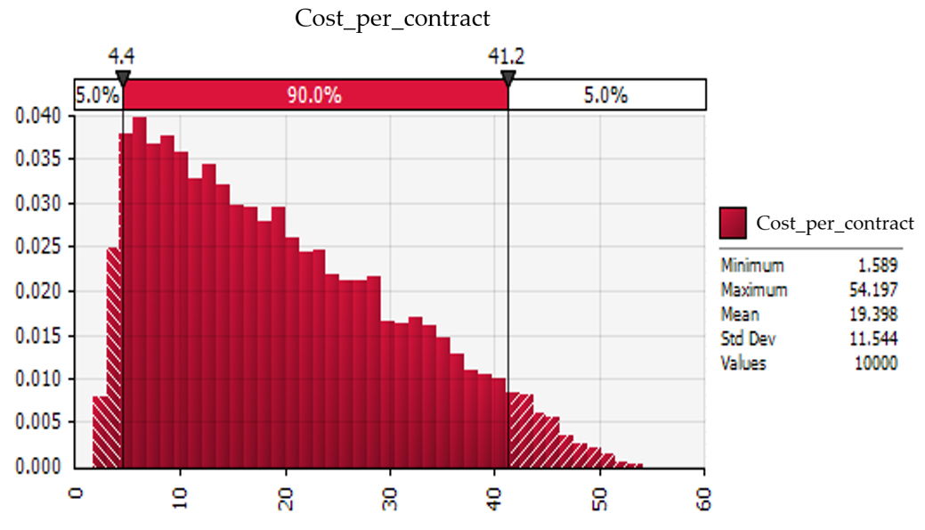
Figure 1. Approximate range of value of measurement variable: cost per contract in 10,000 iterations
4.2.3. Analyse risks affecting the revenue of a sold life insurance contract
There are 5 unknown events affect measurement variable - revenue per life insurance contract. Risk of rumours (regression coefficient -0.887, correlation coefficient -0.05) and risk of appearing new competitors (regression coefficients -0.769, correlation coefficient -0.03) have the greatest impacts. On the other hand, the cumulative effects of 5 events also change the fluctuation range of revenue per life insurance contract from (lowest: 2.812 million VND/contract/year; highest: 111.651 million VND/contract/year) to (lowest: 3.313 million VND/contract/year; highest: 111.744 million VND/contract/year)
In 10,000 random iterations, 90% of iterations have revenue per contract range from about 8.9 to 86.0 million VND/ contract.

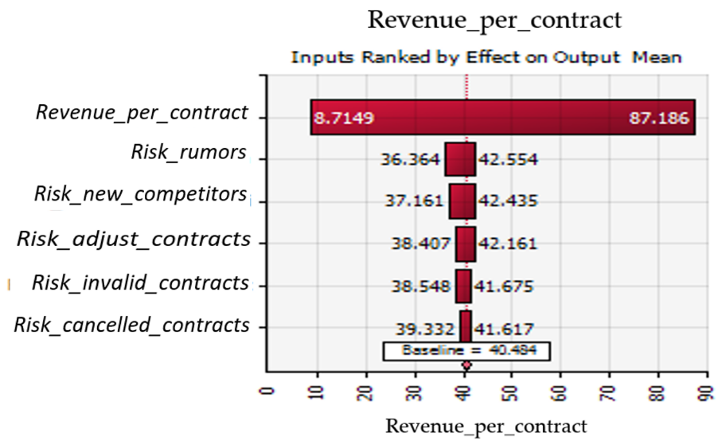

Figure 2. The impact range of each risk to the revenue per contract
3.2.4. Analyse risks affecting the profitability of life insurers

The profit is considered as the targeted variable of the study. This number is calculated based on the variability of the three measurement variables in the simulation model. Exclude the identified events, the analysis results on the impact of 10 unknown events to the variability of profits reveals: Risk of rumor (regression coefficient -1,111.49, correlation coefficient -0.06), risk of appearing new competitors (regression coefficients -996,84, correlation coefficient -0.03) and risk of temporarily invalidating a series of contracts (regression coefficient -601.94, correlation coefficient -0.04) have the greatest impact on targeted variable - profit.

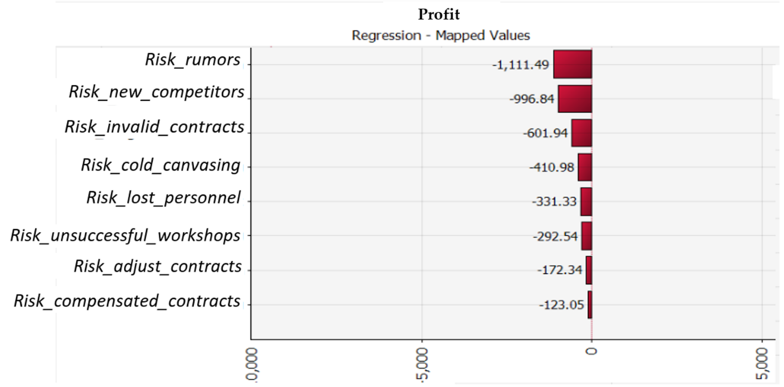

Figure 3. Regression coefficient on the impact level of different risks to profit
Another statistic shows that under the negative and positive impacts of 10 unidentified risks, average profit (Mean) of the life insurers has declined from 19,463.49 million VND/ year in the base year (assume unknown events does not appear) to 16,494.96 million VND/ year in the researched year. The average loss is 2,968.53 million VND/ year.
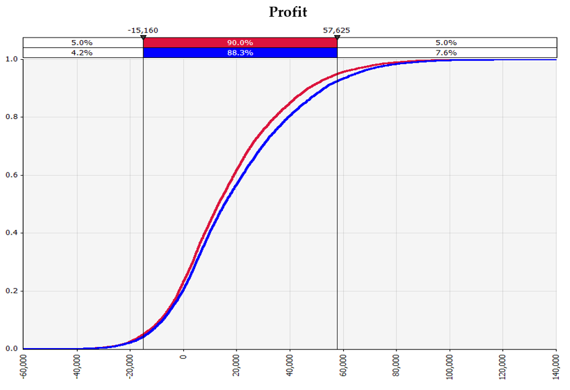

Figure 4. Compare the approximate range of profit between the researched year and the base year
4. Discussion and conclusion
Identifying and managing risk factors affecting business performance is always the top concern of business leaders and academic scholars around the world, not only in the insurance sector but also in many other ones. In this study, the authors develop and analyse the simulated model based on the Monte Carlo method so as to evaluate the impact of defined variables and undefined ones to measurement variables.
The findings in this research have supplemented the knowledge about risks in the life insurance business. Namely, the qualitative research step has figured out 4 major groups of risk that affecting the business results at life insurance companies in Hue city, including: risk group related to accessing customers (including: risk of unsuccessful cold canvassing, risk of organizing unsuccessful workshops), risk group related to the market (including: risk of appearing new competitors, risk of rumors), risk group related to the internal issues (including: risk of changing the insurance policies, risk of losing key personnel), and risk group related to the customers' problems (including: risk of suddenly increasing in the number of compensated contracts, risks of canceling a large number of contracts, Risk of temporarily invalidating a series of contracts, Risk of suddenly adjusting a large number of contracts). This finding helps to clarify the research results of Baranoff and Sager (2002) which mention asset risk, product risk, and capital in the life insurance industry.
Another finding is the number and impact level of unknown events on three measurement variables of the simulation model. Namely, there are 8 unknown risks affecting the number of sold contracts, 6 risks affecting costs per each sold contract and 5 risks affecting the revenue per each life insurance contract. This is supported by the research of Gründl et al. (2006) and Grosen et al. (2002). This finding help life insurers arrange the priority order of controlled and prevented measures to mentioned risks.
Referring to the targeted variable – the profitability of life insurers, the study found that risk of rumours, the risk of appearing new competitors, and risks of cancelling a large number of contracts have the greatest impact on the expected profits of life insurance companies. This finding is partially supported by Cummins and Santomero (2012).
Based on the analysis results and group discussion among risk management experts, the study offers 4 groups of solutions to limit the negative effects of unknown events on the business results of insurance companies in the locality, specifically:
- Solutions related to customer-related risks focus on screening and thorough understanding of invited customers to the workshops, and enhancing customer service networks.
- Solutions related to contract-related risks focus on simplifying transaction procedures, checking more strictly the truthfulness of information declared on the contract.
- Solutions related to cost-related risks include informing clearly and transparently the information of insurance packages and reducing internal costs.
- Solutions related to product quality and employees focus on creating training opportunities, improving knowledge and professional capacity for employees, expanding diversification of agent channels, as well as considering changes in product packages.
In summary, on the basis of risk theories in general and risks in the life insurance business in particular, this study help life insurers identify and analyse the impact features of traditional risks and unknown risks during their business process. Regarding the limitation of this study, the collected data has certain shortcomings. This is rooted in relative evaluation criteria and subjective opinions of interviewees. Therefore, in the future, there should be further research with more focused research scope, data collected in a longer time (such as supervising throughout the process of occurred risks). Moreover, there should be new studies focusing on clarifying the effectiveness of risk prevention methods currently applied by life insurers.

REFERENCES
- Baranoff, E. G., & Sager, T. W. (2002). The relations among asset risk, product risk, and capital in the life insurance industry. Journal of banking & finance, 26(6), 1181-1197.
- Cummins, J. D., & Santomero, A. M. (Eds.). (2012). Changes in the life insurance industry: efficiency, technology and risk management (Vol. 11). Springer Science & Business Media.
- Department of Insurance Management and Supervision (2014), Global Insurance Market Newsletter, No. 22 + 23 (40 + 41) on January 15, 2014, Ministry of Finance.
- Eckles, D. L., Hoyt, R. E., & Miller, S. M. (2014). Reprint of: The impact of enterprise risk management on the marginal cost of reducing risk: Evidence from the insurance industry. Journal of Banking & Finance, 49, 409-423.
- ERC (2013). Global insurance review 2013 and outlook 2014/15, November 2013, Economic Research & Consulting, Swiss Re
- Gahin, F.S. (1971) ‘Review of the Literature on Risk Management’, The Journal of Risk and Insurance 38(2): 309–313.
- Gamerman, D. Markov Chain Monte Carlo: Stochastic Simulation for Bayesian Inference. Boca Raton, FL: CRC Press, 1997.
- Gilks, W. R.; Richardson, S.; and Spiegelhalter, D. J. (Eds.). Markov Chain Monte Carlo in Practice. Boca Raton, FL: Chapman & Hall, 1996.
- Grosen, A., & Jørgensen, P. L. (2002). Life insurance liabilities at market value: an analysis of insolvency risk, bonus policy, and regulatory intervention rules in a barrier option framework. Journal of risk and insurance, 69(1), 63-91.
- Gründl, H., Post, T., & Schulze, R. N. (2006). To hedge or not to hedge: Managing demographic risk in life insurance companies. Journal of Risk and Insurance, 73(1), 19-41.
- Hoyt, R. E., & Liebenberg, A. P. (2008). The value of enterprise risk management: Evidence from the US insurance industry. In unpublished paper, accessed at: http://www. aria. org/meetings/2006papers/Hoyt_Liebenberg_ERM_070606. pdf.
- Hoyt, R. E., & Liebenberg, A. P. (2011). The value of enterprise risk management. Journal of risk and insurance, 78(4), 795-822.
- Jason R.Thacker, CAIA (2011), Risk Management in Insurance, Business program consultant and actuarial development program, Colonial life.
- Judy Feldman Anderso & Robert L.Brown, Risk and insurance, Education and examination committee of the society of actuaries.
- Kevin Dowd, David L. Bartlett, Mark Chaplin, Patrick Kelliher and Chris O’Brien (2007), Risk management in UK insurance industry: The changing state of practice, Centre for Risk & Insurance Studies, University of Nottingham.
- Luciano Machain (2009), "@Risk: Monte Carlo Simulation in Excel", National University of Rosario, Argentina
- Ministry of Finance (2015), Vietnam Insurance Market Supervision 2014, Finance Publishing House, Hanoi 2015.
- Ogawa, S., & Piller, F. T. (2006). Reducing the risks of new product development. MIT Sloan management review, 47(2), 65.
- Palisade corporation, Guide to RISKOptimizer: Simulation optimisation for Microsoft Excel.
- Verbano, C., & Venturini, K. (2013). Managing risks in SMEs: A literature review and research agenda. Journal of technology management & innovation, 8(3), 186-197.
- Bernoulli, D. (1954). Originally published in 1738; translated by L. Sommer. Exposition of a new theory on the measurement of risk. Econometrica, 22(1), 22-36.

PHÂN TÍCH TÁC ĐỘNG CỦA CÁC YẾU TỐ RỦI RO ĐẾN KẾT QUẢ KINH DOANH SẢN PHẨM BẢO HIỂM NHÂN THỌ CỦA CÁC CÔNG TY BẢO HIỂM TRÊN ĐỊA BÀN THÀNH PHỐ HUẾ
Dương Đắc Quang Hảo, Nguyễn Thị Minh Hòa
Trường Đại Học Kinh Tế, Đại Học Huế
Tóm tắt. Trên cơ sở vận dụng phương pháp mô phỏng Monte Carto và sử dụng phần mềm phân tích rủi ro @Risk, nghiên cứu này được thực hiện nhằm nhận dạng các yếu tố rủi ro tiềm ẩn, cũng như đi sâu phân tích tác động của chúng đến kết quả kinh doanh sản phẩm bảo hiểm nhân thọ (BHNT) của các công ty bảo hiểm trên địa bàn thành phố Huế. Để phân tích vấn đề này, nghiên cứu đã tiến hành phỏng vấn chuyên gia dựa trên kỹ thuật DELPHI tại chi nhánh các công ty bảo hiểm nhân thọ lớn trên địa bàn (gồm Bảo Việt Nhân Thọ, Frudential, AIA và PCI Sun Life). Kết quả nghiên cứu chỉ ra rằng: Thứ nhất, bên cạnh các loại biến cố xác định thì tồn tại 10 loại rủi ro có khả năng tác động đến kết quả kinh doanh BHNT. Thứ hai, các loại rủi ro này có tần xuất và mức độ tác động rất khác biệt đến 3 biến đo lường của mô hình mô phỏng. Cuối cùng, Rủi ro tin đồn và Rủi ro xuất hiện đối thủ cạnh tranh mới là những rủi ro tác động mạnh nhất đến lợi nhuận dự kiến của các công ty.
Từ khóa: mô phỏng Monte Carlo, @Risk, rủi ro, bảo hiểm nhân thọ
AUTHORS INFORMATION:
Ms. Duong Dac Quang Hao
Faculty of Business Administration, University of Economics, Hue University
99 Ho Dac Di St., Hue city, Vietnam
quanghao@hce.edu.vn
Signature:

Assoc. Prof. Dr. Nguyen Thi Minh Hoa
Faculty of Business Administration, University of Economics, Hue University
99 Ho Dac Di St., Hue city, Vietnam
minhnhathoa@yahoo.com
Signature: Minh Hoa

Corresponding: quanghao@hce.edu.vn
"-": Risks affect negligibly to measurement variable

