Water retention characteristics of biopolymer hydrogel containing sandy soils

An Thi Phuong Tran, PhD
Department of Hydrological and Geotechnical Engineering, Hue University of Sciences, Hue University, 530000, Vietnam
Department of Civil and Environmental Engineering, Korea Advanced Institute of Science and Technology (KAIST), Daejeon 34141, Republic of Korea
Email: sanga@kaist.ac.kr / phuongan313@gmail.com

Gye-Chun Cho, Ph.D.
Professor, Department of Civil and Environmental Engineering, Korea Advanced Institute of Science and Technology (KAIST), Daejeon 34141, Republic of Korea
Tel: +82-42-869-3622
Email: gyechun@kaist.edu
Ilhan Chang, Ph.D., A.M.ASCE
Corresponding Author, Senior Lecturer, School of Engineering and Information Technology, University of New South Wales (UNSW), Canberra, ACT 2600, Australia
Tel: +61-2-6268-8295
Email: ilhan.chang@unsw.edu.au

ABSTRACT
Vật liệu vi sinh học (microbial biopolymer) được giới thiệu như một chất kết dính đất mới. Vật liệu này được biết đến là thân thiện với môi trường vì khả năng làm giảm lượng cacbon giải phóng ra môi trường và làm giảm sự ảnh hưởng đến hệ sinh thái đất. Để phục vụ cho ngành địa kỹ thuật và nông nghiệp, nhiều loại vật liệu dạng gel đã và đang được sử dụng để cải thiện khả năng giữ nước của đất cát pha và chống lại sự xói mòn bề mặt. Trong nghiên cứu này, đặc tính nước – đất (SWC) của hỗn hợp cát – sét được xử lý bởi xanthan gum biopolymer được đánh giá thông qua thí nghiệm trong phòng. Hỗn hợp cát – kaolin được tin xử lý với xanthan gum hydrogel với hàm lượng xanthan gum lần lượt là 0.0%; 0.25%; 0.5%; 0.75% và 1.0% trên tổng khối lượng đất khô. Kết quả thí nghiệm cho thấy, đường cong nước – đất (SWCC) của đất xử lý xanthan gum cho thấy khả năng giữ nước của đất tăng theo hàm lượng xanthan gum sử dụng. Sự có mặt của xanthan gum gel trong đất làm tăng độ ẩm ban đầu và độ ẩm dư, và ngăn chặn sự mất nước từ đất. Theo đó, đường cong SWC của đất qua xử lý ít dốc hơn đường cong SWC của đất không qua xử lý.
Microbial biopolymers are introduced as a new soil binder which regarded to be environmentally-friendly materials in terms of low carbon emission and low impact on the soil ecosystem. In geotechnical engineering and agriculture, various gel-type materials have been used to improve the water absorbability of sandy soils, and control surface erosion. In this study, the soil-water characteristics of xanthan gum biopolymer-treated sand-clay mixtures are evaluated through a laboratory program using a soil-water characterization apparatus. Sand-clay mixtures are treated with different xanthan gum concentrations as 0% (untreated), 0.1%, 0.25%, 0.5%, 0.75% and 1.0%, to the mass of soil, respectively. Consequently, the xanthan gum-soil water characteristic curve results show the enhanced water holding capacity of soils with higher xanthan gum contents. The presence of xanthan gum hydrogels in the soil increases the initial and residual water contents. Biopolymers retain moisture loss from the soil, which makes the slope of the soil-water reduction curve to be more gradual.
Keywords: xanthan gum; soil-water characteristic curve; water absorption; sand-clay mixture
I. INTRODUCTION
The unsaturated zone is defined as the earth’s terrestrial subsurface that extends from the surface to the regional underground water. An unsaturated soil is commonly defined as having three phases: (1) solids, (2) water and (3) air. In order to understand the relationship between the mass of water in the soil and the energy state of the water phase [1], the soil-water characteristic curve (SWCC) is measured in the laboratory and used in engineering practice. Therefore, the SWCC is known as an essential role in the interpretation of the geotechnical engineering behavior of unsaturated soils. The shape of the SWCC generally depends on the pore size distribution and compressibility of the soil in relation to matric suction [2]. Thus, the SWCC is affected by the initial water content, soil structure, stress history, and soil plasticity [3-5].
The SWCC has three stages that describe the process of desaturation of soil, as shown in Fig.1 [1, 6], which reflects different properties of water in the soil. The capillary saturation zone (or boundary zone) is where the pore-water is in tension, but the soil remains saturated. This stage ends at the air entry value, where the applied suction overcomes the capillary water forces in the largest pore in the soil. The transition zone (desaturation zone) is where water is displaced by air within the pores. This stage ends at the residual water content, where the pore water becomes discontinuous, and the coefficient of permeability is greatly reduced. The residual saturation zone is where the water is tightly adsorbed onto the soil particles, and flow occurs in the form of vapor. This stage is terminated at oven dryness [6].
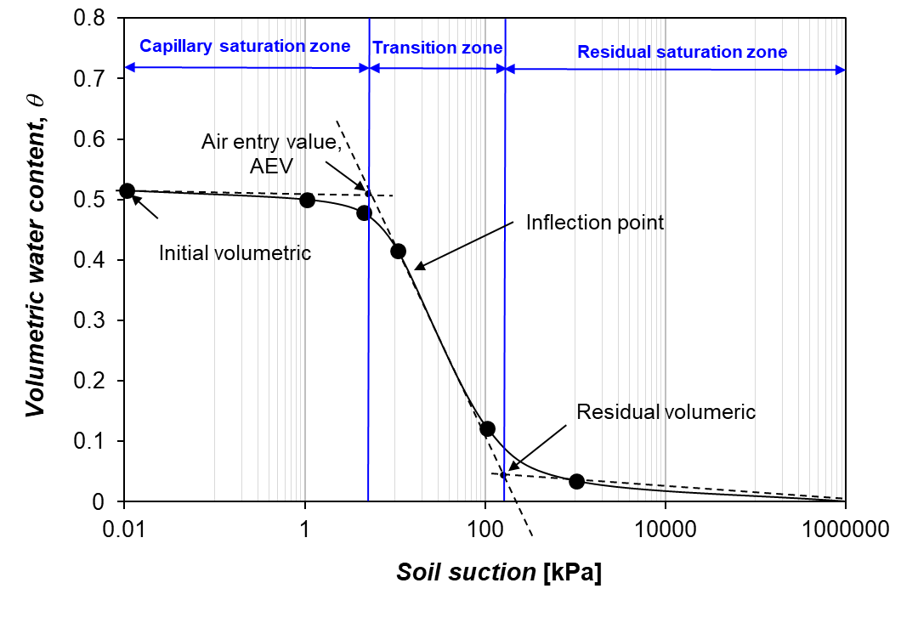
Fig. 1. The soil-water characteristic curve of a soil
The use of hydrogel as soil treatment material [7, 8] has been expressed to be used in geotechnical engineering practices since the beginning of the 21st century. The property of hydrogel is to absorb a considerable amount of water, which significantly affects the plasticity and consistency, density, and porosity of soils [9, 10]. Thus, the SWCC of the soils can be changed by amending the soils with a hydrogel solution.
This study aims to investigate the drying SWCC of biopolymer hydrogel containing soils. To present a hydrogel solution, xanthan gum biopolymer, which shows promising behavior in soil hydraulic conductivity reduction [11] and consistency control [9], was used in this study. The SWCCs of xanthan gum-treated soils are evaluated through a laboratory program. Xanthan gum biopolymer with different content (0.0%, 0.1%, 0.25%, 0.5%, 0.75% and 1.0%, to the mass of soil) was used to treat sand-clay mixtures. Xanthan gum-treated soil specimens were saturated for 24 hours. After that, the drying process was performed by applying pneumatic pressure via a 5-bar pressure ceramic plate extractor cell device. The SWCC results give evidence for the applicability of biopolymers as water storage for soils or vegetation growth.
II. MATERIALS AND EXPERIMENTAL METHOD

2.1 Soils and biopolymer (10.5pt spacing above)
Soil types
Jumunjin sand, which is a standard sand type in Korea, is used in this study. Basic properties of jumunjin sand are as: specific gravity (Gs) as 2.65; coefficient of uniformity (Cu) and coefficient of curvature (Cc) as 1.39 and 0.76, respectively. Fig. 2 shows the particle size distribution of jumunjin sand.
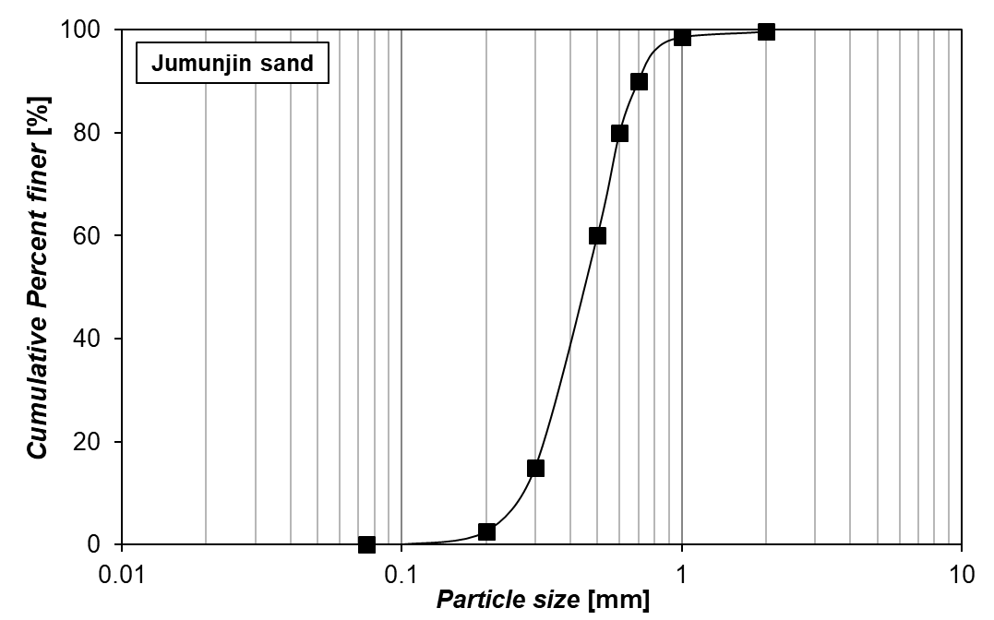
Fig. 2. Particle size distribution of jumujin sand
Kaolinite – Bintang kaolin – which is classified as CH according to the USCS was used. The kaolinite clay has Gs of 2.7 and the average particle size of 44 μm. The clay was mixed with jumunjin sand with a ratio of clay to sand at 1:9 to obtain sand-clay mixture (S9K1)
Xanthan gum
Xanthan gum is an anionic water-soluble exopolysaccharide that is synthesized by the Xanthomonas campestris bacterium [12]. Xanthan gum is composed mainly of D-glucose chains linked via β(1→4) bonds, with side chains consisting of D-mannose and D-glucuronic acid at a ratio of 2:1 [13]. The structure of xanthan gum biopolymer is shown in Fig. 3
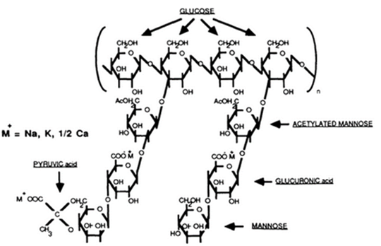
Fig. 3. Structure of xanthan gum (Jansson et al. 1975)
Research grade xanthan gum purchased from Sigmal Aldrich (CAS No.11138-66-2) has been used to represent a hydrogel solution in this study. Xanthan gum is widely used to lubricate and reduce the friction in drill – holes to enhance oil recovery processes [14] since xanthan gum has a high viscosity of solutions and water solubility.

2.2 Experiment method
A xanthan gum hydrogel solution was prepared by dissolving xanthan gum powder into distilled water at room temperature (24°C) according to the target biopolymer to soil content in mass (m_{b}/m_{s} = 0.0%; 0.25%; 0.5%; 0.75% and 1.0%). The initial water content for mixing was set at 10% of the dry weight of the soil. Sand/clay mixture was mixed with xanthan gum hydrogel after being dried at 105°C in the oven for 24 hours.
The drying BSWCCs were obtained via a 5-bar pressure plate extractor device (Fig.4). Xanthan gum – soil mixture was evenly compacted into a steel ring with a diameter of 50 mm and a height of 15 mm before being saturated for 24 hours. After 24 hours of saturation, xanthan gum-sand specimens were placed in the cell. Pneumatic pressure was applied with steps where each pressure step was applied continuously for 24 hours. The maximum air pressure applied was 400 kPa. The volumetric water content of the soil has been calculated via gravimetric water content measured for each pressure. The volumetric water content is calculated as the following equation
(1)
where, w is the gravimetric water content, ρ_{d} is the density of the water (1.0 g/cm³). The matric suction can be assumed by taking the applied air pressure, u_{a} (kPa).
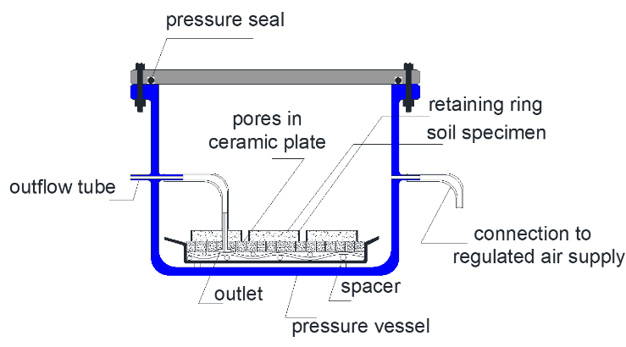
Fig. 4. 5-bar presssure plate extractor device
2.3 Soil-water characteristic fitting curves
The van Genuchten formula [15] is commonly used for SWCC and seepage models for various soils. The volumetric water content (θ_{w}) of soil is expressed as (Eq.2)
(2)
where θ_{w} is the volumetric water content; θ_{s} is the saturated volumetric water content; θ_{r} is the residual volumetric water content; ψ is the soil suction (kPa); α is a soil parameter related to the air entry value (AEV); n is a soil parameter associated with the rate of water extraction from the soil; and m is a soil parameter related to θr and m, which is calculated by m = 1 – (1/n) [16, 17].
In this study, Eq.2 was used to obtain the SWCC parameters of the xanthan gum – treated soils using a nonlinear fitting program [18].

III. RESULTS and analysis

3.1 Effects of xanthan gum on the density of soils
Xanthan gum hydrogels are known to have a pseudoplastic behavior [19], where the viscosity increases with xanthan gum concentration increase (Fig.5). Therefore, the presence of xanthan gum hydrogel in inter-granular pore spaces of sands will change the plasticity of sand.
As the sand-clay mixtures are treated with xanthan gum, xanthan gum will directly interact with kaolinite via hydrogen bonding, where the formed xanthan gum-clay matrix conglomerates sand particles, and results in inter-particle cohesion and friction angle increase [8, 20]. Furthermore, the higher xanthan gum concentration in pore spaces of soils render less free water in pores and can reduce the double-layer thickness of clays [9].
The dry density of xanthan gum-treated soil varies with m_{b}/m_{s} increase as shown in Fig. 6. The dry density of xanthan gum-treated soils shows lower values according to the water adsorption of clays and xanthan gum in soils for m_{b}/m_{s} = 0 to 0.75% conditions. However, the soil dry density increases after m_{b}/m_{s} > 0.75% which implies the majority of xanthan gum-clay aggregation [9], and accompanying conglomeration among sand grains which renders both inter-particle cohesion and friction angle increase [20].
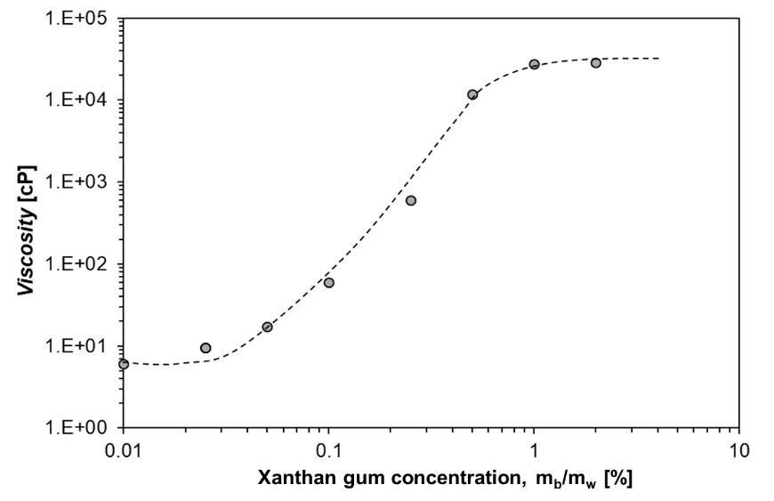
Fig. 5. Viscosity of xanthan gum hydrogel
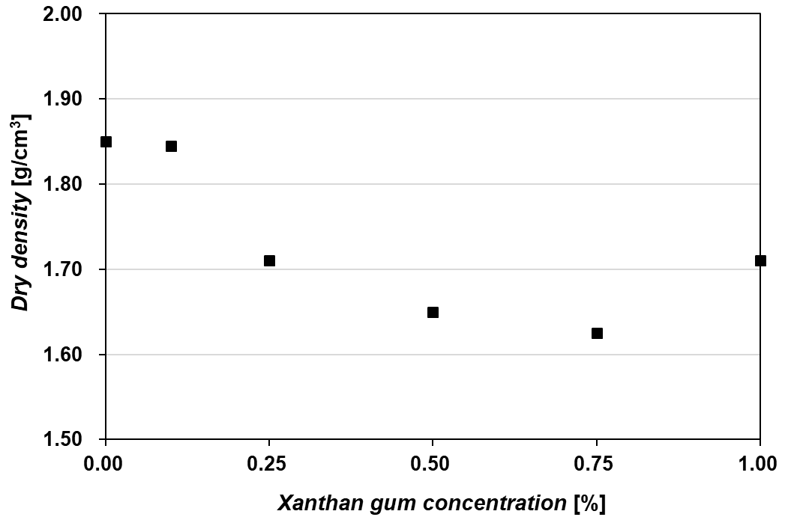
Fig. 6. Dry density of xanthan gum treated soil

3.2 Effects of xanthan gum on water keeping properties of soils
Fig. 7 shows the variation of θ_{w} (volumetric water content) with air pressure increase during drying test for untreated and xanthan gum treated soils. The xanthan gum significantly increases the initial volumetric water content of sands before drying. Xanthan gum-treated soils show higher initial θ_{w} than that of untreated sand, due to the high water-holding capacity of xanthan gum and lower dry density (Fig. 6) which can secure more pore spaces for water to be contained. With the pneumatic pressure (u_{a}) increase, the θ_{w} of untreated soil dramatically decreases, while xanthan gum-treated soils show a gradual reduction of θ_{w}. Furthermore, the air entry (AEV) value can be obtained easily from the SWCC of untreated soil (AEV = 0.5 kPa). However, less steeply reducing SWCCs make it hard to capture the exact AEV for xanthan gum treated soils, even though the AEV of xanthan gum-treated soil seems to be much higher than that of untreated soil. When air pressure increases, residual water within the soil is held by surface tension with sand particles, and water adsorption capacity of the double layer of kaolinite. Meanwhile, water is held within treated soil mainly due to the adsorption capacity of xanthan gum matrix during saturation.
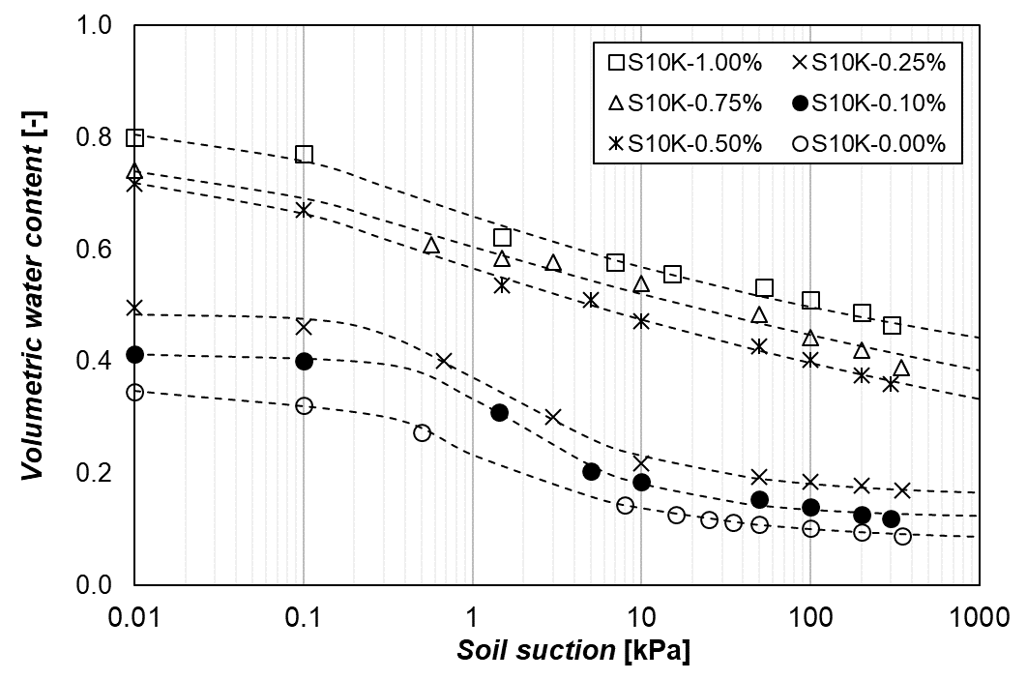
Fig. 7. SWCCs of xanthan gum treated sand/clay mixture
The fitting parameters: α, n, m are summarized in Table 1. For numerical modeling, the change in negative pore water pressure is sensitive to the n parameter. It is because the parameter expresses the water loss rate within soil during the de-absorption process. The n values for the cases of 0%, 0.1%, and 0.25% are higher than that of 0.5%, 0.75% and 1.0%, which shows that the water loss rate of untreated, 0.1% and 0.25% xanthan gum treated soils are faster than that of 0.5%, 0.75% and 1.0%. In other words, water holding capacity of the soil generally increases with xanthan gum content.
Table 1. α, n, m parameters for fitting SWCC curves
Parameters |  | Xanthan gum content [%]
 |  | 0.0 | 0.1 | 0.25 | 0.5 | 0.75 | 1.0
α | [kPa⁻] | 3.215 | 1.135 | 1.828 | 24.773 | 24.773 | 16.781
n |  | 1.417 | 1.632 | 1.514 | 1.079 | 1.066 | 1.113
m |  | 0.087 | 0.387 | 0.339 | 0.074 | 0.062 | 0.101

IV. Discussions
The most feasible use of biopolymer/soil treatment in arid and semi-arid areas is to improve the amount of water within soil pores, and in turn, increases the survivability and the growth of plants or vegetation [21]. At the initial state, biopolymers within the soils can enhance the binding between soil particles. It is because biopolymers form a thin film around sand surface, and interact with clay particles via hydrogen bondings [8]. While there are almost no bonding between soil particles in the untreated soil.
Later, as water is supplied to the untreated soil, water is held mainly by surface tension, and the remaining can quickly go through soil pores. Therefore, under a certain high temperature, the water can easily vapor and empty soil pores. Meanwhile, for the case of the treated soil, biopolymer absorbs water, swells, and fills the soil pores as biopolymer interacts with water due to its hydrophilic properties. The low water loss rate in the biopolymer soil allows the soil holding more water than an untreated soil could make under drying conditions. The process is summarized in Fig.8. Therefore, the vegetation can uptake the water that is retained in the biopolymer treated soils in order to survive through certain drought days.
From geotechnical engineers’ points of views, vegetation is known as one of the effective bio methods to mitigate the slope surface erosion induced by wind or flow. Therefore, the mixing biopolymer with surface soil located along the weakest area of the slope may indirectly enhance the slope stability via providing sustainable vegetation. Furthermore, the rapid water absorption of biopolymers can also reduce the amount of runoff, and in turn, can reduce the energy of the flow, which detaches and transports soil particles down to the toe of the slope. Also, due to the high water holding capacity, the absorbed water can be distributed into the slope slowly and evenly without significant loss of soil particle bonding compared to untreated soil [22].

V. CONCLUSIONS
In order to investigate the effects of xanthan gum biopolymer on the water holding capacity of sandy soil, a drying SWCCs of xanthan treated soil were obtained via the 5-bar plate extractor testing. The experimental results show that the use of xanthan gum biopolymer can improve the water holding capacity of sandy soil via an increase of initial volumetric water content and residual water content. Furthermore, xanthan gum contributes to the formation of a less steeply sloping SWCC of treated sand. In other words, xanthan gum can control the loss rate of water from the soil under any desaturation conditions.
The results of this study can be used to examine biopolymer/soil treatment as a promising countermeasure for agricultural and geotechnical aspects. In agriculture, xanthan gum would have a good performance in improving the water storage of sand/sandy soils which are characterized by their high water-holding capacity, due to the hydrophilic characteristic of xanthan gum. Therefore, the presence of xanthan gum within the soil performs a proper environmental condition for seed germination and vegetation growth in farmlands and even in degraded lands which required reforestation. Furthermore, from the geotechnical engineering points of view, the absorption of xanthan gum can have a good performance in reducing water infiltration into the soil which is an essential factor for slope stability during rainfall.
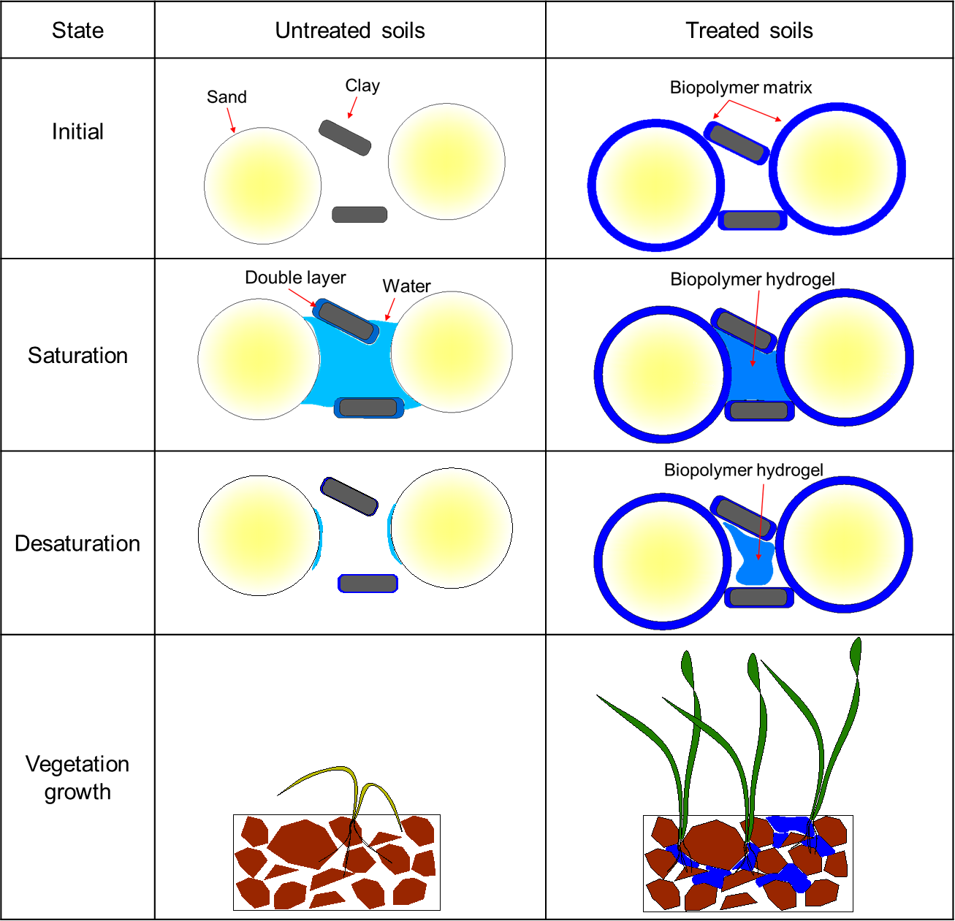
Fig. 8. Effects of biopolymers on drought survivability of vegetation

ACKNOWLEDGEMENTS
This research was supported by a grant (20AWMP-B114119-05) from the Water Management Research Program funded by the Ministry of Land, Infrastructure, and Transport (MOLIT) of the Korean Government; a National Research Foundation of Korea (NRF) grant funded by the Korean Government (MSIP) (No. 2017R1A2B4008635).

REFERENCES
1. Fredlund, D.G., H. Rahardjo, and M.D. Fredlund (2012). Unsaturated soil mechanics in engineering practice. 2012: John Wiley & Sons.
2. Miao, L., F. Jing, and S.L. Houston (2006). Soil-water characteristic curve of remolded expansive soils, in Unsaturated Soils 2006. 2006. p. 997-1004.
3. Lapierre, C., S. Leroueil, and J. Locat (1990). Mercury intrusion and permeability of Louiseville clay. Canadian Geotechnical Journal. 27(6): p. 761-773.
4. Marinho, F.A. (2005). Nature of soil–water characteristic curve for plastic soils. Journal of Geotechnical and Geoenvironmental Engineering. 131(5): p. 654-661.
5. Vanapaﬂi, S., D. Fredlund, and D. Pufahl (1999). The influence of soil structure and stress history on the soil-water characteristics of a compacted till. Geotechnique. 49(2): p. 143-159.
6. Fredlund, M.D. (2000). The role of unsaturated soil property functions in the practice of unsaturated soil mechanics. 2000.
7. Khatami, H.R. and B.C. O’Kelly (2012). Improving mechanical properties of sand using biopolymers. Journal of Geotechnical and Geoenvironmental Engineering. 139(8): p. 1402-1406.
8. Chang, I., J. Im, A.K. Prasidhi, and G.-C. Cho (2015). Effects of Xanthan gum biopolymer on soil strengthening. Construction and Building Materials. 74: p. 65-72.
9. Chang, I., Y.-M. Kwon, J. Im, and G.-C. Cho (2018). Soil consistency and inter-particle characteristics of xanthan gum biopolymer containing soils with pore-fluid variation. Canadian Geotechnical Journal(ja).
10. Han, Y.G., P.L. Yang, Y.P. Luo, S.M. Ren, L.X. Zhang, and L. Xu (2010). Porosity change model for watered super absorbent polymer-treated soil. Environmental Earth Sciences. 61(6): p. 1197-1205.
11. Bouazza, A., W.P. Gates, and P.G.J.G. Ranjith (2009). Hydraulic conductivity of biopolymer-treated silty sand. 59(1): p. 71-72.
12. Poli, A., P. Di Donato, G.R. Abbamondi, and B. Nicolaus (2011). Synthesis, production, and biotechnological applications of exopolysaccharides and polyhydroxyalkanoates by archaea. Archaea. 2011.
13. Babbar, S.B. and R. Jain (2006). Xanthan gum: an economical partial substitute for agar in microbial culture media. Current microbiology. 52(4): p. 287-292.
14. Garcıa-Ochoa, F., V. Santos, J. Casas, and E. Gomez (2000). Xanthan gum: production, recovery, and properties. Biotechnology advances. 18(7): p. 549-579.
15. Van Genuchten, M.T. (1980). A closed-form equation for predicting the hydraulic conductivity of unsaturated soils. Soil science society of America journal. 44(5): p. 892-898.
16. Mualem, Y. (1976a). Hysteretical models for prediction of the hydraulic conductivity of unsaturated porous media. Water resources research. 12(6): p. 1248-1254.
17. Mualem, Y. (1976b). A new model for predicting the hydraulic conductivity of unsaturated porous media. Water resources research. 12(3): p. 513-522.
18. Seki, K. (2007). SWRC fit–a nonlinear fitting program with a water retention curve for soils having unimodal and bimodal pore structure. Hydrology and Earth System Sciences Discussion. 4(1): p. 407-437.
19. Dumitriu, S. (2004). Polysaccharides: structural diversity and functional versatility. 2004: CRC press.
20. Chang, I. and G.-C. Cho (2019). Shear strength behavior and parameters of microbial gellan gum-treated soils: from sand to clay. Acta Geotechnica: p. 1-15.
21. Tran, A.T.P., I. Chang, and G.-C. Cho (2019). Soil water retention and vegetation survivability improvement using microbial biopolymers in drylands. Geomechanics and Engineering. 17(5): p. 475-483.
22. Chang, I., J. Im, S.-W. Lee, and G.-C. Cho (2017). Strength durability of gellan gum biopolymer-treated Korean sand with cyclic wetting and drying. Construction Building Materials. 143: p. 210-221.

