**Process of Constructing and Conducting STEM Lessons in Chemistry Teaching in Vietnam**

**Nguyen Thi Thuy Trang*[1], Dang Thi Oanh2, Pham Thi Binh2, Mai The Hung Anh3**

*1&3 University of Education – Hue University, Vietnam*

*2 Hanoi National University of Education, Vietnam*

**Abstract***.* STEM education is becoming the trend of modern education across world, especially in developed countries as well as in Vietnam. Whereby, teachers are expected to be able to organize learning environments accordingly. In order to facilitate in-service Chemistry teachers as well as pre - service Chemistry teachers in designing of STEM lessons, we proposed process of constructing and conducting STEM lessons in teaching Chemistry that meet goal of the Vietnam’s new general education curriculum. In the scope of this article, we only study students using scientific methods to solve STEM problems as scientists do to create new knowledge. Along with 5E instruction model and NGSS, teachers will conduct STEM lessons effectively. In addition to proposing and clearly describing the steps in the process of constructing and conducting STEM lessons that are consistent with the characteristics of Chemistry subject, the paper also presents the foundations and principles for designing the process. The article also illustrates some samples STEM topics that apply the above process.

***Keywords***: STEM education, Process of constructing STEM lesson, Process of conducting STEM lesson, Chemistry teaching.

Introduction

STEM (is acronym of Science, Technology, Engineering and Maths) Education is becoming the trend of modern education across world, especially in developed countries as well as in Vietnam. In Vietnam's new general education program, it was officially released in December 2018, clearly showing the role of STEM education in the comprehensive development of students to meet skills in the 21st century. Whereby, teachers are expected to be able to organize learning environments accordingly. Through the survey, we found that teachers in Vietnam are quite confused and vague in implementing STEM lessons or activities. There are some identified obstacles impact on the teacher's ability to teach to implement an integrated STEM lesson or activity accordance with some research (Ejiwale, 2013; Huffman, Lawrenz, Thomas, & Clarkson, 2006; Louis S. Nadelson 2013; Shernoff1, Sinha, Bressler, & Ginsburg, 2017). It appears unfortunate that many science and mathematics teachers seem to underprepared for these demands; the professional development programs for teachers in STEM have often been short, fragmented, ineffective, and not designed to address the specific need of individual teachers However, there are some additional identified obstacles that teachers did not have a clear, specific guide to the design and implementation process of STEM lessons.

In teaching chemistry, it is necessary to provide students with STEM challenges so that they can apply interdisciplinary knowledge and skills to solve that STEM problem. Besides, the scientific process is equally important in helping students form their background knowledge by solving STEM problems like scientists have done. The Vietnam’s new general education curriculum attach great importance to students using interdisciplinary knowledge to solve the problem of creating new technology products. However, the amount of time spent on teaching high school science concepts is still high, making it difficult to organize students to address STEM challenges regularly. In this paper, we propose process for conducting STEM lessons right in teaching new lessons in which students apply interdisciplinary knowledge to solve STEM problems according to the scientific process, the product will be a new knowledge system, theoretical models, etc. It is also new technology. After this process, teachers can guide students to use the engineering design process to create new technology like engineers. In the previous article, we organized students to use the technical process to solve STEM problems ((Dang Thi Oanh, Le Van Dung, Mai The Hung Anh, & Nguyen Thi Thuy Trang, 2018). Until now, we have found very little research on the process of conducting STEM lesson using scientific process combined with 5E instruction model.

**Research questions**

1) How to construct an STEM lesson right in teaching new lessons?

2) How to conduct and assess the STEM lessons?

**Purpose of the Study**

Study suggests process of constructing and conducting STEM lessons in teaching new lessons to increase teachers’ confidence in integrating mathematics and technology in chemistry teaching. Especially, Pre-service chemistry teachers need to be trained about STEM education that will make it more convenient to construct and conduct STEM lessons.

**Novelty of study**

1) Proposing in detail the STEM lesson design steps, introducing assessment tools and process of conducting of STEM lessons in accordance with the Vietnam’s new general education curriculum.

2) Integrating STEM problems right in teaching new lessons because the amount of time in the new general education program in Vietnam to study new knowledge in the science curriculum including Chemistry is 70 periods / 1 year/ 1 class/ 1 subject. Therefore, for students to approach and solve STEM problems, teachers should design STEM issues right in the new lessons of science subjects that will be more convenient.

3) In Vietnamese schools, students hardly use the scientific process to discover science as scientists do. Therefore, the research using scientific processes for students to solve STEM problems then create new knowledge for themselves.

On that basis, teachers can refer and apply flexibly and creatively in the implementation of teaching STEM lessons.

**Content**

1. Overview of Process of Constructing and Conducting STEM Lessons

The most common instructional strategy was the engineering design process. As found in most commercially produced lessons (Carter, 2013) and typical of many STEM professional development workshops (Laboy-Rush, 2011; Shernoff1 et al., 2017), this was not unexpected. Lessons containing scientific investigations were probable (Hayward, 2016). A Collection Of Elementary Stem Design Challenges Based Children’s Literature (Hice, 2013) introduced 11 STEM challenges. Another study also detailed 25 STEM lessons (Mary Margaret Capraro & Capraro, 2016). Intel Introduced the Design Process and 5 STEM challenges (Brenda Musilli President, Intel Foundation). In addition, STEM lessons are also designed online on websites.

In general, the above studies have specifically introduced STEM lessons. Nevertheless, we found that 1) the literatures still lacks the theory of specific guidance on what teachers need to do in each step of the process, 2) These designs are still not suitable for the context and conditions of Vietnam, 3) There are very few studies using the 5E instruction model combined with the scientific process to implement STEM lessons. Vietnam is gradually internationalizing and changing education to suit the world. However, there are still many difficulties in terms of conditions as well as approaches to STEM education. Teachers need specific guidance to implement STEM education to meet the path of innovation of education.

2. Foundations to Build the Process

2.1. STEM Cycle

While Bloom’s Taxonomy traditionally arranges remembering, understanding, applying, analyzing, evaluating and creating in a pyramid, with each skill on its own level, we believe that analyzing, evaluating and creating happen simultaneously at the top as seen in fig 1. The three higher order thinking skills work in tandem when students are being scientists and engineers. In the classroom, using these skills together, at the same time, comprises authentic learning. It is students being scientists and engineers, using the higher order thinking skills of creating, evaluating, and analyzing to solve problems. The STEM classroom provides one of the best opportunities to teach students these higher order thinking skills that are transferable to all subjects.

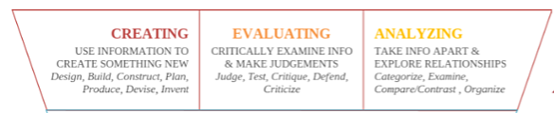

# *Figure 1. Three higher order thinking skills*

# (<https://www.knowatom.com/blog/defining-effective-stem-instruction>*)*

Locked in the STEM cycle are the seeds of critical thinking—creative, evaluative, and analytical thinking skills that are transferrable and that make students trainable. These skills are the key to workforce  development and the underpinnings of a student’s future college and career opportunities.

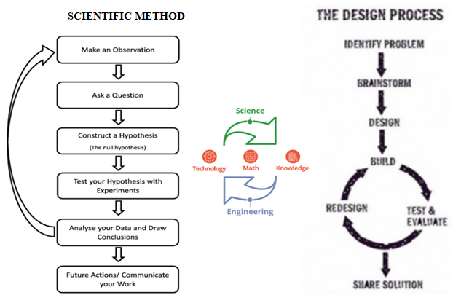

***Figure 2. STEM cycle***

***(***<https://www.knowatom.com/blog/what-is-the-stem-cycle>)

In this cycle (see figure 2), Science in the STEM cycle is described by an arrow from Technology to Knowledge representing the process of scientific innovation. This means, scientists rely on existing technology, always ask questions and work to answer them by examining hypotheses, collecting data, processing and eventually inventing scientific knowledge. In contrast, Engineering in the STEM cycle is described by an arrow from Knowledge to Technology that represents the technical process. That means, engineers use that scientific knowledge to identify, design solutions, test solutions to solve problems, design, develop and create new technologies to solve solve human problems and make scientific research more effective. In the middle of the cycle is technology, math and knowledge. Mathematics is a bridge between the two, providing a common language, a quantitative and objective way to approach science and technology rather than qualitative or subjective. Technology facilitates both scientific experiments and technical design, and knowledge that provide materials for the entire cycle. Applying STEM cycle to education field, STEM education provides students in practical issues ("current technology") that need to be addressed, requiring students to explore, occupy scientific knowledge and apply knowledge to design and implement problem solving (new "technology") solutions.

Thus, each STEM lesson will give students assignments to solve a relatively complete problem, requiring students to mobilize existing knowledge and explore and occupy new knowledge. That process requires students to follow the "Scientific Process" (to gain new knowledge) and "Engineering Process" to use that knowledge to design and implement solutions ("new technology") to solve the problem.

In this article, we only study at the level that students solve STEM problems to gain new knowledge according to the scientific process as scientists do. Students imitate scientists to create new knowledge for themselves through make an observation, ask a question, form a hypothesis, make a plan and conduct an experiment, analyze the data and draw conclusions, and share result. Teachers need to seek to challenge students at the highest level. In order to do this, teachers need a level of sophistication that goes well beyond canned experiments, workbooks and texts with questions at the end of the reading. They need the ability to create those gaps between current levels of skill and future levels. Their students can look at a novel scenario, analyze it and form an approach to answering a question of solving a problem related that relates specifically to the scenario before them. Students can connect the knowledge and skills they’ve acquired in other lessons and units to this new scenario, enabling them to design experiments and prototypes, gather data and form evidence-based conclusions.

**2.2. Vietnam’s New General Education Curriculum**

For high school curriculum, all course requirements in specialization subjects used to be stipulated by the MOET and involved a total of 6 hours per week in mathematics, physics, chemistry, and biology in the natural science track; and literature, history, geography, and foreign languages in the social sciences and foreign language track. Beyond concentration subjects, all students take a core curriculum that includes subjects ranging from Vietnamese to foreign language (mostly English), mathematics, and physical and military education (Education in Vietnam, 2017, November 8) .

Thus, the amount of time in the new general education program in Vietnam to study new knowledge in the science curriculum including Chemistry is high. Therefore, for students to approach and solve STEM problems, teachers should design STEM issues right in the new lessons of science subjects that will be more convenient. This is a foundation to study building process of STEM teaching.

**2.3. The 5E Model and NGSS**

If it is to be of use with the Next Generation Science Standards (NGSS), the 5E instructional model (Bybee, 2006) must move from a traditional model of instruction to a next generation model of instruction. Specifically, here is how it looks for each of the Es as shown in figure 3. (Vigeant, 2017, May 14)

3. Principals of building process of constructing and conducting STEM lessons

National Academy of Engineering and National Research Council emphasized strategies that built knowledge and skills “within and across disciplines” (National Academy of Engineering and National Research Council, 2014). From the research, they found the following four principles related to the “design of integrated STEM learning experiences”. They include:

1. Making integration explicit,

2. Attending to students’ disciplinary knowledge (p. 91),

3. Attending to the social aspects of learning (p. 92),

and 4. Supporting the development of interest in identity (p. 94).

Jolly (2014) identified six principles found in a well-designed STEM lesson (Jolly, 2014). These principles overlap greatly with Cunningham and Higgins (2014). They were

1. Focus on real-world issues and problems

2. Guided by the [engineering design process](http://www.nasa.gov/audience/foreducators/plantgrowth/reference/Eng_Design_5-12.html#.U58POF4UGvM)

3. Immerse students in hands-on inquiry and open-ended exploration

4. Involve students in productive teamwork

5. Apply rigorous math and science content your students are learning

6. Allow for multiple right answers and reframe failure as a necessary part of learning.

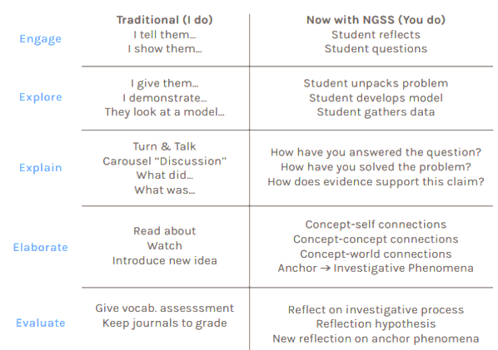

*Figure 3. The traditional 5E model and next generation model of instruction*

*(*<https://www.knowatom.com/blog/what-is-the-5e-instructional-model>)

In keeping with the principles of the world and the Vietnamese education program, we have defined the following design principles:

1. Ensure learning objective

2. Ensure pedagogy

3. Ensure compatibility with the 5E instruction model and scientific method practice

4. Focus on real-world issues and problems

5. Ensure flexibility and creativity

6. Ensure development

4. Process of Constructing and Conducting STEM Lessons

STEM to study new knowledge is STEM built on the knowledge base that students have not yet learned (or learned but not yet completed). Instead of teachers who teach new knowledge to students as usual, students will be like scientists using steps in the scientific process to solve STEM problems that teachers require, from then students control themselves, forming new knowledge that corresponds to the problem they need to solve.

To construct and conduct STEM lessons to study new knowledge, pre-service Chemistry teachers or in- service Chemistry teachers in Vietnam can use the process including the following steps

4.1. Process of constructing STEM lesson

*a) Identify problems (STEM lessons, topics)*

This is the first and quite important thing. First of all, teachers need to analyze Chemistry program and content in Vietnam’s new general education curriculum. Teachers consider the requirements of topics. Then teachers can point out the contents of chemical knowledge can create problematic and challenging situations that connect with the real world context, connect with global goals, connect with NGSS. Teachers also can point out the connection of relevant Chemistry knowledge content in that situation to the subjects in STEM field to build up the name of STEM-oriented learning problems. In addition, to identify STEM issues, teachers can rely on stories or problems in real life from news or scientific documentary films that are related to chemical knowledge. As a result, students feel that the lessons become lively and associated with the daily stories that students often hear about. Or ideas may also stem from the actual activities of factories and agencies in the fields related to science and technology. This makes it easier for students to navigate their careers in future.

Next, name the STEM topic. The name of the STEM topic is very important. When naming STEM topics, teachers need to pay attention to writing briefly, expressing the problem to be solved, stimulating the excitement and desire to solve the problem of students.

Finally, describe the problem of STEM topic. Teachers briefly describe the problematic situation of STEM topics that students need to solve. Teachers write about why you have chosen this topic. Are there common misconceptions? What do students struggle to understand? Think about what your STEM activities will help to address/help students to achieve. STEM education simulates the way scientists invent scientific knowledge. However, STEM education is not about turning students into scientists, so when teachers choose or build problems of STEM topics, besides paying attention to context to ensure the selection content is real. It is necessary to look at both the scope of influence and the complexity of the problem so that it is suitable for students in terms of education level, type of school, regional characteristics.

For example, when teaching a chemical topic of 12th grade on domestic water treatment in Vietnam's general education curriculum. Teachers can build the topic name "Design of Household Water Filter System".

Teacher introduction: This project is designed for high school students. The project uses a real-world problem and allows free students to demonstrate their creative thinking ability to create a water filter rather than emphasizing turning pond water, river water into drinking water. Upon completion of this project, students will have practical experience in creating a three-dimensional model to test their theory of finding the most effective way of water filtration. Students will need a basic understanding of the importance of clean water for life and the criteria regarding the classification of which water is drinkable. Students must also have knowledge of the adsorption of carbon; effects of sand and gravel; The effect of water quality depends on the number of filter layers. Students need practical observations to ask a question; Students formulate hypotheses; Collect evidence, data to answer the hypothesis. Students can find simple materials from home such as cloth, gravel, gauze, tulle, etc to conduct experiments. Draw conclusion and present their findings and solutions in a class presentation. This project allows students to demonstrate their ability to effectively work in teams while displaying their critical thinking and problem solving aptitude. With a variety of guiding and open-ended questions, students are given many opportunities to develop strong metacognitive skills. Additionally, because this is a small group project/presentation, students will foster teamwork and communication skills throughout the project.

*b) Write NGSS; The Global Goals; Objectives & Outcomes; Content Areas; Grouping; Time limits; Space and location; Age appropriate; Review, reflect and evaluation; Resources and materials; Constraints or rules*

Teachers write the description of the STEM topic in the right column of table 1

*Table 1. Constructing STEM lesson template*

|  |  |
| --- | --- |
| Item | Description |
| *NGSS* | <https://www.nextgenscience.org/evidence-statements>  List NGSS for your topic |
| The Global Goals | Topics selected should belong to the global goals. <https://www.globalgoals.org/resources> |
| Content Areas | List content areas of subjects in STEM field |
| Age appropriate | Write the year group or age range |
| Grouping | How many students will be in each team? |
| Resources and materials | Write a list of resources and materials needed for your lesson |
| Space and location | Write the type of space you will need for your lesson (classroom, lab, outside space, etc.) |
| Objectives & Outcomes | Write the list of aims for your lesson. What do you want students to achieve?  Objectives must be expressed by action verbs that can be quantified, assessing the level of understanding of students' knowledge, skills and attitudes such as list, find, interpret, summarize, calculate, use, discuss, design, judge, etc (Bloom’s Taxonomy, Dave and Krathworl) |
| Review, reflect and evaluation | Write how you plan to assess students’ work. Marking written work? Questioning and discussion?  Rubric for presentation  Rubric for teamwork  Rubric for Scientific method |
| Constraints or rules | - Write how your students will capture their understanding – will they write a report? Create a poster? Will there be a question and answer session? How they use scientific method? |
| Time limits | - Write a brief description of the activity the students will be doing, including how much time they will need to complete the activity. Leave a space between each activity or number each activity. |

For instance, the above topic "Design of Household Water Filter System"

|  |  |
| --- | --- |
| Item | Description |
| NGSS | MS-ESS3-3; HS-ESS3-3; HS-ETS1-2; HS-ESS2-5.  For details, please visit the following website address: <https://www.nextgenscience.org/evidence-statements> |
| The Global goals | Clean Water and Sanitation (Goal 6 in action)  One in three people live without sanitation. This is causing unnecessary disease and death. Although huge strides have been made with access to clean drinking water, lack of sanitation is undermining these advances. If we provide affordable equipment and education in hygiene practices, we can stop this senseless suffering and loss of life. |
| Content Areas | Chemistry, Biology, Physic, Geographic, Mathematic, Technology, Engineering |
| Age appropriate | 11th grade students |
| Grouping | 5-6 students per group; mixed |
| Resources and materials | Poster paper, textbooks and library books, class notes, KLEWS sheet.  Activity instruction  Gravels, silica sand (quartz), activated coal, filter paper, plastic pipe fittings, hole saws, plastic bottles 2 liters, some pieces of cloth, pot, porcelain cup, plastic bag. |
| Space and location | Classroom, lab, outside |
| Objectives & Outcomes | *Knowledge*  * Science  - Describe about reverse osmosis, ion exchange, micro filtration, ultrafiltration, photochemistry, distillation, adsorption.  - State the physical and chemical properties of water, and can explain why those properties make it a common solvent and a molecule of life.  - Present the importance of water in biological functions. Explain the effect of potable water on non-potable water on eukaryotes.  - Design solutions according to scientific method.  - Communicate scientific ideas with scientific presentations.  * Engineering  - Develop management and support skills in the topic  * Technology  - Use the internet to access information; using some computer software for analyzing and sharing results with others  - Water filtration system model  * Maths  - Use geometric skills to build their filters by matching the corners and making sure that all water samples are required to go through the filter.  - Explain the relationship between surface area and filtration efficiency  *Skills*  Use the scientific process to form the background knowledge, design a simple model of water filtration system at home to solve the problem of lack of clean water.  *Attitude*  Conscious to preserve and use clean water.  Recognize the importance of using interdisciplinary knowledge to address life's problems. |
| Review, reflect and evaluation | Rubric for formative assessment; summative assessment; discuss; self-assessment; questioning |
| Constraints or rules | Students must use scientific method to solve STEM problems |
| Time limits | 1 week |

4.2. Process of conducting STEM lesson

The process of conducting STEM activities is designed according to active teaching methods and techniques with 5 types of learning activities that have been improved, combining 5E instruction models and scientific method to solve STEM problems are listed below.

|  |  |  |
| --- | --- | --- |
| Teacher’s activities | | Students’ activities |
| *Engage (15 – 20 mins)* | | |
| - Opening the lesson by projecting videos, introducing hypothetical or practical situations, gameshows, crosswords, exploratory experiments to elicit excitement, form learning motivation, or question meant to engage students, snag their interest, and offer the opportunity for them to share what they already know on the subject.  - To help students make connections between their preexisting knowledge base and the new ideas that will come down the pipeline in the lesson or unit, use **KLEWS** charts (Katz, 2017, May 23), in which determine what students already Know by asking them the essential question and what they want to learn (in “W” column) during this step about 5 mins. If students discover an answer to their wondering during the lesson or by doing independent reading, the post it is moved to the L column. Providing evidence of their new understanding of the material in the “E” column. At the end of the lesson, students go back to this chart to list what they learned in ''S'' column.  - Encouraging students to express their opinions freely, collect their KLEWS charts and write their questions on the board. Select useful questions of students to create STEM problems to solve.  - Divide the class into small groups and provide students with the necessary resources and materials, learning outcomes & objective, constraints or rules related to the problem. | | - Observe carefully what is happening in the world around.   1. –List what already know **(**in “K” column**)**. Write the responses on a post-it note and place the notes under the K column. In the “W” column, **Wonder** about some of the observations. Write those wonderings on post-it notes and put them on the chart.Ask questions about what want to learn or what don’t yet understand.   - Agree on constraints or rules provided by teachers |
| *Explore*  (can be flexible about the expected time depending on the difficulty level of the problem) | | |
| - Circulate classroom, aid students and answer questions.  - Limit on time for each step (10mins/a step)  - Provide necessary resources and materials for each step  - Record student observations in the “E” column (Note that NGSS standards require that students make their own observations rather than being given the content). | Work in group and conduct set of steps that all scientists use  + Observation – the use of senses to study something. Observations are followed by a question  + Researching – reading literature to have a background of information that already exists concerning your question  + Hypothesizing – a possible explanation for an observation  + Designing an experiment – experimentation supports or rejects hypothesis  + (Variables) – a variable is any factor that affects the outcome of an experiment. Each experiment must contain a control and an independent variable.  + Collecting, organizing, and analyzing data  - Provide **evidence in the “E” column**  + Reporting the results so that other scientists may test your conclusions | |
| *Explain (30 mins)* | | |
| - Gather students as a class and discuss students’ observations, experiments and conclusions. Each Group of students communicates their experiences to the class for about 2 minutes. Each group should:  1. State their testable question  2. Explain how they designed their experiment and why they felt that was the appropriate method  3. Present the results  4. Present their conclusion  - Control students in groups to ask questions and discuss each other.  - Ask questions for each step  - Then explains scientific concepts or terms encountered during exploration.  - Ask students write what they’ve learned from their observations in the ''L'' column  - The ****“S”**** column is the last column for students to be completed | | - Present and explain what they have learned and experienced.  - Presented difficulties encountered during the explore process  - Answer questions  - Complete “L” and “S” column. |
| *Elaborate (15 mins)* | | |
| - Elaborate on their understanding, applying what they’ve learned to new situations to deepen their skills  - Encourage students to ask other questions, the extended questions necessary for the scientific world through this experiment  - The question may be:  + Ask the chemical questions you want to study further  + Consider questions that can be further studied.  + Write those questions on paper  - Provides some practical situations that require students to apply new scientific concepts to solve them. | | - Actively participate in raising questions and problems during the experiment  - Write what want to know or ask questions about what don’t yet understand in the “W” column.  - Solve situations |
| *Evaluate (30 mins)* | | |
| - Awareness questions of scientific concepts that meet the learning objectives  - Rubric of using scientific method to solve STEM problem  - Rubric of working in group  - Rubric of reporting and presenting the products | | - Evaluate, reflecting on and providing evidence of their new understanding of the material in the “E” column.  - Peer assessment, self-assessment, evaluation of teamwork effectiveness, assessment of the effectiveness of using scientific methods, etc. |

5. Sample STEM topic apply the process of constructing and conducting STEM lessons

*Name of topic:* Starch – an essential energy source for the body

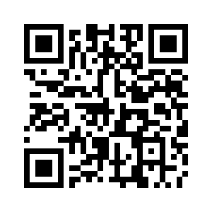Because the topic provides details of the design steps and many resources and materials, readers can view it directly on the web built by the author via the *QR code* as shown in figure 4 or <http://lophochoaonline.com/mod/page/view.php?id=295>.

*The context*: Starch is one of three indispensable groups of nutrients for the human body. However, there are many people that say: To lose weight, you must say no to starch. So if not using long-term starches have health effects? How does starch play a role in humans and animals? How is starch produced? Why is starch a vital energy source for the body? Students apply the STEM interdisciplinary knowledge to prove that the above view is true or false, thereby calculating the amount of starch per day to provide suitable for each human needs without boycott the starch. If you're a Nutritionist, Holisitic Nutrition Consultant, Health Coach or knowledgable Personal Trainers (PT) to help other obtain optimal health, give diet advice and offer meal plans related starch.

*Figure 4. QR code*

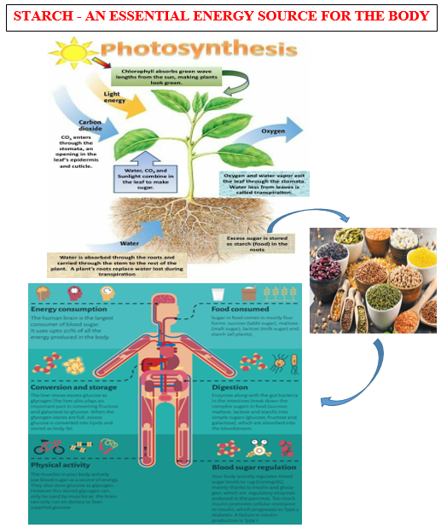

*Figure 5. Demo image for the STEM topic*

Conclusion

The paper clearly presented the steps in the process of constructing and conducting STEM lessons in teaching chemistry. Earlier, the article presented the foundations and principles for building the process. The article explained the reasons for choosing a 5E instruction model combined with scientific process as well as KLEWS chart in conducting STEM lessons. The article also illustrates an STEM topic in teaching chemistry with the content related to *STARCH*. We piloted this process to train in-service chemistry teachers and pre-service chemistry teachers who construct and conduct STEM lessons. Most of them commented that this process helped them reduce part of the education innovation burden, especially in implementing STEM education (Detailed results will be presented in the next article).

**Acknowledgement**

The authors would like to thank the leaders, teachers and students of Thua Thien Hue’s High Schools, pre – service chemistry teachers of Hue University’s College of Education in Vietnam for the supports given to this work.

REFERENCES

Bybee, R. W., Taylor, J. A., Gardner, A., Van Scotter, P., Powell, J. C., Westbrook, A., & Landes, N. (2006). The BSCS 5E Instructional Model: Origins and Effectiveness. The office of Science Education.

Dang Thi Oanh, Le Van Dung, Mai The Hung Anh, & Nguyen Thi Thuy Trang. (2018). STEM Education: Organizing high School Students in Vietnam using Engineering Design Process to Fabricate Water Purification Systems. *American Journal of Educational Research, 6*(9), 1289-1300. doi: 10.12691/education-6-9-8

Education in Vietnam. (2017, November 8). Retrieved from https://wenr.wes.org/2017/11/education-in-vietnam.

Ejiwale, J. A. (2013). Barriers to Successful Implementation of STEM Education. *Journal of Education and Learning, 7*(2), 63-74.

Hayward, J. (2016). *An Analysis of Secondary Integrated STEM Lesson Plans: Common Characteristics, Learning Expectations and the Impact from the Teacher's Definition of I-STEM.*

Hice, T., Baker, L., Gandy, G., Mccracken, K., & Whitmore, R. (2013). *A Collection Of Elementary STEM Design Challenges Based Children’s Literature*.

Huffman, D., Lawrenz, F., Thomas, K., & Clarkson, L. (2006). Collaborative evaluation communities in urban schools: A model of evaluation capacity building for STEM education. *New Directions for Evaluation*. doi: https://doi.org/10.1002/ev.179.

Jolly. (2014). Six Characteristics of a Great STEM Lesson. Retrieved from https://[www.edweek.org/tm/articles/2014/06/17/ctq_jolly_stem.html](http://www.edweek.org/tm/articles/2014/06/17/ctq_jolly_stem.html).

Katz, K., & Zembal-Saul, C. (2017, May 23). KLEWS Chart Template. Retrieved from https://[www.oercommons.org/authoring/22028-klews-chart-template](http://www.oercommons.org/authoring/22028-klews-chart-template).

Laboy-Rush, D. (2011). Integrated STEM education through project based learning. [White paper]. Retrieved from <http://www.slideshare.net/dlaboyrush/integratingstem-education-through-project-based-leaming>.

Louis S. Nadelson , J. C., Patricia Pyke , Anne Hay , Matthew Dance & Joshua Pfiester. (2013). Teacher STEM Perception and Preparation: Inquiry- Based STEM Professional Development for Elementary Teachers. *The Journal of Educational Research, 106*(2), 157-168. doi: 10.1080/00220671.2012.667014

Mary Margaret Capraro, J. G. W., & Capraro, M. J. E. a. R. M. (2016). *A Companion to Interdisciplinary STEM Project Based Learning*. The Netherlands: Sense Publishers.

National Academy of Engineering and National Research Council. (2014). STEM Integration in K-12 Education: Status, Prospects, and an Agenda for Research. Washington, DC: The National Academies Press. doi: https://doi.org/10.17226/18612.

Shernoff1, D. J., Sinha, S., Bressler, D. M., & Ginsburg, a. L. (2017). Assessing Teacher Education And Professional Development Needs For The Implementation Of Integrated Approaches To STEM Education. *International Journal of STEM Education, 4*(13), 2-16. doi: 10.1186/s40594-017-0068-1.

Vigeant, F. (2017, May 14). What is the 5E Instructional Model?. Retrieved from https://[www.knowatom.com/blog/what-is-the-5e-instructional-model](http://www.knowatom.com/blog/what-is-the-5e-instructional-model).

1. Corresponding Author: Nguyen Thi Thuy Trang E-mail: nguyenthithuytrang@dhsphue.edu.vn