TRADITIONAL FOOD PRODUCTS AND THEIR PROMOTION STRATEGY IN VIETNAM
Hoang Thanh Long^{1*}, Pham Xuan Hung¹, Nguyen Thi Thuy Hang¹, Duong Thi Tuyen¹, Nguyen Huu Linh¹
¹University of Economics, Hue University, Vietnam
* Corresponding author

ABSTRACT
Traditional products development and their interest have been increasing among stakeholders recently. This research applies mixed methods of comprehensive literature review and secondary data collection related to the Vietnamese traditional food products (TFPs) production and a national promotion strategy for these products, namely the One Commune One Product program (OCOP). The results show that Vietnam have lots of traditional products including foods, drinks, fermented products… of which foods dominate the most proportion. In this study, TFPs in Vietnam are categorized into groups of traditional fermented products of alcoholic beverages, fish products, meat, soybean products and vegetables. Additionally, the OCOP program have attained significant results of developing the TFPs, increasing income and improving livelihoods for farmers.
Keywords: traditional food products, promotion strategy, OCOP, Vietnam

1. INTRODUCTION
Despites of the globally increased of the food market, the attention in TFPs is increasing among customers, producers and policy marker in both developed and developing countries (Balogh, Békési, Gorton, Popp, & Lengyel, 2016; Jordana, 2000; Vanhonacker et al., 2013; Verbeke, Guerrero, Almli, Vanhonacker, & Hersleth, 2016). TAPs have been highly appreciated for their positive benefits of locally unique, environmentally friendly and healthy. As a result, TAPs contributes an important component of cultures, history, and lifestyles devoting to the development and sustainability of rural regions (Antonia Trichopoulou, Soukara, & Vasilopoulou, 2007).
The special geographical position has brought Vietnam a humid tropical climate, monsoon and very diverse natural conditions, differentiated between regions across the country. Vietnam is a country with a long-standing agricultural civilization, with a basic community-based organization, thus Vietnamese agriculture, forestry, fisheries and craft villages are especially rich (Ho, Hoang, Wilson, & Nguyen, 2018; Hogarth & Belcher, 2013; Long et al., 2019; Luu, Nguyen, & Newman, 2014). Stemming from the above characteristics, Vietnam has been considered to occupy is a very diverse and rich system of products, each locality throughout Vietnam has its own typical products of the countryside. Vietnamese people normally name their local products and specialties after the name of their locality as both a special feature to indicate the origin of the product, and to show pride of their countryside. Agricultural and livestock products of Vietnam are very diverse such as food, animals, plants, flowers, fruits, medicinal plants, industrial plants (V. N. Thanh & Anh, 2016). Among these traditional products, TFPs occupied the majority proportion of nearly 80% and contributing important part for increasing income, improving livelihoods for farmers in the countryside of Vietnam(Hogarth & Belcher, 2013; Luu et al., 2014; V. N. Thanh & Anh, 2016; Trinh et al., 2003).
Despite the great potential and opportunities for development, it is surprising that there have been still very little studies focused on categorizing Vietnamese traditional food products and evaluating the national promotion strategies for these products. Therefore, this study aims to systematize groups of traditional food products in Vietnam and initially assess the promotion strategy for TFPs through the national strategic program of One Commune One Product (OCOP) after 3 years of implemented from 2018-2020.

2. MATERIALS AND METHODS

2.1. Materials
There have been many definitions in the literature concerning the Traditional Food Products (TFPs) topic in line with the increasing interest in TFPs (see table 2.1). A TFPs is believed to be connected to a distinct area, mentioning the collaboration of the people functioning in that place (Jordana, 2000). It has to also be portion of cultural customs that will certainly guarantee its continuity over time. The European Commission, in 2006, defined ‘‘traditional’’ foods: “Traditional means proven usage in the community market for a time period showing transmission between generations; this time period should be the one generally ascribed as one human generation, at least 25 years’’ (No, 2006)
Lately, the EuroFIR FP6 Network of Excellence has proposed an explanation of traditional food. This is an elaborative description that comprises announcements about traditional ingredients, traditional composition, and traditional type of production and/or processing (Antonia Trichopoulou et al., 2007). In Europe, Italian Ministry of Agriculture is the only one that officially defines TAPs as “Agrifood products whose methods of processing, storage and ripening are consolidated with time according uniform and constant local use’’ (A. Trichopoulou, Vasilopoulou, Georga, Soukara, & Dilis, 2006).

Table 2.1. Definitions of traditional food products
Definition of the TFPs | Sources
A TFPs is considered to be related to a distinct region, and part of culture that involves the cooperative operation of households in that region | (Bertozzi, 1998)
TFPs are agri-food products whose methods of handling, preserving, and ripening are stabilized over times relating to form and persistent local habit. | (Agricoltura, 1999)
To be identified as traditional, a product has to be connected to an area, then be admitted to a category of traditions, in return ensuring its cohesion in the future | (Jordana, 2000)
Traditional refers to recognized consumption in local market over times that is transmitted over generations; a period of minimum 25 years | (EU, 2006a)
A TFPs contain an identical characteristic or characteristics, which differentiate it obviously with alike products of the similar group regarding the usage of traditional ingredients (raw elements or elementary products) or traditional composition or processing technique. | (EuroFIR,2007)
Source: (Verbeke et al., 2016)
Adopted from the above descriptions, this research apply a lately definition of TFPs which has been developed by (Gellynck & Kühne, 2008). TFPs are products that the crucial procedure happen in a definite place at local, regional or national level; are genuine in their technique, origin of primary material, and production method; are commercially available for about 25 years, and are part of the local cuisine, culture.

2.2. Methods
This research applied mixed methods that are a comprehensive literature review with secondary data collection and Key Informant Interviews (KIIs). In order to only review quality articles, internationally renowned citation database Scopus, Scholar, and Web of Science were mainly selected. Moreover, some more papers researched on Vietnam are also reviewed. Keywords, such as “traditional products” “Vietnamese traditional foods”, “characteristics of traditional foods”, “promotion strategy for traditional foods products”, “OCOP for traditional food products”... were used for searching suitable articles.
For the beginning, a number of 190 articles were chosen based on the analysis of title, keywords and abstract. These papers were analyzed in detail, and finally only 70 of them were selected. Articles were excluded beyond the scope of the research focusing only on traditional food products in Vietnam. Of these, only 24 articles were focused on Vietnam, which has been further processed and analyzed in detail in Section 3. All of the selected papers are focused on the basis of two main aspects, namely: traditional foods products and their promotion strategy in Vietnam.
Secondary data of this paper regarding the processes, outputs, implication of the OCOP program after 3 years of officially operation has been collected from official reports of OCOP programs, reports from provinces participated in the strategy and the report summary of OCOP program for the period of 2018-2020 from Vietnamese Government. Some primary data related to favors, difficulties in implementing the OCOP program in Thua Thien Hue province was extracted from KIIs with important representatives of Department of Agriculture and Rural Development, Department of Agriculture Extension, Department of Planning and Investment, Farmer Union have also been arranged.

3. RESULTS AND DISCUSSION

3.1. Traditional food products in Vietnam
Vietnam is a country with a humid tropical monsoon climate with an average temperature of > 200C, heavy rainfall (1500-2000 mm/year), humidity > 80%, along with a diversity of natural resources. allows Vietnam to develop an agriculture that is diversified in species and rich in crops and livestock all year round and can apply methods of intensive farming, increasing cropping, intercropping... Crops and livestock have many favor conditions to growth and develop, especially tropical organisms. With an area stretching from North to South, together with the diversity of climate, weather, soil conditions, it has created a diversity of crops, livestock, and local products in each province. These products carry the identity of each locality. Agricultural and livestock products of Vietnam are very diverse such as food, animals, plants, flowers, fruits, medicinal plants, industrial plants (V. N. Thanh & Anh, 2016).
Each of these products has a reputation associated with place names such as Cau Duc pineapple, sliced ​​fish Hau Giang, Long Tri sugar mandarin orange, Nga Bay coriander orange, Vinh orange, Dien Bien rice, Hong A red dust rice, Le Bo sweet potatoes, Phu Quoc,Phan Thiet fish sauce; Tra My cinnamon, Da Lat flowers, Nhat Tan peach blossoms, Bac Kan soaked rose, Thanh Ha litchi, Luc Ngan, Hung Yen longan, Hoai Loc mango, Yen Chau mango, Binh Thuan dragon fruit, Binh Tan sugarcane, Kim Tan sugar cane, coconut Ben Tre, Lang Son anise, Ngoc Linh ginseng (Ngoc Linh mountain), Buon Ma Thuot coffee, Khe Sanh coffee, Thai Nguyen tea, Moc Chau tea, Tien Lang pipe tobacco, Binh Phuoc cashew, Quang Tri pepper (Dan & Ping, 2018; Doris Becker, 2009; Duc & Long, 2008; Dung, 2013; Marsh & MacAulay, 2002; V. N. Thanh & Anh, 2016; V. N. Thanh et al., 2016; Thi Ut & Kajisa, 2006; Wetterwald, Zingerli, & Sorg, 2004).
The specific products associated with place names are valuable assets, which are considered as community brands. At the same time, these products are local: identifying and validating the concept of "local" through the market. This is the evidence that these products bring long-term potential value of not only economics but also sociality. The social element here implies in the recognition of customs and practices, which increase traditional values, helping to foster the connection between local people and regional history, traditions (Akter, Jabbar, Ehui, & Goletti, 2004; Ban et al., 2005; Marsh, MacAulay, & Hung, 2006).

Table 3.1. Typical traditional products in Vietnam
 | Names of Products | General characteristics
Foods | Hai Ninh sweet potatoes  (Quang Binh province) | Sweet potatoes harvested from white sand
 |  | Leave in sun in 2 days, 10 days in room temperature
 |  | Boil in 2-3 hours
 |  | 3-4 days in sunshine
 | Grill Fish Ba Be  (Bac Kan province) | Fresh fish aclamped in small bamboo sticks
 |  | Drained then exposed to the sun to shrink.
 |  | Gentle sun exposure, 2-3 days, intense sunlight just 1 at noon was able to use.
 | Banh cay Lang Nguyen  (Thai Binh province) | Pork fat has been diced and marinated with sugar
 |  | The ingredients are kept stir-fried until the grease is clear and crispy
 |  | Peanuts and sesame, carrot, fresh ginger, tangerine peel are also added
 |  | The mixture continues to be rolled, cut into long slices like pumpkin jam and dried.
 | Red Pupmkin  (Hai Phong city) | Pumpkin is considered a golden food because it contains many vitamins and minerals
 | Giao Thuy Nem  (Nam Dinh province) | Made from clean the skin and meat of pork.
 |  | Pig's pork skin is grasped meticulously and quite meticulously.
 |  | Thinh must be made from Hai Hau's original eight-rice rice
 | Mint Honey  (Ha Giang province) | A precious medicine, bearing the scent of stone plateau, highland herbal essence
 |  | Extracted from Mint flower
 |  | Strengthen health, increase vitality, work well with sore throat, diabetes
 | Ninh Giang Rice Cake  (Hai Duong province) | Rice is a specialty of Kinh Mon Kinh sticky rice, which is famous nationwide.
 |  | The cake includes pork neck fat, lotus seed, glutinous rice flour, and hemp leaf meal
 |  | Steam for about 2 hours until the cake gets up to the typical aroma
 | Van Yen Cinnamon | Cinnamon sticks (bark, trunk, cinnamon leaf): Used as a medicine scale in traditional medicine, meal spices
 |  | Cinnamon powder: Used as medicine or spices
 |  | Cinnamon oil
 | Nghĩa Hồ Honey  (Bac Giang province) | 100% pure from lychee flowers on the hills
 |  | High in glucose and fructose: simple sugar, restore health very well.
 |  | No mixed sugar cane, stored at temperatures of 20 ° C for a few years remains undamaged.
 | Tân Trào sticky Rice  (Hai Phong city) | Natural soil sources, alluvial water sources, very suitable for Glutinous rice
 |  | Traditional specialties of Kien Thuy people in Tet holiday
Drink | Na Hang Corn wine  (Tuyen Quang province) | The yeast is synthesized from more than 20 types of rare and valuable tobacco leaves
 |  | These medicinal plants are picked in the dry weather, then minced, crushed, mixed well;
 |  | one part boil the water and filter the residue and knead with the dough and mold it into a yeast
 |  | When the glaze turns white and fragrant, it is left to dry about 1/3 of the weight.
 |  | After the brewing period, the distillation process will produce the specialty corn wine of Na Hang forest
 | Tan Cuong Tea  (Thai Nguyen province) | The terrain is mainly covered by a hill with a height of less than 200m and a gentle slope.
 |  | a strong aroma, a strong and stable odor, acrid, harmonious, sweet, aftertaste with no acidic or bitter taste, very attractive
Source: (OCOP, 2019)

Table 3.2. Typical traditional fermented products in Vietnam
Foods | Substrates | Nature and uses | Microorganisms | Regions | References
Banh men | Rice, herbs, inoculum | Starter culture for alcohol production | Rhizopus oryzae (= Amylomyces rouxii), R. microsporus, Mucor indicus, M. circinelloides, Saccharomycopsis fi buligera, Saccharomyces cerevisiae, Issatchenkia orientalis, Pichia anomala, Candida tropicalis, P. ranongensis, Clavispora lusitaniae, Pediococcus pentosaceus, Lactobacillus plantarum, Lb. brevis, Weissella confusa, and W. paramesenteroides | All regions | Lee and Fujio (1999), Dung et al. (2006), and Thanh et al. (2008)
Fish sauce | Fish, salt | Hydrolysis products of fi sh, liquid sauce | Bacillus, Micrococcus, Staphylococcus, Streptococcus, Lactobacillus, Clostridium | All regions | Noguchi et al. (2004) and Uchida et al. (2004)
Shrimp paste | Shrimp, salt | Hydrolysis products of shrimp, semisolid product | Bacillus, LAB | All regions | Dinh et al. (2015)
Nem chua | Pork, sugar, garlic, spices | Lactic acid fermen | Lb. plantarum, Pediococcus pentosaceus, Lb. brevis, Lb. farciminis, C. haemulonii, C. halonitratophila, C. maltosa, C. parapsilosis, C. sake | All regions | Le Thanh Mai et al. (2011) and Do Thi Thuy Le et al. (2014)
Tuong | Glutinous rice, soybean, salt, water | Microbial hydrolysis products of rice, soybean | A. oryzae, B. subtilis | Northern Vietnam | Nguyen Thi Viet Anh (2010)
Fermented vegetables | Vegetables, salt | Lactic acid fermentation of vegetables | Lb. fermentum, Lb. pentosus, Lb. plantarum, Lb. brevis, Pd. pentosaceus, B. subtilis | All regions | Inatsu et al. (2005) and Doan Thi Lam Nguyen et al. (2013)
Source: (V. N. Thanh & Anh, 2016)

3.1.1. Fermented alcoholic beverages products
In Vietnam, traditional alcohol fermentation of rice has centuries of history. Before the introduction of beer, this had been the main way of obtaining alcoholic drinks. Even now, traditional production of alcohol from rice still makes up 80 % of the total national distilled liquor production. A vast network of small breweries is producing alcohol across the country. There is at least one of such breweries in nearly every village. Besides, alcohol production can be the main activity of a whole village. Even if the definition of brand names and trademarks did not exist in Vietnamese culture, the liquors produced by villages with centuries of tradition such as Lang Van (Bac Giang), Dai Lam (Bac Ninh), Lang Ngau (Hanoi), Kim Son (Ninh Binh), Lang Voc (Ha Nam), Phu Le (Ben Tre), Bau Da (Binh Dinh), San Lung, Ban Pho (Lao Cai), Mau Son (Lang Son), and Go Den (Long An) have long been known for the taste and quality.
In Asian countries, rice wine is a popular alcoholic beverage; e.g. wine from purple glutinous rice (Oryza sativa var. glutinosa) is a well-known and popular traditional product in Vietnam (Dung, 2013). In Vietnam, the production of rice wine is a source of income for farmer families in rural areas. It is mostly manufactured at home-scale using solid-state starters in tablet form and the wine is prepared under nonsterile and marginally controlled conditions (Dung, 2013; Lee & Fujio, 1999).

Table 3.3. Traditional Fermented Alcohol in Vietnam
Products | Characteristics | References
Traditional  Fermentation  Alcohol | - Before beer, main way to obtain alcoholic drinks  - Small operation  - One or two workers  - Long experience (only 28.9% having less than 10 years’ of experience)  - 94.4% used family labor in their production  - Raw materials: ordinary rice (50.6%), glutinous rice (39.8%)  - The point of sale was typically in the village where the alcohol was made (69.9%) or nearby (24.1%) with only 6.0% being sold beyond the local area  - Despite of the differences, breweries share the same production principle where starter (banh men) containing a relatively stable microbial community is used  - Made for household consumption, the rest is given to relatives, the so-called non-commercial alcohol  - Both producing and selling directly to consumers known to the sellers  - Numerous of benefits: preserve traditional way of producing alcohol that well satisfy local values and tastes; working chances for women in sparing time contributing to family income; spent grain from alcohol is feed to livestock | (Luu et al., 2014)  (V. N. Thanh et al., 2016)  (Peters, 2011)
Although alcohol can be produced from different starch-containing materials such as rice, corn, cassava, sweet potatoes, etc., rice is still the most common due to wide availability and acceptance. Being one of the world’s largest rice producers and the countries where rice cultivation originated, Vietnam possesses a rich assortment of rice varieties and so the rice liquors produced from. Also, with 54 distinct ethnic groups, there is high variation in methods for alcohol production. Despite of the differences, breweries share the same production principle where starter (banh men) containing a relatively stable microbial community is used. Banh men provides microorganisms necessary for breaking down of starch and subsequent fermentation of the released monomers to ethanol. By loopback inoculation, banh men is passed from generation to generation and has become the cultural and technological heritage of the country.

3.1.2. Fermented fish products
With a coastal line of 3444 km and a dense network of rivers and lakes across the country, fishery has long been an important part of Vietnam’s economy. Currently, Vietnam is one of the world’s leading exporters of fish and fishery products. Traditional fermentation of fishery products is indispensable in providing ingredient for Vietnamese cuisine. According to the Ministry of Agriculture and Rural Development (MARD) statistics, annually around 240,000 tons of fishery products are used for fabrication of fish sauce, shrimp paste, and other fermented products. Among that, fish sauce accounts for 85 % of the raw material use. The total revenue of the fishery fermentation industry is estimated at 200 million USD. Similar to other traditional fermentation processes, production of fish sauce and shrimp paste is mainly based on small-scale operations. If the country has 63 industrial enterprises operating in the field, there are more than 1900 small-scale cottage operators, producing fermented fishery products across the country. Although this contributes to the product diversity, there is a serious concern of sanitation standard. Fermented fishery products could be classified into two categories: (a) proteolytic products from salted fish (fish sauce) similar to nampla (Thailand), shottsuru (Japan), and patis (Philippine) and (b) lactic acid fermentation product from fish and shrimp, similar to narezushi (Japan) and pla chom (Thailand).
- Fish sauce (Nước mắm)
Fish sauce has been produced in Vietnam for centuries. It is an amber-colored liquid extracted from the fermentation of fish with sea salt. It has salty taste, sweet umami of protein hydrolysate, and specific aroma of fermented fish. Fish sauce is indispensable Vietnamese culinary ingredient. It is used as dipping sauce, marinated ingredient, and additive for soup. Fish sauce has been used as a high calorie and nutritional drink for fisherman. Fish sauce is produced mainly by small-scale manual operators, mostly at household level. The production is located along the coastline from the north to the south of Vietnam. The method of production varies at different areas and results in unique products for each region. Famous brands include Phu Quoc, Nha Trang, Phu Yen, Phan Thiet, Dong Hoi, Hau Loc, Cua Lo, Cat Hai, and Van Don.

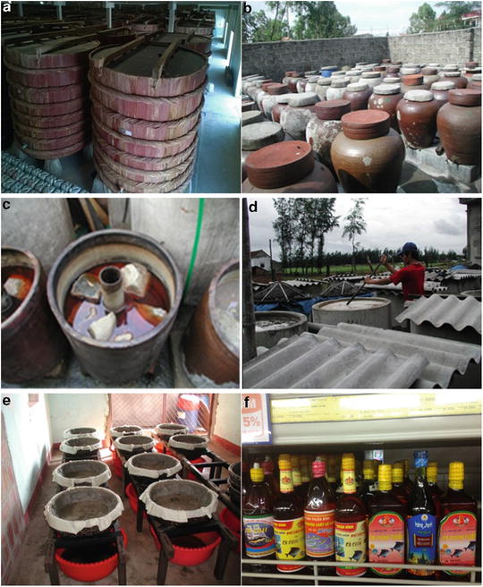

Figure 1. Traditional fish sauce
- Shrimp paste (Mắm Tôm/ Mắm Ruốc)
In Vietnam, the fermented shrimp paste is a traditional food produced by natural fermentation of whole fresh shrimp mixed with salt (10–15%, w/w) exposed to sunlight for 1–3 months before utilization. The Vietnamese fermented shrimp paste has various colors from dark-brown to reddish brown, and different dried matters and flavors due to the different production processes, such as the amount of salt and fermentation conditions, and the presence of different naturally occurring bacteria in the product (Anh, Mi, & Van Hung, 2015).
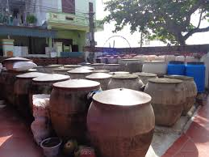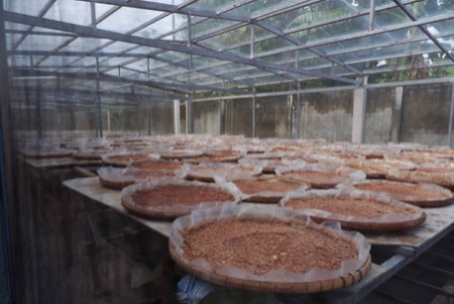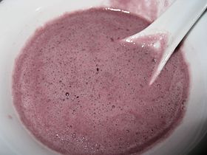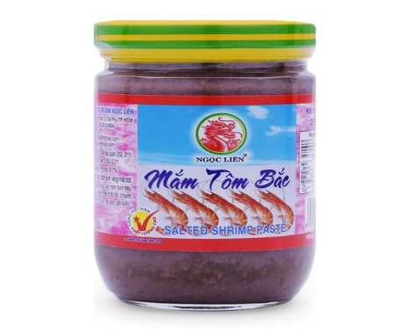
Figure 2.

3.1.3. Fermented meat
Nem chua is a popular lactic acid fermentation product of uncooked meat. The famous brands are Uoc Le (Hanoi), Phung (Hanoi), Vinh Yen (Quang Ninh), Thanh Hoa, Dong Ba (Hue), Ninh Hoa (Khanh Hoa), Lai Vung (Dong Thap). Nem chua from each region has a unique taste and flavor, but, perhaps, nem chua of Thanh Hoa is the most famous (V. N. Thanh & Anh, 2016).
Nem chua is a traditional uncooked fermented meat product of Vietnam. It is made of lean ground pork mixed with boiled pig skin cut into thin strings. The meat paste is shaped into cubes on which some producers put a thin slice of garlic. The cubes are partly wrapped in a leaf ‘Oi’ of the plant Psidium guajava for decoration and flavor. After that, the cubes are wrapped with banana leaves to provide the anaerobic environment for the fermentation process and to inhibit entrance of potentially pathogenic microorganisms. The fermentation takes place without addition of a starter culture or any further cooking or heating and occurs for 2 to 4 days at ambient temperature (H. Nguyen, Elegado, Librojo-Basilio, Mabesa, & Dizon, 2009).
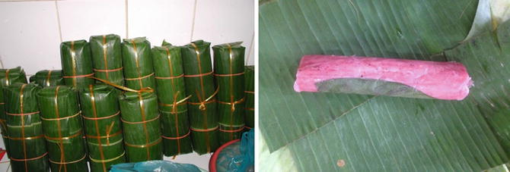

Figure 3. Fermented meat (Nem chua)

3.1.4. Fermented soybean products
Soybean paste (Tương in Vietnamese) is a traditional fermented food used in Vietnamese cuisine that made by ground soybean and sticky rice. Tương was prepared by mixing of mashed soybeans with salt solution and steamed sticky rice containing fungal species Aspergillus oryzae. The mixture was then incubated for at least 15 to 20 days to create fermented soybean paste (Doan Van Thuoc & Le Thi Viet Ha, 2018). The famous brands are Ban (Hung Yen), Cu Da (Hanoi), Kha Do (Vinh Phuc), and Nam Dan (Nghe An). Tương is used as dipping sauce for vegetable and meat and for cooking. Production of Tương has long history and especially popular in northern part of Vietnam (V. N. Thanh & Anh, 2016). Production of Tương. (a) Mixing of moldy glutinous rice on bamboo tray; (b) racks for cultivation of mold; (c) jar of clay for fermentation of tuong; (d) final product.
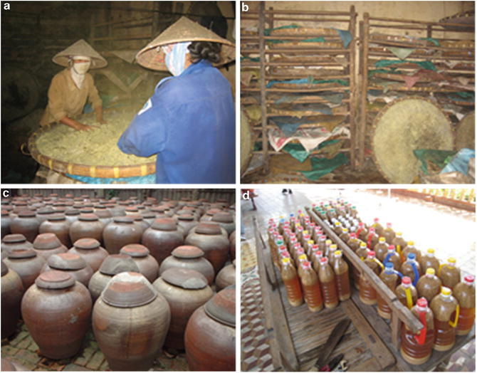

Figure 4. Fermented soybean products

3.1.5. Fermented Vegetables
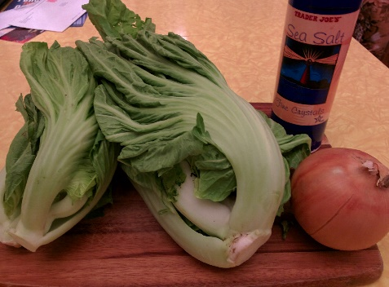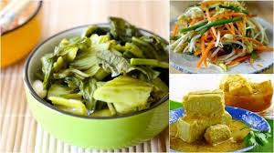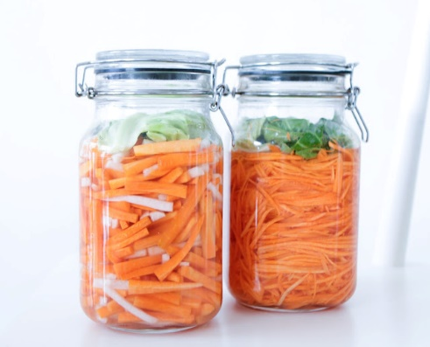

Figure 5. Fermented vegetables
Despite the large diversity in fermented vegetables produced around the world, the type of fermented vegetable used often depends on the season and geographical area. In Vietnam, in general, ‘dua muoi’ (fermented mustard or beet) and ‘ca muoi’ (fermented eggplant) are prepared in most areas throughout the year. In contrast, onion and cabbage fermentations are nearly only performed during the winter period. Dua muoi exists in many varieties: ‘dua cai be’ is fermented mustard, whereas ‘dua cu cai’ refers to fermented beet. They are made of fresh mustard or beet and are mixed with onions, sugar and salt (D. T. L. Nguyen et al., 2013).

3.2. The promotion strategy for traditional food products under the OCOP program

3.2.1. Background of the OCOP program in Vietnam
The "One Commune One Product" program (OCOP) has been available in more than 40 countries in Asia, Africa, and Latin America despite of their different names in countries (L. H. Thanh, Nhat, Dang, Ho, & Lebailly, 2018). The purpose of this strategy is each locality clearly identifies its advantageous products, from which to focus on investing and developing those products. Japan is a pioneer and very successful country with a strategy of socio-economic development in rural areas towards endogenous development and added value, focusing on investing in available resources and products in each location (Claymone & Jaiborisudhi, 2011; Natsuda, Igusa, Wiboonpongse, & Thoburn, 2012; Schumann, 2016; Yamazaki, 2010).
In Vietnam, Quang Ninh is the first province in the country to implement the model "One Commune One Product" since 2013 and has achieved many positive results. And according to the criteria and standards of the current OCOP Program, Quang Ninh has over 300 rated OCOP products (L. H. Thanh et al., 2018). Following the success of Quang Ninh, many provinces and cities across the country have also implemented the program. The OCOP program is not only meaningful in terms of production development, but also in solving many important problems in rural areas such as poverty reduction, job creation, social security, environment, promotion of rural development, people's creative intelligence, forming sustainable community economic linkage organizations. Improve the quality of local human resources through programs to develop rural industries, improve the value of products, goods and market access knowledge.
With these goals in mind, OCOP has become a key rural economic program associated with building a new and model countryside. The program is an economic development program in rural areas based on strengths and advantages, especially products and traditional craft villages of localities and regions across the country. From the meaning and value of the OCOP Program proven over the past 10 years, the Party and State have paid attention to and set forth the policy of developing a unified OCOP economic program in the whole country. The program "One commune one product" for the period of 2018 - 2020 has been approved and promulgated by the Government with an estimated budget of 45,000 billion VND. The Government has also issued a set of criteria for evaluating and classifying OCOP products. Relevant ministries, branches and most localities have issued many legal documents, plans, guidelines, circulars in order to widely implement the OCOP Program in recent years.

3.2.2. Initial results after 3 years of implementation 2018 – 2020 of OCOP program
Responding to the OCOP Program, provinces and cities have established and developed plans for OCOP development. By 2021, the OCOP economic program has been implemented in 63 provinces and cities nationwide. There have been 60/63 provinces and cities organizing product evaluation and rating, showing that the awareness and sense of direction for the implementation of the OCOP Program is increasingly positive. In addition to the localities with depth such as Quang Ninh and Hanoi, the localities that actively deploy quickly and effectively are located in the Northwest, Central Highlands, and Southwest regions. This shows the relevance of the OCOP Program in production development, contributing to promoting new rural construction in these difficult areas.
At the provincial and city level: all 63 provinces in Vietnam have issued Provincial OCOP Program Schemes/Plans, some provinces have issued Directives of the Standing Provincial Party Committee on the OCOP Program. The People's Committees of the provinces have formed the apparatus to implement the Program, assign tasks and mobilize the participation of the whole political system from the province to the district, especially the relevant departments and branches. 100% of provinces and cities have issued documents supplementing the OCOP program implementation tasks to the Steering Committee for new rural construction at the district level. 50% of provinces have added the OCOP Program implementation task to the Steering Committee for New Rural Development at the commune level and assigned a staff member in charge of the OCOP at the commune level. Many localities have used the apparatus of the New Rural Program to implement the OCOP Program, creating convenience and synchronization in the implementation process. By the end of 2020, 25 provinces have assigned the New Rural Coordination Office and 38 provinces have assigned the Rural Development Sub-Department to be the program's standing agency.
Regarding product development results and OCOP subjects, in the period 2018 - 2020, there were 2,961 subjects registered to participate in the Program with 6,210 products. Subjects have been supported to improve quality, develop products, improve capacity, 874 products have been supported to standardize on quality; 792 products are supported in terms of intellectual property registration; 1,266 products are supported in terms of packaging and labeling; 1,098 enterprises and cooperatives are supported to improve their capacity; 1,552 subjects are supported in trade promotion and product introduction. According to the results of evaluation and classification of products, the whole country has 4,759 OCOP products that are recognized with 3 stars or more. In which, the Red River Delta leads the country with 1,759 products (accounting for 37.16%), the Northern mountainous region accounts for 20.56%, followed by the Mekong River Delta with 15%, the lowest is the East region. South with 88 products (accounting for 1.85%). Products with 3 stars accounted for 62.05%; 4-star products accounted for 36.2% and 5-star potential products accounted
for 1.72%.

Figure 6. Percentage of OCOP products based on star in 2018-2020
Source: (OCOP, 2021)
In terms of product structure by group, there are 3,789 products (accounting for 80%) in the food group, 8.8% in the interior and decorative souvenir group, 6.3% in the beverage group, and the rest are products. other products. In particular, 35 community tourism products and services have been recognized as OCOP products. There have been 2,610 subjects with products recognized as OCOP, of which: 37.8% are cooperatives, 27.7% are small and medium enterprises, 31.7% are registered production establishments/ households, business registration, the rest is the cooperation group.
In terms of resources for implementation, the program mobilized 22,845 billion VND (expected to be 45,000 billion VND), of which OCOP organizations mobilized resources and borrowed over 93% (up 6.6% compared to the plan) the proposed plan is 86.6%); budgets at all levels (including integrated sources) accounted for 7% (decreased by 6.4% compared to the planned plan of 13.4%).

Figure 7. Production units participated in OCOP 2018-2020
Source: (OCOP, 2021)
Another important success of the OCOP Program is that trade promotion has been actively and effectively implemented by ministries, branches and localities. The Ministry of Industry and Trade quickly issued a decision on the standardization of OCOP centers/points of sale, helping the country to have more than 142 OCOP centers/sale points. OCOP fairs and exhibitions at provincial and regional levels with more than 10,000 booths gradually become local brands and tourist destinations. The modern retail system in the country (large commercial centers such as Central Retail, Saigon Coop, Mega Market...) has also actively participated in consuming OCOP products.

Figure 8. OCOP products structure by group
Source: (OCOP, 2021)

3.2.3. Difficulties, existences and recommendation for a sustainable development of OCOP program
Along with the achieved results, the OCOP Program still has many difficulties and problems. As a new program, related to many fields, especially the requirement to arouse the potential and advantages of localities for rural economic development, therefore, in the initial stage of implementation, some localities still many confusions in how to do it, identifying advantages, potentials and production subjects, only focusing on perfecting existing products, not paying attention to developing new products associated with raw material areas, especially traditional villages.
Resources to implement the Program are limited, mainly integrated, while a number of support mechanisms have not been concretized, not paying attention to the development of value chains, raw material areas and processing facilities… leading to difficulties in implementation in some localities.
Many subjects do not understand clearly about the orientation and requirements of the Program, especially the provisions of law in the production and distribution of products, so they confuse product quality with packaging and labels..
On the basis of experience in implementing the Program in the period of 2018-2020, in the period of 2021-2025, it is necessary to develop a program framework suitable to the potentials and advantages of the localities, mobilizing the participation of business actors, economy, all levels and sectors in the implementation of the Program.
Trade promotion activities, connecting supply - demand for OCOP products need to be associated with annual national, regional and local OCOP product fair programs; Creative design centers develop OCOP products in association with startup programs, attracting the participation of subjects.
Localities need to focus on assessing their potentials and strengths, especially the potential of local raw materials, rural industries, and community-based tourism in order to have appropriate policies and solutions to develop products. OCOP products. Ministries and central agencies have stepped up support in advertising and trade promotion, guiding localities and subjects to apply regulations related to quality, food safety and intellectual property... strengthen international cooperation in the implementation of the Program, continue to advise on the improvement and expansion of the regional and international OCOP product network, increase exchange of experiences, training, and trade promotion of products. OCOP products.
For the program to be more effective, the Government needs to allow the continued implementation of the Social Policy Credit Program to support production development and expand the loan audience to develop rural industries, especially in rural areas to develop the OCOP Program in particularly difficult areas.

4. CONCLUSION
The traditional products of Vietnam are diverse and rich in types and designs, from food products, beverages, fermented products, handicrafts... with high quality, suitable in line with the tastes of domestic and international consumers. Moreover, as they are formed, grown and developed from the localities, traditional products are suitable for the soil, climate and weather conditions of the regions. Additionally, these traditional products are manufactured according to a long-standing, handmade process that is environmentally friendly and is considered good for consumers' health. Therefore, it has potential for development and is considered as one of products that can increase incomes and improve the lives of rural people. On that basis, the Vietnamese government has issued and implemented the nationwide OCOP strategy. Within 3 years of implementation 2018-2020, the OCOP strategy has made great contributions in promoting the development of traditional products, forming high quality products, consuming, connecting the market and the value chain of these products have been formed and developed. However, the implementation of the OCOP strategy still has many problems, the linkage between the parties is still limited, the market information is still not truly clear, leading to the improvement of income and livelihood for people from the production of these traditional products is limited. This can be a suggestive direction for future research aimed at raising incomes and improving people's livelihoods from the production of traditional agricultural products under the direction of the OCOP program.

REFERENCES
Agricoltura, M. (1999). Decreto Legislativo 30 Aprile 1998 n. 173. Decreto Ministero Agricoltura(350).
Akter, S., Jabbar, M. A., Ehui, S. K., & Goletti, F. (2004). Competitiveness of poultry and pig production in Vietnam: an application of policy analysis matrix. Retrieved from.
Anh, D. B. Q., Mi, N. T. T., & Van Hung, P. (2015). Isolation and optimization of growth condition of Bacillus sp. from fermented shrimp paste for high fibrinolytic enzyme production. Arabian Journal for Science and Engineering, 40(1), 23-28.
Balogh, P., Békési, D., Gorton, M., Popp, J., & Lengyel, P. (2016). Consumer willingness to pay for traditional food products. Food policy, 61, 176-184. doi:https://doi.org/10.1016/j.foodpol.2016.03.005
Ban, N. K., Regalado, J., Hung, N. P., Dung, N. Q., Binh, B. M., & Anh, T. P. (2005). Rattan resource of Bach Ma National Park, Thua Thien Hue province. Agricultural Review, 14.
Bertozzi, L. (1998). Tipicidad alimentaria y dieta mediterránea. El color de la alimentación mediterránea. Elementos sensoriales y culturales de la nutrición, 15-41.
Claymone, Y., & Jaiborisudhi, W. (2011). A study on one village one product project (OVOP) in Japan and Thailand as an alternative of community development in Indonesia. The International Journal of East Asian Studies, 16(1), 51-60.
Dan, N. N., & Ping, L. G. (2018). Land Unit Mapping and Evaluation of Land Suitability for Agro–forestrye in Thua Thien Hue province–VietNam as an Example. Paper presented at the IOP Conference Series: Earth and Environmental Science.
Doan Van Thuoc, D. T. X., & Le Thi Viet Ha, L. D. H. (2018). Dang Huong Tra. Fungal and Aflatoxin Contamination in Soybean Paste Collected from Ban Village, Hung Yen Province, Vietnam. American Journal of Microbiology and Biotechnology, 5(2), 25-28.
Doris Becker, P. N. T. v. H. Đ. T. (2009) Phát triển chuỗi giá trị - công cụ gia tăng giá trị cho sản xuất nông nghiệp. In.
Duc, N. V., & Long, T. (2008). Poultry production systems in Vietnam. Animal genetics and breeding department, National Institute of animal husbandry, Vietnam.
Dung, N. (2013). Vietnamese rice-based alcoholic beverages. International Food Research Journal, 20(3), 1035.
The protection of geographical indications and designations of origin for agricultural products and foodstuffs., (2006a).
Gellynck, X., & Kühne, B. (2008). Innovation and collaboration in traditional food chain networks. Journal on Chain and Network Science, 8(2), 121-129.
Ho, T. Q., Hoang, V.-N., Wilson, C., & Nguyen, T.-T. (2018). Eco-efficiency analysis of sustainability-certified coffee production in Vietnam. Journal of Cleaner Production, 183, 251-260.
Hogarth, N., & Belcher, B. (2013). The contribution of bamboo to household income and rural livelihoods in a poor and mountainous county in Guangxi, China. International Forestry Review, 15(1), 71-81.
Jordana, J. (2000). Traditional foods: challenges facing the European food industry. Food Research International, 33(3–4), 147-152. doi:http://dx.doi.org/10.1016/S0963-9969(00)00028-4
Lee, A., & Fujio, Y. (1999). Microflora of banh men, a fermentation starter from Vietnam. World Journal of Microbiology and Biotechnology, 15(1), 51-55.
Long, H. T., HO, T. M. H., Burny, P., Dogot, T., Hao, N. D., & Lebailly, P. (2019). An Economic Analysis of Traditional Agriculture Products: The Case of Chicken in Thua Thien Hue Province, Vietnam. Asian Social Science, 15(10), 149-158.
Luu, B. N., Nguyen, T. T., & Newman, I. M. (2014). Traditional alcohol production and use in three provinces in Vietnam: an ethnographic exploration of health benefits and risks. BMC Public Health, 14(1), 731.
Marsh, S. P., & MacAulay, T. G. (2002). Land reform and the development of commercial agriculture in Vietnam: policy and issues. Agribusiness Review, 10, 1-19.
Marsh, S. P., MacAulay, T. G., & Hung, P. (2006). Agricultural development and land policy in Vietnam. Agricultural development and land policy in Vietnam.
Natsuda, K., Igusa, K., Wiboonpongse, A., & Thoburn, J. (2012). One Village One Product – rural development strategy in Asia: the case of OTOP in Thailand. Canadian Journal of Development Studies / Revue canadienne d'études du développement, 33(3), 369-385. doi:10.1080/02255189.2012.715082
Nguyen, D. T. L., Van Hoorde, K., Cnockaert, M., De Brandt, E., Aerts, M., Binh Thanh, L., & Vandamme, P. (2013). A description of the lactic acid bacteria microbiota associated with the production of traditional fermented vegetables in Vietnam. International journal of food microbiology, 163(1), 19-27. doi:https://doi.org/10.1016/j. ijfoodmicro. 2013.01.024
Nguyen, H., Elegado, F., Librojo-Basilio, N., Mabesa, R., & Dizon, E. (2009). Isolation and characterisation of selected lactic acid bacteria for improved processing of Nem chua, a traditional fermented meat from Vietnam. Beneficial Microbes, 1(1), 67-74.
No, C. R. E. (2006). On the protection of geographical indications and designations of origin for agricultural products and foodstuffs. Official Journal of the European Union of 31.3. 2006, 50, 12-25.
OCOP. (2019). OCOP products.
OCOP. (2021). Summary of the OCOP program in the periods of 2018-2020. Retrieved from
Peters, E. J. (2011). Appetites and aspirations in Vietnam: Food and drink in the long nineteenth century: Rowman Altamira.
Schumann, R. F. (2016). A Study of One Village One Product (OVOP) and Workforce Development: Lessons for Engaging Rural Communities around the World. School of Business and Public Administration.
Thanh, L. H., Nhat, L. T., Dang, H. N., Ho, T. M. H., & Lebailly, P. (2018). One Village One Product (OVOP)—A Rural Development Strategy and the Early Adaption in Vietnam, the Case of Quang Ninh Province. Sustainability, 10(12), 4485.
Thanh, V. N., & Anh, N. T. V. (2016). Ethnic fermented foods and beverages of Vietnam. In Ethnic Fermented Foods and Alcoholic Beverages of Asia (pp. 383-409): Springer.
Thanh, V. N., Thuy, N. T., Chi, N. T., Hien, D. D., Ha, B. T. V., Luong, D. T.,... Van Ty, P. (2016). New insight into microbial diversity and functions in traditional Vietnamese alcoholic fermentation. International journal of food microbiology, 232, 15-21.
Thi Ut, T., & Kajisa, K. (2006). The impact of green revolution on rice production in Vietnam. The Developing Economies, 44(2), 167-189.
Trichopoulou, A., Soukara, S., & Vasilopoulou, E. (2007). Traditional foods: a science and society perspective. Trends in Food Science & Technology, 18(8), 420-427. doi:http://dx.doi.org/10.1016/j.tifs.2007.03.007
Trichopoulou, A., Vasilopoulou, E., Georga, K., Soukara, S., & Dilis, V. (2006). Traditional foods: Why and how to sustain them. Trends in Food Science & Technology, 17(9), 498-504. doi:http://dx.doi.org/10.1016/j.tifs.2006.03.005
Trinh, L. N., Watson, J. W., Hue, N. N., De, N. N., Minh, N., Chu, P.,... Eyzaguirre, P. B. (2003). Agrobiodiversity conservation and development in Vietnamese home gardens. Agriculture, ecosystems & environment, 97(1-3), 317-344.
Vanhonacker, F., Kühne, B., Gellynck, X., Guerrero, L., Hersleth, M., & Verbeke, W. (2013). Innovations in traditional foods: Impact on perceived traditional character and consumer acceptance. Food Research International, 54(2), 1828-1835. doi:http://dx.doi.org/10.1016/j.foodres.2013.10.027
Verbeke, W., Guerrero, L., Almli, V. L., Vanhonacker, F., & Hersleth, M. (2016). European consumers’ definition and perception of traditional foods. In Traditional Foods (pp. 3-16): Springer.
Wetterwald, O., Zingerli, C., & Sorg, J.-P. (2004). Non-timber forest products in Nam Dong District, Central Vietnam: ecological and economic prospects. Schweizerische Zeitschrift fur Forstwesen, 155(2), 45-52.
Yamazaki, J. (2010). A Comparative Analysis of One Village One Product (OVOP) and its Replicability in International Development: Erasmus University.

