**Tập. 30 Số. 2A (2024): TẠP CHÍ PHÂN TÍCH HÓA, LÝ VÀ SINH HỌC**

[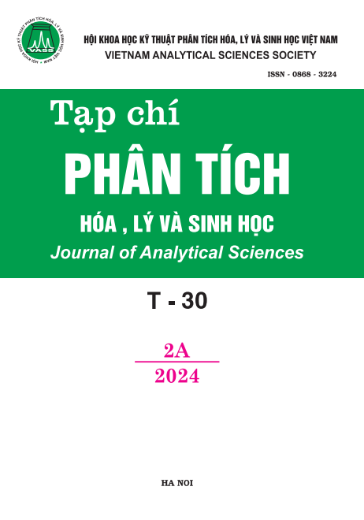](https://vjol.info.vn/index.php/TCPTHLS/issue/view/8282)

**Phát hành ngày:**2024-07-10

**ĐỘNG HỌC HẤP PHỤ FUCHSIN ACID TRÊN VẬT LIỆU Al-BENTONITE**

Đến tòa soạn 10-05-2024

Nguyễn Lê Mỹ Linh*, Võ Văn Tân

Đại học Sư phạm, Đại học Huế

*Email: [nlmlinh@hueuni.edu.vn](mailto:nlmlinh@hueuni.edu.vn)

**SUMMARY**

**ADSORPTION KINETICS OF FUCHSIN ACID ONTO Al-BENTONITE**

In the present work, the Al-bentonite was prepared by the modification of Wyoming bentonite with cation aluminium by ultrasound - assisted cation exchange. X-ray diffraction (XRD), infrared spectroscopy (FT-IR), and nitrogen adsorption/desorption isotherms were utilized to characterize the modified bentonite. The Al-bentonite was employed for the removal of fuchsin acid from aqueous solution. Fuchsin acid adsorption followed the pseudo-second-order kinetic model. The determined activation energy of this fuchsin acid adsorption was 5.17 kJ/mol.

**Keywords:** Al pillared bentonite, fuchsin acid, isotherms, adsorption kinetics