Short-Term Bitcoin Forecasting Across Multiple Horizons: The Effectiveness of GRU Networks

Hoa Tran Thai^{1, 2}, Thanh Manh Le², Cuong H. Nguyen-Dinh³, Hai-Phuong Thi Duong^{1,}
¹University of Economics, Hue University, Viet Nam.
²University of Sciences, Hue University, Viet Nam.
³ University of Finance – Marketing, Viet Nam
Abstract. This study proposed a GRU-based framework for short-term multi-horizon Bitcoin forecasting and validated its effectiveness through a systematic comparison with four state-of-the-art baseline architectures: Long Short-Term Memory (LSTM), Bidirectional LSTM (Bi-LSTM), one-dimensional Convolutional Neural Networks (1D-CNN), and Transformer networks over multiple time horizons. Based on daily Bitcoin price data spanning from September 17, 2014, to June 11, 2025, the models were systematically evaluated under three forecasting horizons—3-day, 5-day, and 7-day—using various input window sizes. Model performance was quantitatively assessed through five standard metrics: Mean Squared Error (MSE), Root Mean Squared Error (RMSE), Mean Absolute Error (MAE), Mean Absolute Percentage Error (MAPE) and the Coefficient of Determination (R²). Experimental results demonstrate that the GRU model consistently outperforms the other architectures in terms of predictive accuracy, temporal stability, and computational efficiency across all tested configurations. Notably, this study provides one of the first comprehensive benchmarks of these deep learning models under consistent experimental settings, offering practical guidance for selecting forecasting architectures in highly volatile cryptocurrency markets.
Keywords: Bitcoin forecasting, Deep learning, Time series prediction, Cryptocurrency price, GRU networks.
- Introduction
The precise prediction of closing prices for a crypto-historical series, such as Bitcoin, is an important challenge in finance, economics, and data science [1], [2]. Cryptocurrencies show high volatility, nonlinearity, and sensitivity to different market influences, which makes them a challenge for legacy forecasting methods [3], [4]. To this end, recent work has focused on deep learning methods, such as LSTM, Bi-LSTM, GRU, 1D-CNN, and Transformer models, to study these problems and enhance predictive accuracy [5], [6], [7]. Such methods are especially suitable for capturing complicated temporal dependencies and chaotic patterns in cryptocurrency time series, and they represent a departure from traditional econometric models to data-based, flexible forecasting techniques. However, despite these advances, comparative studies systematically evaluating these architectures under consistent experimental settings across multiple forecasting horizons remain scarce [8], [9]. This is the gap that this study fills.
Among the various deep learning architectures, the GRU has emerged as a particularly promising model for cryptocurrency price forecasting [3], [10]. Bitcoin’s extreme volatility, decentralized structure, and increasing global adoption demand require forecasting techniques that can efficiently handle complex temporal patterns and adapt to rapid market changes [1], [4]. Many of the above nonlinear, chaotic behaviors are difficult to capture using traditional statistical models such as ARIMA and GARCH [7]. For these reasons, GRU presents a more advantageous opportunity, characterized by a compact architecture, quicker convergence, and robust predictive accuracy, compared to other deep learning models, including LSTM, Bi-LSTM, 1D-CNN, and Transformer networks. These advantages make GRU especially suitable for modeling cryptocurrency prices in highly volatile environments.
This study offers three main contributions. First, it establishes a solid benchmark for five of the leading deep learning architectures – including LSTM, GRU, Bi-LSTM, Transformer, 1D-CNN, among others – through a systematic evaluation of their respective performance against multiple forecasting horizons and various sliding window types. Secondly, it provides novel insights into the impact of different input-output window lengths on forecasting, therefore enabling the development of targeted time-series prediction frameworks. Finally, it arrives at the empirical finding that GRU consistently presents the highest accuracy, stability, and computational efficiency in the prediction of price dynamics within a volatile market in all considered cases.
The remainder of this paper is organized as follows. Section 2 reviews related works on cryptocurrency price forecasting using deep learning models. Section 3 describes the sliding window technique employed in this study and details the architectures of the deep learning models evaluated. Section 4 presents and discusses the experimental results across multiple sliding window configurations. Finally, Section 5 concludes the paper and highlights directions for future research.
- Related works
Accurately forecasting cryptocurrency prices remains a major challenge, largely due to the market’s high volatility and complex, non-linear behavior. Traditional econometric models such as ARIMA, which rely on assumptions of linearity and stationarity, often struggle to capture these intricate patterns, resulting in limited predictive effectiveness in such dynamic environments. In response, deep learning architectures have become powerful alternatives, as their structure is inherently suited to modeling complex, non-linear relationships in sequential data. Studies such as Siami-Namini et al. [5] have empirically confirmed this, showing that both LSTM and Bi-LSTM models significantly outperform ARIMA by effectively capturing these underlying dynamics. This section analyzes the evolution of these advanced models to contextualize the contributions of this study.
To tackle the intricate temporal patterns found in financial time series, early deep learning efforts focused on RNNs. Although RNNs were specifically designed to handle sequential data, they often struggled in practice due to the vanishing gradient problem, which made it difficult for them to capture long-term dependencies. A breakthrough came in 1997 when Hochreiter and Schmidhuber introduced the LSTM network [11]. With its innovative gating mechanism that carefully controls the flow of information, LSTM effectively overcame this limitation and enabled models to retain and learn from long-range patterns. Consequently, the LSTM network has established itself as a foundational benchmark in financial forecasting. Its efficacy is well-documented; for instance, Lin [6] demonstrated significant predictive power by applying an LSTM-based model to achieve high accuracy on daily Bitcoin prices.
To enhance contextual representation, Bi-LSTM networks process input sequences in both forward and backward directions, thereby enabling the model to simultaneously incorporate information from preceding and succeeding time steps. This bidirectional capability has proven particularly effective in financial forecasting. For instance, amidst the high demand and significant volatility of cryptocurrencies like Bitcoin, there is a pressing need for accurate prediction models to assist investors. Addressing this, Prabhnoor Singh et al. [12] evaluated a Bi-LSTM model using historical price data to forecast future closing prices, concluding that it substantially outperforms other regression models and previous studies. Similarly, a comparative analysis of Bitcoin volatility forecasting showed that a multivariate Bi-LSTM model was more effective than classical econometric procedures. The model's strength is not limited to finance; in their work on sentiment analysis, Mahadevaswamy and Swathi [13] also reported that a Bi-LSTM network yielded notable improvements over unidirectional models.
Despite their effectiveness, LSTMs can introduce significant computational overhead. The GRU, a streamlined variant introduced by Cho et al. [14], offers a compelling alternative. By using a simpler gating mechanism, GRUs often achieve performance comparable to LSTMs but with greater computational efficiency, making them faster to train. In their study, Dutta et al. [10] applied a GRU-based approach to Bitcoin prediction and concluded that it was both robust and computationally efficient. A comparative study by Bouteska et al. [15] also found that GRU models outperformed other machine learning methods for forecasting various cryptocurrencies. This efficiency makes GRU particularly attractive for applications in fast-paced cryptocurrency markets.
Seeking to build upon the successes of recurrent networks, researchers began exploring methods to augment their capabilities, leading to hybrid architectures that fuse different model strengths. One common approach involves using a 1D-CNN as a feature extractor, as CNNs excel at identifying local patterns and spatial hierarchies in data. For example, Li and Dai [16] developed a CNN-LSTM hybrid model and showed that it enhanced both price level and directional forecasts for Bitcoin. Other recent studies have reinforced this, showing that hybrid CNN-LSTM models can outperform individual components by effectively capturing both spatial and temporal dependencies in financial data [17].
More recently, the Transformer, which relies entirely on self-attention mechanisms, has revolutionized sequence modeling [18]. This has led to state-of-the-art results in many domains, and researchers have begun applying them to financial forecasting. However, the presumed dominance of Transformers in time series forecasting was critically challenged by the foundational work of Zeng et al. [19]. Their study demonstrated that surprisingly simple architectures, including linear variants, could achieve competitive or even superior performance, underscoring the principle that architectural complexity is not a universal proxy for predictive accuracy. Meanwhile, other researchers developed specialized variants like Hidformer for stock forecasting and explored the advantages of Transformers for high-frequency trading [20], [21].
Although a growing body of literature demonstrates the merits of individual models, a conspicuous gap remains in the comparative evaluation of their effectiveness. Many studies focus on a limited set of models or use different datasets and evaluation metrics, making direct comparison difficult. As noted in recent reviews, there is a lack of comprehensive comparative analysis of different deep learning architectures across various financial markets and time horizons. The field lacks a systematic benchmark where these diverse architectures are evaluated under consistent experimental settings [8]. Therefore, this study is conducted to provide a comprehensive performance comparison of LSTM, Bi-LSTM, GRU, Transformer, and 1D-CNN across various forecasting horizons. Our objective is to replace anecdotal evidence with a robust empirical foundation, thereby offering validated guidance for selecting the most effective forecasting solution.
- Bitcoin Price Forecasting Method Based on GRU Networks and Sliding Window Technique
  - Time Series Preprocessing Using the Sliding Window Approach
To transform the Bitcoin price data $B∈R^{n×m}$ into a supervised learning format suitable for deep learning models, we employ the sliding window technique. This method generates overlapping sequences of input-output pairs by sliding a fixed-size window across the time series.
For a given time step $t$, the input sequence $I_{t}∈R^{l×m}$ consists of historical data from the preceding $l$ time steps (lookback window), while the corresponding output $O_{t}∈R^{p×l}$ represents the target values for the subsequent $f$ time steps (forecast horizon). This process results in an input tensor $I$ and an output tensor $O$, allowing the model to learn the mapping from past market states to future price trajectories. The procedure for generating these sequences is detailed in Algorithm 1.
Algorithm 1. Generating sliding window data
Input:
data: Normalized time series dataset (size n x m)
l: Input window size (lookback period)
f: Output window size (forecast horizon)
Output:
I: Input sequences (features)
O: Output sequences (targets)
function GenerateSlidingWindow(data, l, f):
Initialize I = [], O = []
N = len(data)
for i in range(N - l - f + 1):
i_t = data[i : i + l, :]
o_t = data[i + l : i + l + f, target_feature_index]
Append i_t to I
Append o_t to O
return I, O
  - Architecture of the Gated Recurrent Unit Networks
The proposed framework uses a Gated Recurrent Unit (GRU) network to model temporal dependencies in Bitcoin price data for multi-step forecasting. As a streamlined alternative to LSTM, the GRU employs update and reset gates to efficiently capture long-term dependencies in volatile cryptocurrency time series. The model includes two stacked GRU layers (128 units each), each followed by a dropout layer (rate 0.2) to prevent overfitting, and a dense layer for forecasting future prices. The GRU architecture is shown in Fig. 1.
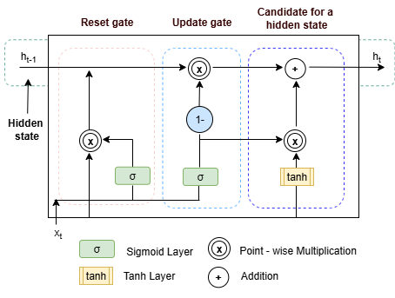
Fig. 1. The internal architecture of a GRU unit
Each GRU cell uses sigmoid (σ) and hyperbolic tangent (tanh) activations to manage information flow via two gates. The below formulations follow Cho et al. [14].
At time step t, the computations are:
- Update gate determines the balance between retaining the previous state and incorporating new information in Equation (1):
$$z_{t}=σ (W_{z}x_{t}+U_{z}h_{t-1}+b_{z})$$ | (1)
- Reset gate controls the influence of the previous state on the candidate state in Equation (2):
$$r_{t}=σ \left(W_{r}x_{t}+U_{r}h_{t-1}+b_{r}\right)$$ | (2)
- Candidate hidden state computes the potential new state based on the input and modulated previous state in Equation (3):
$${\tilde{h}}_{t}=tanh (W_{h}x_{t}+U_{h}(r_{t}⨀ h_{t-1}+b_{h})$$ | (3)
- Hidden state combines the candidate and previous states, weighted by the update gate in Equation (4):
$$h_{t}=z_{t} ⨀ {\tilde{h}}_{t}+\left(1-z_{t}\right) ⨀{ h}_{t-1})$$ | (4)
where:
  - $x_{t}$: input vector (e.g., Bitcoin open, high, low, volume) at time t,
  - ${ h}_{t-1}$, $h_{t}$: previous and new hidden states,
  - ${\tilde{h}}_{t}$: candidate hidden state,
  - $z_{t}$, $r_{t}:$update and reset gate activations,
  - $W_{z}$, $W_{r}$, $W_{h}$, $U_{z}$, $U_{r}$, $U_{h}$: weight matrices,
  - $b_{z}$, $b_{r}$, $b_{h}$: bias vectors,
  - σ: sigmoid function,
  - tanh: hyperbolic tangent function,
  - ⊙: element-wise multiplication.
The GRU processes Bitcoin price sequences transformed via the sliding window approach, evaluated across configurations (10, 3), (15, 5), and (21, 7), where the first number indicates the window sizes, and the second represents the forecast sizes. It is trained with MSE loss and the Adam optimizer. The GRU’s efficiency and ability to model both short- and long-term dependencies make it ideal for capturing Bitcoin’s volatile price dynamics.
  - Baseline Architectures
To validate the effectiveness of the proposed GRU framework, this study benchmarks its performance against four established deep learning architectures widely used in financial time series forecasting. The first baseline is the LSTM network, introduced by Hochreiter and Schmidhuber [11], which addresses the vanishing gradient problem inherent in traditional RNNs by utilizing a memory cell composed of input, output, and forget gates to regulate information flow and learn long-term dependencies. Building upon this, the Bi-LSTM extends the standard architecture by processing the input sequence in both forward and backward directions, thereby capturing context from both past and future states simultaneously to enhance feature representation [5], [12]. We also evaluate the 1D-CNN [16], which effectively employs convolutional filters to extract local features and short-term patterns from temporal sequences. Finally, the comparison includes the Transformer model, introduced by Vaswani et al. [18], which represents a paradigm shift from recurrent processing by relying entirely on self-attention mechanisms to weigh the significance of different time steps, theoretically facilitating the modeling of global dependencies within the series.
- Experiment
  - Dataset and Preprocessing
This study uses a daily Bitcoin price dataset (BTC) from Yahoo Finance spanning September 17, 2014, to June 11, 2025, comprising 3,922 trading days. Each record includes open, high, low, close prices, and volume. A sliding window approach converts the time series into a supervised learning form, mapping past observations to future prices. Three configurations are evaluated: (10, 3), (15, 5), and (21, 7), where the first number is the input window size and the second is the forecast horizon. Input features (open, high, low, close, volume) are normalized to [0, 1]; outputs are future close prices. Data is split chronologically: 80% for training-validation (3:1 split) and 20% for testing, ensuring consistent evaluation across models.
  - Model Training and Evaluation
All models were implemented using TensorFlow and Keras, and trained on Google Colaboratory with GPU acceleration for faster convergence. Early stopping (patience = 30) with automatic weight restoration and learning rate reduction (for Transformer) was applied to improve generalization.
The predictive performance of five deep learning models - LSTM, GRU, Bi-LSTM, Transformer, and 1D-CNN - was systematically evaluated across three forecasting configurations (10-3, 15-5, 21-7). Evaluation was conducted using four standard regression metrics: MSE, RMSE, MAE, MAPE and R². These metrics are summarized in Table 1.
Table 1. Definitions and interpretations of evaluation metrics used to assess model performance
Metric | Formula
MSE | $$MSE=\frac{1}{n}\sum_{i=1}^{n}{{(y_{i}-\hat{y_{i}})}^{2}}$$
RMSE | $$RMSE=\sqrt{MSE}$$
MAE | $$MAE=\frac{1}{n}\sum_{i=1}^{n}{\left|y_{i}-\hat{y_{i}}\right|}$$
MAPE | MAPE = $\frac{100}{N}\sum_{i=1}^{n}{\left\lceil \frac{y_{i}-{\hat{y}}_{i}}{y_{i}}\right\rceil }$
R² | $$R^{2}=1-\frac{\sum_{i=1}^{n}{{(y_{i}-{\hat{y}}_{i})}^{2}}}{\sum_{i=1}^{n}{{(y_{i}-{\overline{y}}_{i})}^{2}}}$$
The experimental results presented in Table 2 and Fig. 2 - Fig. 7 provide compelling evidence of the superior forecasting capability of the GRU model across all evaluated short-term forecasting configurations. Unlike previous analyses based solely on normalized values, Table 2 reports prediction errors transformed back to the original USD scale, together with percentage-based metrics (MAPE), thereby improving the practical interpretability of the results for financial applications.
Table 2. Quantitative evaluation results of deep learning models under the original USD scale and percentage-based error metrics.
Configuration | Model | MSE (USD²) ↓ | RMSE (USD) ↓ | MAE (USD) ↓ | MAPE (%) ↓ | R² ↑
Configuration 1  (10,3) | LSTM | 10.44×10⁶ | 3,228 | 2,227 | 2.62 | 0.99051
Configuration 1  (10,3) | GRU | 9.70×10⁶ | 3,117 | 2,117 | 2.49 | 0.99114
Configuration 1  (10,3) | Bi-LSTM | 11.44×10⁶ | 3,387 | 2,347 | 2.76 | 0.98956
Configuration 1  (10,3) | Transformer | 13.67×10⁶ | 3,706 | 2,640 | 3.11 | 0.98749
Configuration 1  (10,3) | 1D-CNN | 12.68×10⁶ | 3,569 | 2,541 | 2.99 | 0.98840
Configuration 2  (15,5) | LSTM | 14.42×10⁶ | 3,790 | 2,614 | 3.07 | 0.98682
Configuration 2  (15,5) | GRU | 14.17×10⁶ | 3,767 | 2,607 | 3.06 | 0.98699
Configuration 2  (15,5) | Bi-LSTM | 15.29×10⁶ | 3,915 | 2,682 | 3.15 | 0.98594
Configuration 2  (15,5) | Transformer | 21.01×10⁶ | 4,587 | 3,334 | 3.92 | 0.98069
Configuration 2  (15,5) | 1D-CNN | 23.49×10⁶ | 4,847 | 3,382 | 3.98 | 0.97845
Configuration 3  (21,7) | LSTM | 20.88×10⁶ | 4,571 | 3,239 | 3.81 | 0.98065
Configuration 3  (21,7) | GRU | 17.90×10⁶ | 4,227 | 2,917 | 3.43 | 0.98346
Configuration 3  (21,7) | Bi-LSTM | 21.13×10⁶ | 4,591 | 3,263 | 3.84 | 0.98049
Configuration 3  (21,7) | Transformer | 27.35×10⁶ | 5,223 | 3,892 | 4.58 | 0.97474
Configuration 3  (21,7) | 1D-CNN | 23.62×10⁶ | 4,859 | 3,490 | 4.10 | 0.97814
Specifically, under the first configuration (10 input steps, 3 output steps), GRU achieved the lowest prediction error with MSE = 9.70 × 10⁶ USD², RMSE = 3,117 USD, MAE = 2,117 USD, and MAPE = 2.49%, while also attaining the highest coefficient of determination (R² = 0.99114). These results outperform not only recurrent architectures such as LSTM (RMSE = 3,228 USD) and Bi-LSTM (RMSE = 3,387 USD) but also more complex models including Transformer (RMSE = 3,706 USD) and 1D-CNN (RMSE = 3,569 USD). The low MAPE value further indicates that GRU predictions deviate from actual Bitcoin prices by only about 2.5% on average, highlighting its practical forecasting reliability.
As the input-output window expanded in the second configuration (15, 5), GRU continued to maintain its leading position with MSE = 14.17 × 10⁶ USD², RMSE = 3,767 USD, MAE = 2,607 USD, MAPE = 3.06%, and R² = 0.98699. Although the performance gap between GRU and LSTM became smaller in this setting, GRU still yielded the lowest overall error measures. In contrast, Transformer and 1D-CNN exhibited substantially larger forecasting errors, reaching RMSE values of 4,587 USD and 4,847 USD, respectively, with corresponding MAPE values of 3.92% and 3.98%. These findings demonstrate the robustness of GRU in handling increased temporal dependencies while preserving numerical stability and generalization capability.
In the third configuration (21, 7), which represents the longest forecasting horizon considered in this study, GRU once again achieved the best overall performance with MSE = 17.90 × 10⁶ USD², RMSE = 4,227 USD, MAE = 2,917 USD, MAPE = 3.43%, and R² = 0.98346. This result is particularly noteworthy given the widespread assumption in the literature that Transformer-based architectures are better suited for modeling long-range dependencies. Contrary to this expectation, Transformer delivered the weakest results under this configuration, yielding MSE = 27.35 × 10⁶ USD², RMSE = 5,223 USD, MAE = 3,892 USD, MAPE = 4.58%, and R² = 0.97474. The substantially higher percentage error indicates that Transformer struggled to capture the highly nonlinear and chaotic dynamics of Bitcoin prices within short lookback windows.
The superior performance of the GRU model can be attributed to its architectural design. As described in Section 3.2, GRU employs a compact gating mechanism consisting of update and reset gates. Compared with the three-gate structure of LSTM, this design reduces the number of trainable parameters, thereby lowering the risk of overfitting on highly volatile Bitcoin price data. Specifically, the reset gate (r_{t}) regulates the influence of previous hidden states on candidate representations, enabling the model to adapt more effectively to abrupt market fluctuations, whereas the update gate (z_{t}) controls the integration of historical and newly observed information. Furthermore, the relatively short lookback windows considered in this study (10–21 days) may not fully exploit the self-attention capability of Transformer models, which generally benefit from substantially longer contexts. Consequently, the simpler yet more efficient gating mechanism of GRU proves more suitable for short-term Bitcoin forecasting tasks.
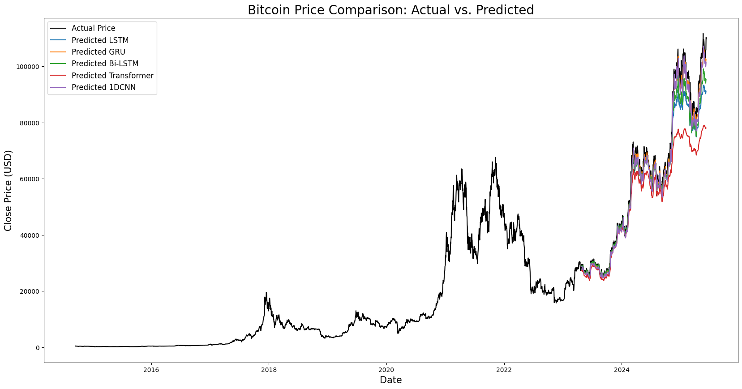  Fig. 2. Comparison between actual and predicted Bitcoin closing prices across deep learning models under Configuration 1 | 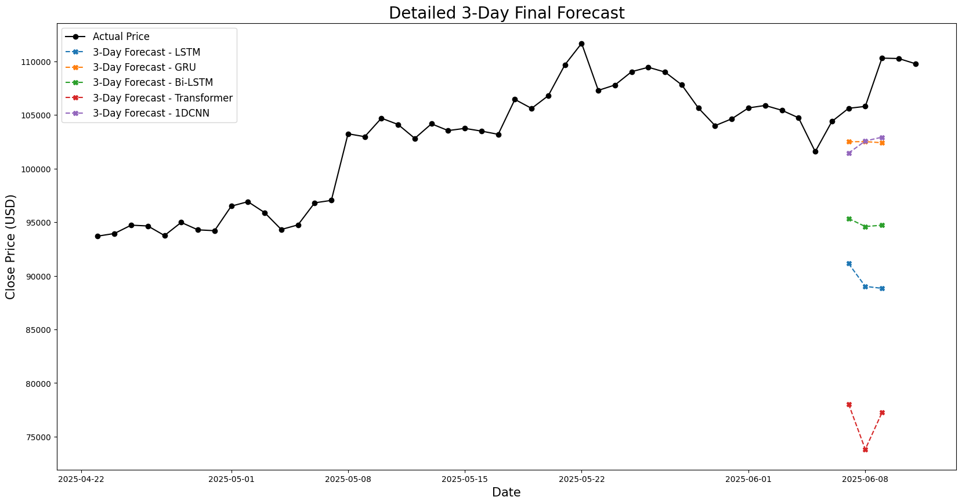  Fig. 3. Detailed visualization of the 3-day final forecasts by deep learning models compared to actual Bitcoin prices

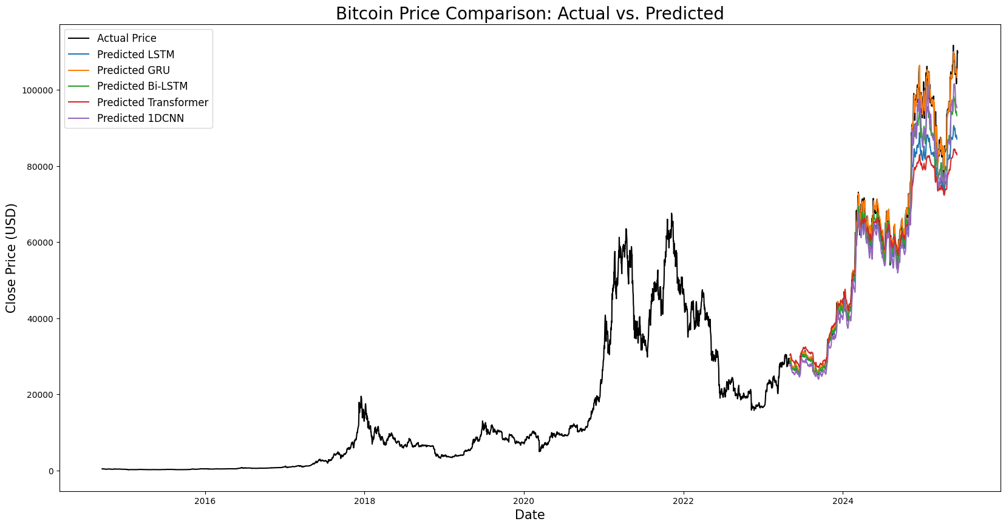  Fig. 4. Comparison between actual and predicted Bitcoin closing prices across deep learning models under Configuration 2 | 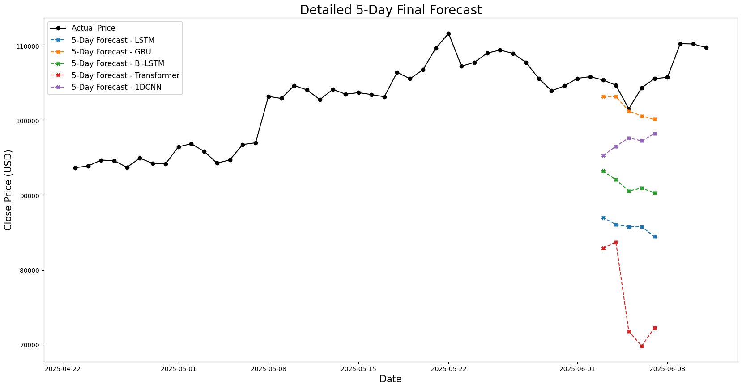  Fig. 5. Detailed visualization of the 5-day final forecasts by deep learning models compared to actual Bitcoin prices

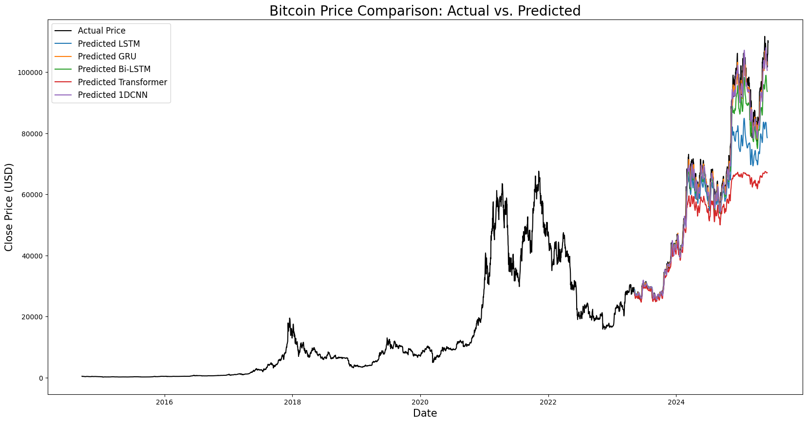  Fig. 6. Comparison between actual and predicted Bitcoin closing prices across deep learning models under Configuration 3 | 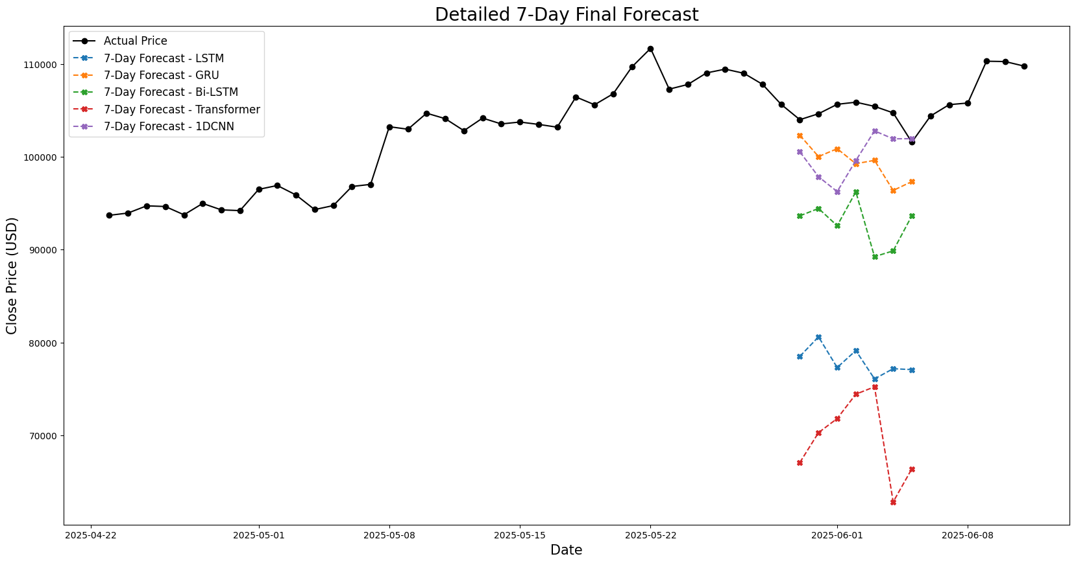  Fig. 7. Detailed visualization of the 7-day final forecasts by deep learning models compared to actual Bitcoin prices
Visual comparisons further reinforce these findings. In Fig. 2, Fig. 4, and Fig. 6 which depict the full-range forecast trajectories for each model under the three configurations, GRU predictions align more closely with actual Bitcoin closing prices than those of any other architecture. The consistency and smoothness of GRU outputs suggest a strong capacity to internalize temporal patterns without overfitting. Meanwhile, Transformer and 1D-CNN models demonstrate higher volatility in prediction curves, with occasional divergences from true trends.
Additionally, Fig. 3, Fig. 5, and Fig. 7 offer a magnified view of the final forecast windows. In every scenario, the GRU model closely follows the actual price trends, showing strong alignment in both precise values and overall direction. These findings emphasize the GRU’s strength, accuracy, and flexibility across various input-output setups, confirming its effectiveness and efficiency for forecasting cryptocurrency prices over multiple time frames.

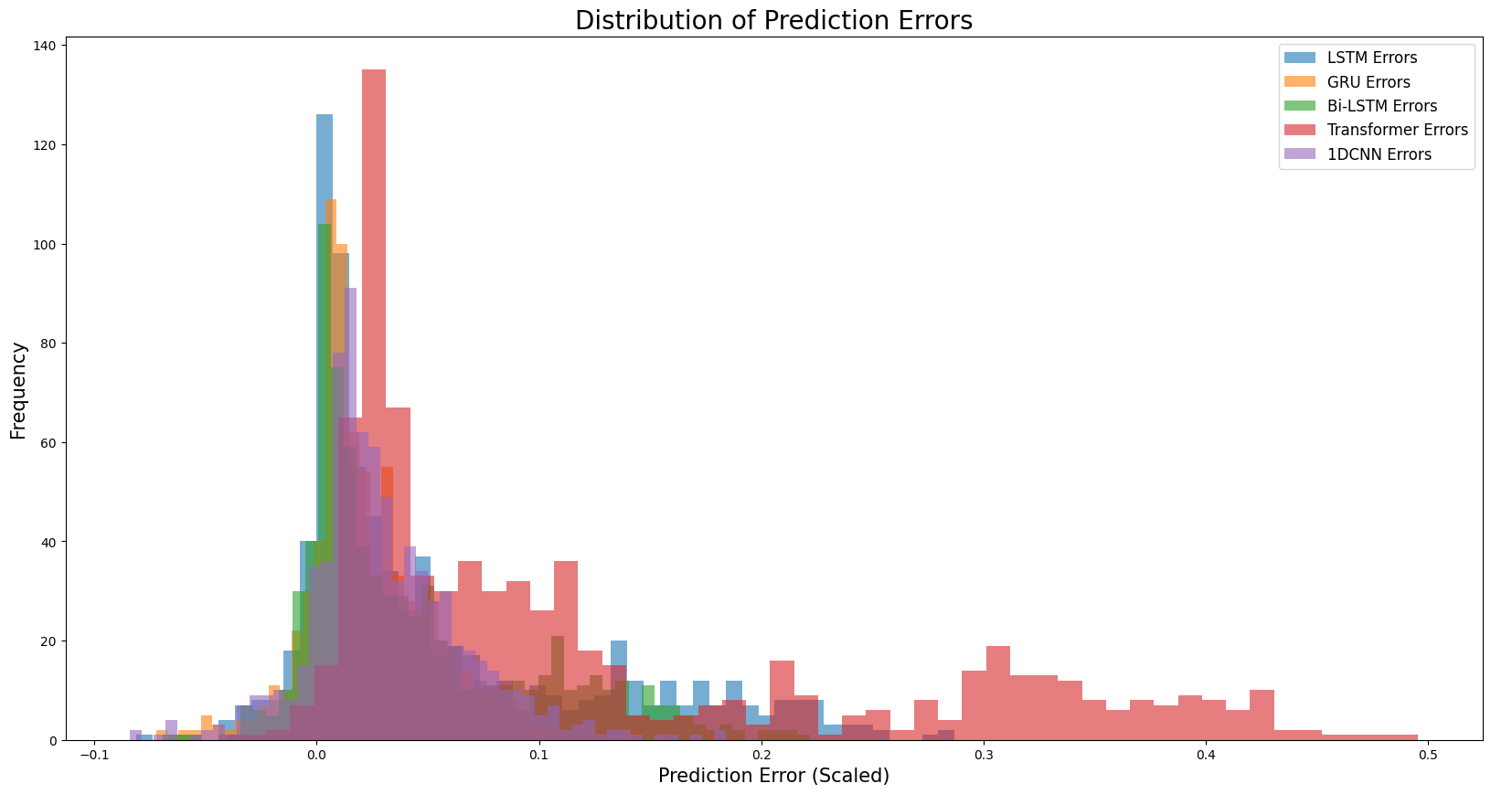  Fig. 8. Distribution of scaled prediction errors across deep learning models for Bitcoin forecasting (Configuration 1). | 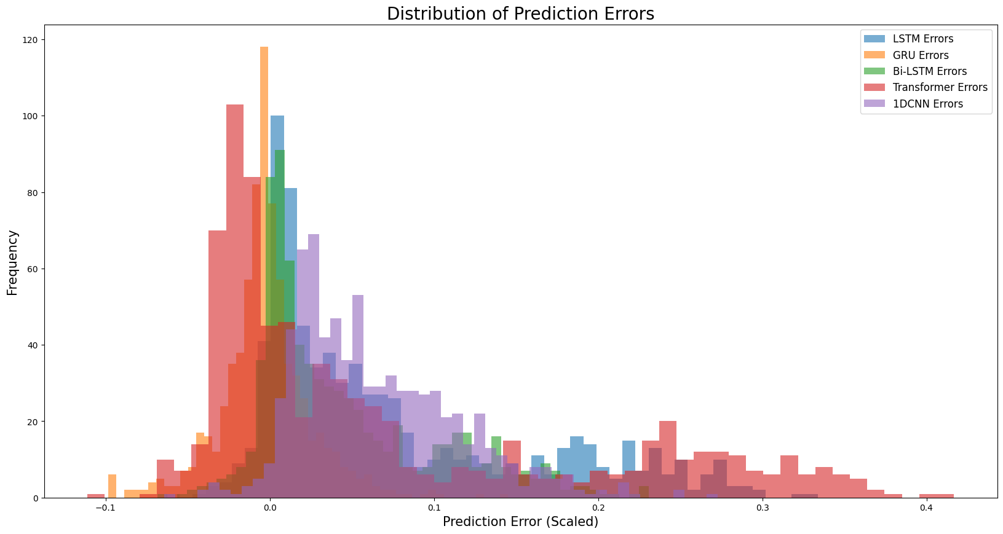  Fig. 9. Distribution of scaled prediction errors across deep learning models for Bitcoin forecasting (Configuration 2).
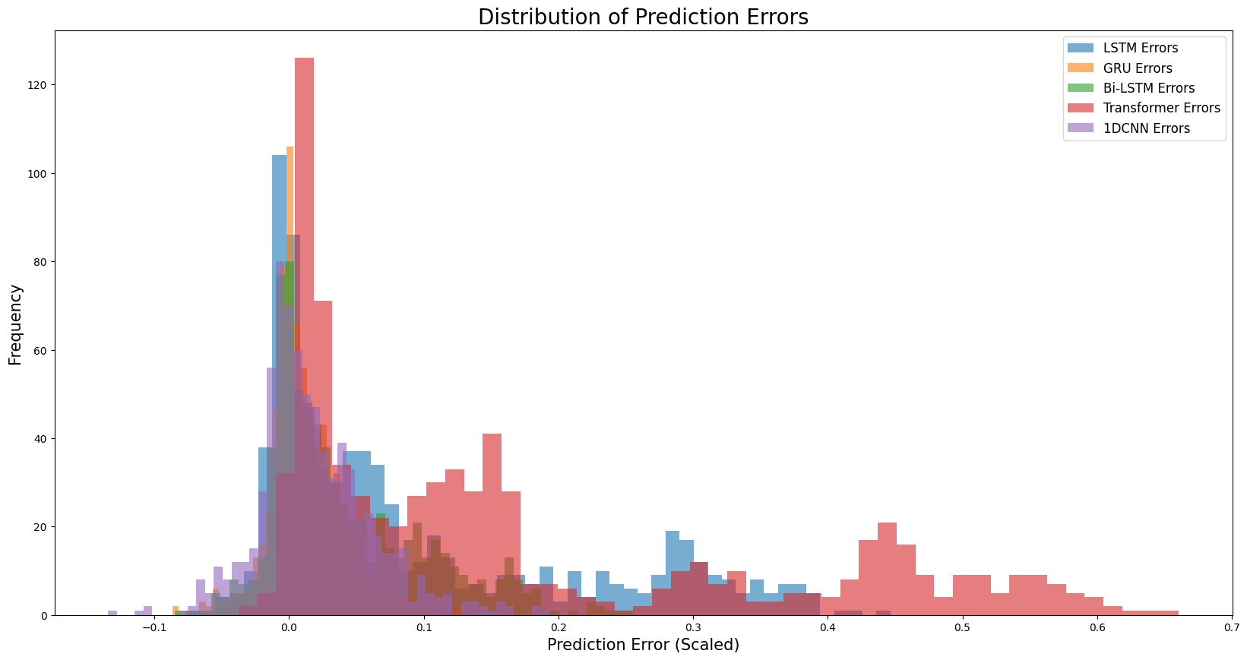
Fig. 10. Distribution of scaled prediction errors across deep learning models for Bitcoin forecasting (Configuration 3).
The error distribution plots (Fig. 8 - Fig. 10) presented further substantiate the performance distinctions among the five evaluated models across configurations 1 - 3, respectively. Each histogram shows how the scaled prediction errors are spread out, making it easy to visually evaluate any bias, variability, and how closely the errors cluster around zero. In an ideal case, a well-tuned model would have errors that are tightly grouped near zero with little variation, signaling that its predictions are both accurate and reliable.
In all three setups, the GRU model shows the most tightly packed and balanced error distributions, with most errors concentrated close to zero. This limited spread indicates minimal bias and strong consistency, meaning the GRU delivers accurate and reliable predictions over time. Additionally, the slim tails in its histograms suggest it produces fewer extreme forecasting errors than other models.
By contrast, the error distributions of Transformer and 1D-CNN are significantly broader and more skewed, particularly in the second and third configurations. These patterns indicate higher variance and a greater occurrence of large prediction errors, confirming their relative instability in mid-to-long forecasting setups. LSTM and Bi-LSTM show intermediate performance, with error distributions that are wider and more dispersed than GRU, but narrower than Transformer and CNN.
The difference between these distributions becomes clearer as the size of the input-output window grows. This highlights the GRU model’s ability to maintain low and stable error variance across increasing forecast horizons, a key attribute for deployment in real-world financial forecasting systems where consistent performance is critical under shifting market conditions.
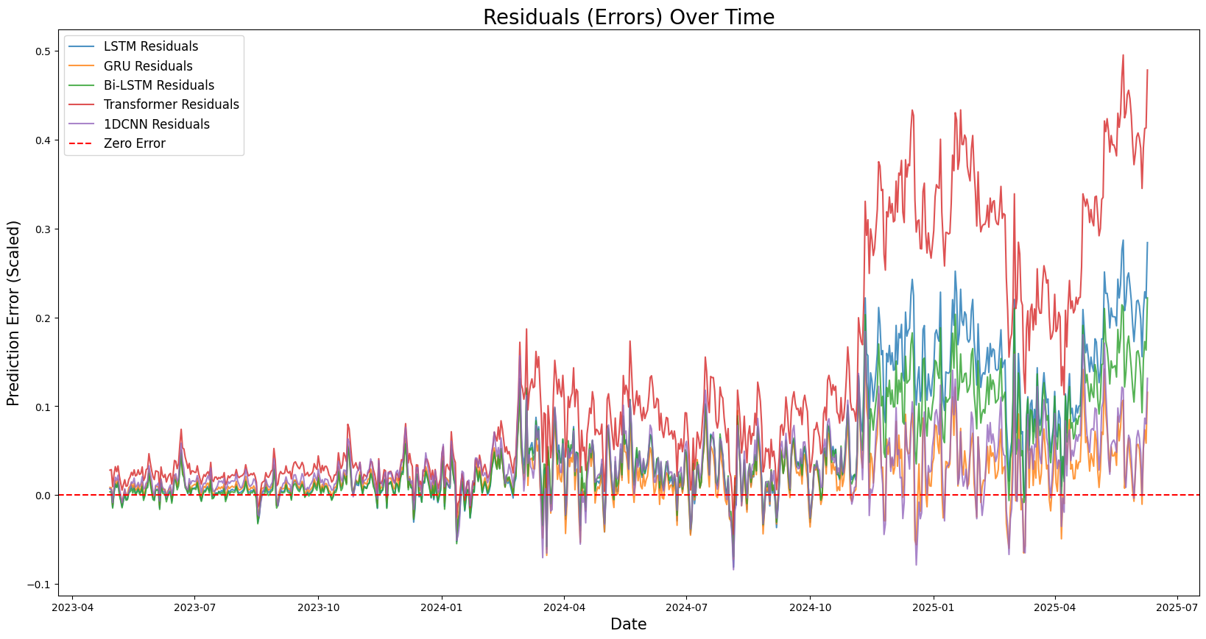  Fig. 11. Scaled residual error trends over time for deep learning models under Configuration 1. | 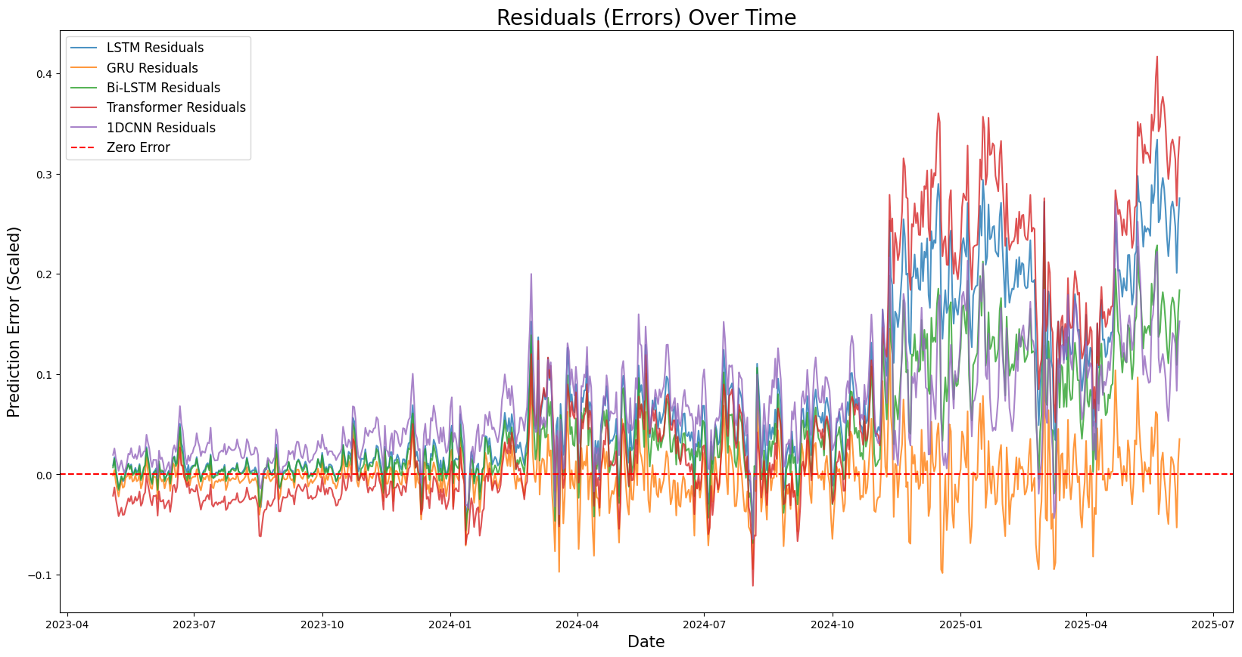  Fig. 12. Scaled residual error trends over time for deep learning models under Configuration 2.
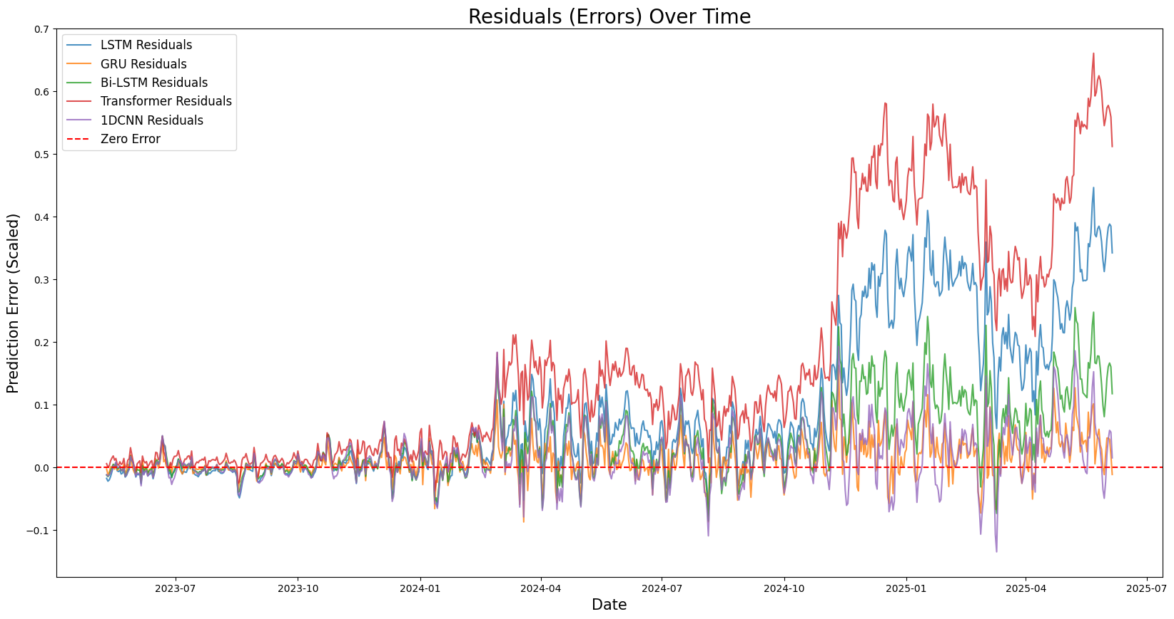
Fig. 13. Scaled residual error trends over time for deep learning models under Configuration 3.
The temporal behavior of residual errors is visualized in Fig. 11 - Fig. 13 for configurations 1 - 3, respectively. These charts show how the residuals — the gap between predicted and actual Bitcoin closing prices — change over time. Tracking these error patterns is crucial for spotting consistent biases, shifts in model behavior, or instability over time, all of which can affect how dependable a forecasting model is in the fast-changing world of finance.
In all three setups, the GRU model shows the most consistent and steady residual patterns, with variations closely clustered around the zero line. This suggests that GRU not only keeps forecasting errors low on average but also spreads them out evenly over time, avoiding any long-term drift or bias in one direction. This performance points to a strong ability to generalize and adapt over time — both of which are essential for managing the ever-changing nature of cryptocurrency markets.
In contrast, the Transformer model exhibits residual trends with more pronounced volatility and occasional bursts of persistent over-or under-estimation, particularly in the third configuration. These fluctuations may reflect overfitting to short-term patterns or failure to capture abrupt regime shifts in the time series. LSTM and Bi-LSTM show moderate stability, yet occasional error clustering indicates sensitivity to localized trends and transitions.
The comparative smoothness and neutrality of GRU’s residuals over time provide compelling empirical support for its robustness and adaptability, especially under varying market dynamics and extended forecasting horizons. These findings, when taken together with the earlier analyses, reinforce the conclusion that GRU offers the most balanced trade-off between accuracy, stability, and temporal consistency among the evaluated models.
Overall, the experimental findings challenge prior assumptions regarding the dominance of the Transformer model in long-term financial forecasting. In this study, GRU consistently outperformed all four other architectures across every forecasting horizon. These results underscore the importance of context-specific model selection and suggest that GRU offers an effective and computationally efficient alternative for multi-horizon stock price prediction.
- Conclusion
This study establishes a comprehensive benchmark for multi-horizon forecasting of Bitcoin price by comparing five representative deep learning architectures (LSTM, GRU, Bi-LSTM, Transformer, 1D-CNN) systematically. The obtained results show that the GRU system is superior to the other systems in predictive ability, model stability, and computational efficiency at all forecast horizons. Although the LSTM and Bi-LSTM can achieve good prediction results in the short term, their performance decreases with an increasing prediction horizon. The transformer model did not perform better than anticipated, indicating that the model may have limitations on very volatile financial time series like Bitcoin. Despite these results, the research is limited by its exclusive reliance on historical price data and the use of short lookback windows (10–21 days), which may restrict attention-based models from capturing long-range dependencies effectively. Future work should therefore explore hybrid architectures that integrate recursive and attention mechanisms, while incorporating alternative data sources such as blockchain metrics and market sentiment to enhance robustness. Additionally, applying explainable AI (XAI) approaches could gain further insights into how these models actually learn and interpret cryptocurrency market patterns, leading towards more transparent and trustworthy forecasting systems.
Acknowledgement
This research was funded by Hue University, Vietnam, under the research project code DHH2025-06-164.

References
[1] H. Sebastião and P. Godinho, “Forecasting and trading cryptocurrencies with machine learning under changing market conditions,” Financ Innov, vol. 7, no. 1, Jan. 2021, doi: 10.1186/s40854-020-00217-x.
[2] S. Corbet, A. Meegan, C. Larkin, B. Lucey, and L. Yarovaya, “Exploring the dynamic relationships between cryptocurrencies and other financial assets,” Economics letters, vol. 165, pp. 28–34, 2018.
[3] S. B. Akbar, K. Thanupillai, and V. Govindarajan, “Forecasting Bitcoin price using time opinion mining and bi-directional GRU,” IFS, vol. 42, no. 3, pp. 1825–1833, Feb. 2022, doi: 10.3233/jifs-211217.
[4] P. Katsiampa, “Volatility estimation for Bitcoin: A comparison of GARCH models,” Economics letters, vol. 158, pp. 3–6, 2017.
[5] S. Siami-Namini, N. Tavakoli, and A. S. Namin, “A Comparative Analysis of Forecasting Financial Time Series Using ARIMA, LSTM, and BiLSTM,” Nov. 21, 2019, arXiv: arXiv:1911.09512. doi: 10.48550/arXiv.1911.09512.
[6] Q. Lin, “Price Prediction of Bitcoin Using LSTM Neural Network,” BCP Business & Management, vol. 38, pp. 2738–2744, Mar. 2023, doi: 10.54691/bcpbm.v38i.4183.
[7] J. F. Diaz and J.-H. Chen, “Testing for long-memory and chaos in the returns of currency exchange-traded notes (ETNs),” Journal of applied finance and banking, vol. 7, no. 4, p. 15, 2017.
[8] O. B. Sezer, M. U. Gudelek, and A. M. Ozbayoglu, “Financial time series forecasting with deep learning: A systematic literature review: 2005–2019,” Applied soft computing, vol. 90, p. 106181, 2020.
[9] T. K. Samson, “Comparative analysis of machine learning algorithms for daily cryptocurrency price prediction,” Inf. Dyn. Appl, vol. 3, no. 1, pp. 64–76, 2024.
[10] A. Dutta, S. Kumar, and M. Basu, “A gated recurrent unit approach to bitcoin price prediction,” Journal of risk and financial management, vol. 13, no. 2, p. 23, 2020.
[11] S. Hochreiter and J. Schmidhuber, “Long short-term memory,” Neural computation, vol. 9, no. 8, pp. 1735–1780, 1997.
[12] P. Singh, P. Goel, and R. Bajaj, “Predictive Analysis of Bitcoin Prices Using Bidirectional Long Short-Term Memory Networks,” in 2024 3rd International Conference on Computational Modelling, Simulation and Optimization (ICCMSO), June 2024, pp. 114–119. doi: 10.1109/ICCMSO61761.2024.00035.
[13] U. B. Mahadevaswamy and P. Swathi, “Sentiment analysis using bidirectional LSTM network,” Procedia Computer Science, vol. 218, pp. 45–56, 2023.
[14] K. Cho et al., “Learning Phrase Representations using RNN Encoder-Decoder for Statistical Machine Translation,” Sept. 03, 2014, arXiv: arXiv:1406.1078. doi: 10.48550/arXiv.1406.1078.
[15] A. Bouteska, M. Z. Abedin, P. Hajek, and K. Yuan, “Cryptocurrency price forecasting–a comparative analysis of ensemble learning and deep learning methods,” International Review of Financial Analysis, vol. 92, p. 103055, 2024.
[16] Y. Li and W. Dai, “Bitcoin price forecasting method based on CNN‐LSTM hybrid neural network model,” The Journal of Engineering, vol. 2020, no. 13, pp. 344–347, July 2020, doi: 10.1049/joe.2019.1203.
[17] I. E. Livieris, E. Pintelas, and P. Pintelas, “A CNN–LSTM model for gold price time-series forecasting,” Neural Comput & Applic, vol. 32, no. 23, pp. 17351–17360, Dec. 2020, doi: 10.1007/s00521-020-04867-x.
[18] A. Vaswani, N. Shazeer, N. Parmar, J. Uszkoreit, L. Jones, AN. Gomez, L. Kaiser, I. Polosukhin “Attention is all you need,” Advances in neural information processing systems, vol. 30, p. I, 2017.
[19] A. Zeng, M. Chen, L. Zhang, and Q. Xu, “Are transformers effective for time series forecasting?,” in Proceedings of the AAAI conference on artificial intelligence, 2023, pp. 11121–11128. Accessed: July 24, 2025. [Online]. Available: https://ojs.aaai.org/index.php/AAAI/article/view/26317
[20] K. Ł. Szydłowski and J. A. Chudziak, “Hidformer: Transformer-Style Neural Network in Stock Price Forecasting,” Dec. 27, 2024, arXiv: arXiv:2412.19932. doi: 10.48550/arXiv.2412.19932.
[21] F. Barez, P. Bilokon, A. Gervais, and N. Lisitsyn, “Exploring the Advantages of Transformers for High-Frequency Trading,” Feb. 20, 2023, arXiv: arXiv:2302.13850. doi: 10.48550/arXiv.2302.13850.

Corresponding: dthphuong@hueuni.edu.vn.

