Enhancing GRU Forecasting Accuracy with Empirical Mode Decomposition for Bitcoin Prices
Hoa Tran Thai¹, Tuan Nguyen Thanh¹, Huong Phan Thi Thu¹, Ho Quoc Dung², Lien Thi Quynh Le1

1 University of Economics, Hue University,
49000 Hue, Viet Nam
2School of Engineering and Technology, Hue University,
49000 Hue, Viet Nam

{tranthaihoa, nguyenthanhtuan, phanthithuhuong, hqdung, lethiquynhlien}@hueuni.edu.vn
Abstract. Bitcoin price forecasting is challenging because of its nonlinear, volatile, and non-stationary behavior. To address this issue, this study proposes an EMD-GRU framework that combines Empirical Mode Decomposition (EMD) with Gated Recurrent Units (GRU) for Bitcoin price prediction. First, the original price series is decomposed into several intrinsic mode functions (IMFs), each capturing distinct frequency patterns. Then, separate GRU models are trained on each IMF, and the final forecast is obtained by aggregating the component predictions. Experiments on daily Bitcoin price data from Yahoo Finance show that the proposed model outperforms the baseline GRU. Specifically, EMD-GRU reduces the RMSE from 9519.78 to 5422.74 and improves the R² from 0.887 to 0.963. The results demonstrate that decomposition-based learning can substantially enhance forecasting accuracy for complex financial time series.
Keywords: Bitcoin, decomposition technique, EMD, GRU, time series forecasting.
1 Introduction
The rapid growth of cryptocurrencies, particularly Bitcoin, has attracted significant attention from both academic researchers and financial practitioners. As a highly volatile and speculative asset, Bitcoin exhibits complex price dynamics characterized by nonlinearity, non-stationarity, and abrupt fluctuations [1]. Accurate forecasting of Bitcoin prices plays a critical role in portfolio management, algorithmic trading, and financial risk assessment. However, these inherent characteristics make reliable prediction a challenging task for traditional time series models.
Conventional statistical approaches, such as autoregressive integrated moving average (ARIMA) and generalized autoregressive conditional heteroskedasticity (GARCH), have been widely applied to financial time series forecasting [2]. While these models are effective in capturing linear dependencies and volatility clustering, they often fail to model the nonlinear and multi-scale nature of cryptocurrency price movements [3]. In recent years, deep learning models, including recurrent neural networks (RNNs), long short-term memory (LSTM), and GRU, have demonstrated improved performance in time series prediction due to their ability to learn complex temporal dependencies. Among these models, GRU offers a simpler architecture with fewer parameters compared to LSTM, while maintaining competitive predictive capability [4].
Despite their advantages, GRU-based models still face limitations when applied directly to raw Bitcoin price series. The original time series typically contains mixed-frequency components, where short-term noise, medium-term oscillations, and long-term trends are superimposed. Learning such heterogeneous patterns simultaneously increases model complexity and may reduce forecasting accuracy. As observed in empirical studies, GRU models trained on raw data often exhibit lagging behavior and higher prediction errors during periods of high volatility [5].
To address these challenges, this study proposes a hybrid forecasting framework that integrates EMD with GRU. EMD is an adaptive signal decomposition technique that decomposes a non-stationary time series into a set of IMFs, each representing oscillatory modes at different frequency scales [6]. By transforming the original complex signal into multiple simpler components, EMD enables the GRU model to learn distinct temporal patterns more effectively. In the proposed EMD-GRU framework, individual GRU models are trained on each decomposed component, and the final prediction is reconstructed by aggregating the outputs of all components.
The effectiveness of the proposed approach is validated using daily Bitcoin price data obtained from Yahoo Finance. Experimental results demonstrate that the EMD-GRU model significantly outperforms the baseline GRU model across multiple evaluation metrics. Specifically, the proposed method reduces the RMSE from 9519.78 to 5422.74 and improves the R² from 0.887 to 0.963. These findings suggest that decomposition-based learning enhances the capability of deep neural networks in modeling complex financial time series.
The remainder of this paper is organized as follows. Section 2 reviews related work on Bitcoin price forecasting, deep learning models, and decomposition-based methods. Section 3 describes the proposed EMD-GRU methodology in detail. Section 4 presents the experimental setup and results. Section 5 discusses the findings, and Section 6 concludes the paper with directions for future research.
2 Related Work
Bitcoin price forecasting remains a challenging problem due to its nonlinear, non-stationary, and highly volatile characteristics. Recent surveys indicate that although deep learning has become dominant in financial time series forecasting, improvements in predictive performance are often incremental and strongly dependent on data preprocessing rather than model architecture alone [7], [8]. This suggests that current research may overemphasize model complexity while underexploring signal representation.
Early studies demonstrated that recurrent neural networks can capture temporal dependencies in Bitcoin prices. McNally et al. showed that LSTM-based models outperform traditional approaches in short-term prediction tasks [9]. However, subsequent work revealed that such improvements are not consistently robust across datasets. For example, Mudassir et al. found that predictive performance often depends more on feature engineering than on model capability itself [10]. This indicates that learning directly from raw or feature-augmented series may not fully address the inherent complexity of Bitcoin price dynamics.
More recent research has focused on enhancing deep learning architectures and incorporating additional input features. Lamothe-Fernández et al. demonstrated that using multiple explanatory variables improves prediction accuracy [11]. Similarly, Liu et al. reported that deep learning models benefit from richer input representations [12]. However, these approaches increase model complexity and reduce interpretability. More importantly, they do not address the fundamental issue that Bitcoin price series consist of mixed-frequency components, which remain entangled in the input data.
GRU has emerged as an efficient alternative to LSTM due to its simpler structure and competitive performance. Dutta et al. showed that GRU achieves comparable accuracy with fewer parameters [13]. Hansun et al. further confirmed that GRU performs effectively in multivariate cryptocurrency prediction [14]. Recent comparative studies also identify GRU as a strong baseline among deep learning models [15], [16]. Nevertheless, these studies primarily focus on model benchmarking rather than improving the structure of the input signal. As a result, GRU models still struggle to capture heterogeneous temporal patterns when trained on raw data.
To address signal complexity, decomposition-based approaches have been introduced. EMD, proposed by Huang et al., provides an adaptive method for decomposing nonlinear and non-stationary signals into intrinsic mode functions [17]. Extensions such as ensemble EMD further improve robustness against noise [18]. These methods allow time series to be separated into components representing different frequency scales, thereby simplifying the learning task.
Recent studies have combined decomposition techniques with deep learning models. Parvini et al. integrated wavelet decomposition with LSTM and demonstrated improved forecasting performance [19]. Chang et al. proposed a CEEMDAN-based framework for cryptocurrency prediction, showing that multi-scale reconstruction enhances accuracy [20]. Mizdrakovic et al. further developed a decomposition-aided LSTM model and reported improvements in both prediction and interpretability [21]. Similarly, Koo and Kim proposed a decomposition-based LSTM approach for Bitcoin forecasting [22]. Additional studies have also explored hybrid decomposition-learning frameworks and reported consistent improvements in financial forecasting tasks [23], [24].
Despite these advances, two key limitations remain. First, most GRU-based forecasting models continue to operate on raw or feature-enhanced time series without explicitly addressing the multi-scale structure of the data [13], [15]. Second, although decomposition-based approaches have shown effectiveness with LSTM and its variants, their impact on GRU has not been systematically evaluated [21], [22]. Furthermore, many existing studies combine multiple techniques simultaneously, making it difficult to isolate the contribution of signal decomposition.
Therefore, a clear research gap exists: there is a lack of systematic investigation into whether empirical mode decomposition alone can enhance GRU-based forecasting for Bitcoin price series under controlled experimental conditions. This study addresses this gap by proposing an EMD-GRU framework that decomposes the original signal into intrinsic components and evaluates the effectiveness of component-wise learning using consistent datasets and evaluation metrics.
3 Methodology
3.1 Overview of the Proposed EMD-GRU Framework
This study proposes a hybrid forecasting framework that integrates EMD with GRU to improve Bitcoin price prediction. The main objective is to address the nonlinearity and non-stationarity of financial time series by decomposing the original signal into multiple simpler components before applying deep learning.
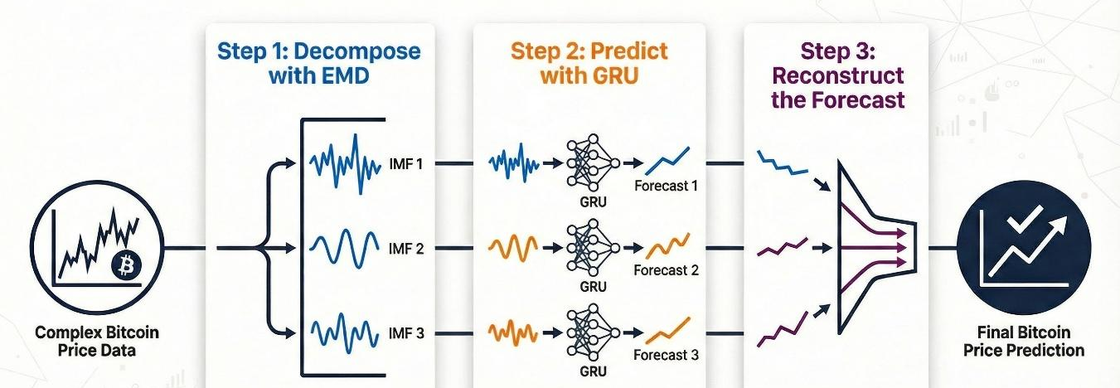
Fig. 1. Workflow of the proposed EMD-GRU framework for Bitcoin price forecasting
Let 𝑥(𝑡) denote the original Bitcoin closing price series. Instead of directly training a GRU model on 𝑥(𝑡), the proposed method first applies EMD to decompose the signal into a set of IMFs, each representing oscillatory patterns at different time scales. These components are then modeled independently using GRU networks, and the final prediction is reconstructed by aggregating all component-wise outputs.
As illustrated in Fig. 1, the proposed framework consists of three main stages: (1) signal decomposition using EMD, (2) component-wise forecasting using GRU models, (3) reconstruction of the final prediction. This design transforms a single complex forecasting problem into multiple simpler subproblems, enabling more effective learning. The overall process of the proposed method is summarized as Algorithm 1.
Algorithm 1. EMD-GRU Forecasting
Input: Bitcoin price series 𝑥(𝑡)
Output: Predicted price $\hat{y}\left(t\right)$
Apply EMD to decompose 𝑥(𝑡) into {𝐼𝑀𝐹1,𝐼𝑀𝐹2,…,𝐼𝑀𝐹𝐾}.
For each 𝐼𝑀𝐹𝑖:
a. Normalize the data
b. Construct sliding window samples
c. Train a GRU model
Generate predictions ${\hat{y}}_{i}\left(t\right)$
Aggregate predictions:
$\hat{y}(t) = \sum_{i=1}^{K}{{\hat{y}}_{i}\left(t\right)}$
Return final forecast
3.2 Empirical Mode Decomposition (EMD)
EMD introduced by Huang et al. [17], is an adaptive signal decomposition technique designed for nonlinear and non-stationary time series. Unlike traditional methods such as Fourier or wavelet transforms, EMD does not require predefined basis functions.
The original signal 𝑥(𝑡) is decomposed into a set of intrinsic mode functions and a residual component:
$$x(t)=\sum_{i=1}^{N}{IMF_{i}\left(t\right)}+r\left(t\right)$$ | (1)
Each IMF satisfies the following conditions:
- The number of extrema and zero crossings differs by at most one.
- The local mean of the upper and lower envelopes is zero.
In the context of Bitcoin price data, the decomposed components can be interpreted as follows:
- High-frequency IMFs: Capture short-term fluctuations and market noise
- Medium-frequency IMFs: Represent cyclic or intermediate-term dynamics
- Low-frequency IMFs and residual: Reflect long-term trends
By separating these components, EMD reduces signal complexity and facilitates more effective learning by downstream models. This decomposition-based strategy has been shown to improve forecasting performance in financial time series applications [23].
3.3 GRU-Based Forecasting Model
GRU is a class of recurrent neural networks designed to capture temporal dependencies while addressing the vanishing gradient problem. Compared to LSTM, GRU offers a simpler architecture with fewer parameters while maintaining strong predictive performance [14]. The GRU architecture is shown in Fig. 2.
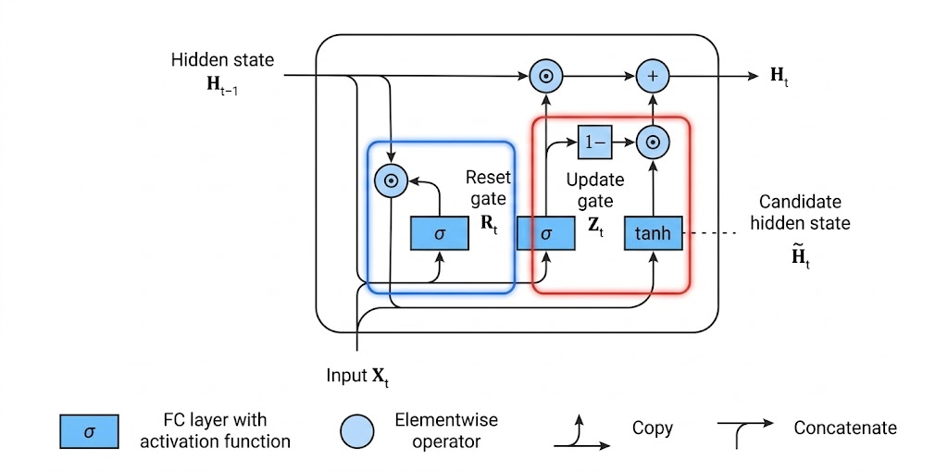
Fig. 2. The internal architecture of a GRU unit
At each time step 𝑡, the GRU unit computes:
Update gate:
$$z_{t}=σ (W_{z}h_{t-1}+U_{z}x_{t}+b_{z})$$ | (2)
Reset gate:
$$r_{t}=σ \left(W_{r}h_{t-1}+U_{z}x_{t}+b_{z}\right)$$ | (3)
Candidate hidden state:
$${\tilde{h}}_{t}=tanh (W_{h}(h_{t-1}⨀ r_{t}+U_{h}x_{t}+b_{h})$$ | (4)
Hidden state update:
$$h_{t}=z_{t} ⨀ {\tilde{h}}_{t}+\left(1-z_{t}\right) ⨀{ h}_{t-1})$$ | (5)
where:
- $x_{t}$: input vector (e.g., Bitcoin open, high, low, volume) at time t,
- ${ h}_{t-1}$, $h_{t}$: previous and new hidden states,
- ${\tilde{h}}_{t}$: candidate hidden state,
- $z_{t}$, $r_{t}:$update and reset gate activations,
- $W_{z}$, $W_{r}$, $W_{h}$, $U_{z}$, $U_{r}$, $U_{h}$: weight matrices,
- $b_{z}$, $b_{r}$, $b_{h}$: bias vectors,
- σ: sigmoid function,
- tanh: hyperbolic tangent function,
- ⊙: element-wise multiplication.
In this study, a two-layer GRU architecture is employed. The first GRU layer outputs a sequence representation, followed by a second GRU layer that produces a fixed-length feature vector. Dropout layers are applied after each GRU layer to mitigate overfitting. A fully connected layer maps the learned representation to the final output.
The model is trained using the Adam optimizer with a maximum of 200 epochs, batch size of 32, and early stopping with a patience of 20 epochs based on validation loss.
3.4 Evaluation Metrics
To assess forecasting performance, the following metrics are summarized in Table 1.
Table 1. Definitions and interpretations of evaluation metrics used to assess model performance.
Metric | Formula
MSE | $$MSE=\frac{1}{n}\sum_{i=1}^{n}{{(y_{i}-\hat{y_{i}})}^{2}}$$
RMSE | $$RMSE=\sqrt{MSE}$$
MAPE | $$MAPE=\frac{100\%}{n}\sum_{i=1}^{n}{\left|\frac{y_{i}-\hat{y_{i}}}{y_{i}}\right|}$$
MAE | $$MAE=\frac{1}{n}\sum_{i=1}^{n}{\left|y_{i}-\hat{y_{i}}\right|}$$
R² | $$R^{2}=1-\frac{\sum_{i=1}^{n}{{(y_{i}-{\hat{y}}_{i})}^{2}}}{\sum_{i=1}^{n}{{(y_{i}-{\overline{y}}_{i})}^{2}}}$$

These metrics provide complementary perspectives on prediction accuracy, error magnitude, and model fitting capability.
4 Experiments
The dataset used in this study consists of daily Bitcoin closing prices obtained from Yahoo Finance. The time series exhibits strong volatility, nonlinear dynamics, and non-stationary behavior, making it a suitable benchmark for evaluating forecasting models.
As shown in Fig. 3, the Bitcoin price series contains multiple growth cycles and abrupt fluctuations. These characteristics highlight the presence of mixed-frequency components, including short-term noise and long-term trends. Such complexity motivates the use of decomposition-based approaches to improve prediction performance. The proposed EMD-GRU model is evaluated against a baseline GRU model trained directly on the original Bitcoin price series.

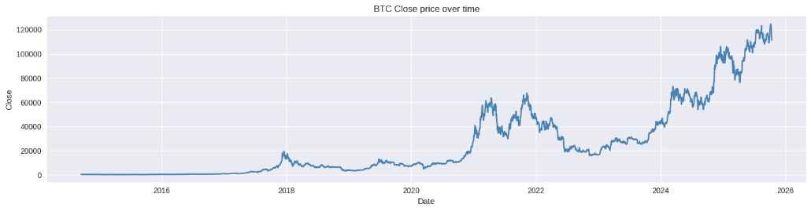
Fig. 3. Daily Bitcoin closing price collected from Yahoo Finance
As shown in Fig. 4, the EMD procedure separates the original Bitcoin price series into nine IMFs with distinct temporal scales. The first three components mainly capture high-frequency volatility and local shocks, IMF4–IMF6 reflect medium-term oscillatory movements, whereas IMF7–IMF9 represent low-frequency trend dynamics. This result provides empirical support for the proposed EMD-GRU design, since the decomposition converts a single heterogeneous series into simpler sub-series that can be modeled more effectively by GRU before reconstruction.
Based on this decomposition, the forecasting experiment compares the baseline GRU trained on the raw series with the proposed EMD-GRU trained on the decomposed components under the same optimization settings.
The GRU architecture consists of two recurrent layers with 128 hidden units, followed by dropout layers and a fully connected output layer. The models are trained using the Adam optimizer with a maximum of 200 epochs and a batch size of 32. Early stopping is applied with a patience of 20 epochs based on validation loss, and 10% of the training data is used for validation. For both models, the same preprocessing pipeline and training configuration are applied to ensure a fair comparison.
Table 2. Performance comparison between GRU and EMD-GRU models.
Model | MSE | MAE | RMSE | MAPE (%) | R²
GRU | 9.06 x 107 | 6808.97 | 9519.78 | 7.33 | 0.887
EMD-GRU | 2.94 x 107 | 4182.02 | 5422.74 | 5.03 | 0.963

The results in Table 2 demonstrate that the proposed EMD-GRU model consistently outperforms the baseline GRU across all evaluation metrics.
Specifically, the EMD-GRU model reduces RMSE from 9519.78 to 5422.74, corresponding to an improvement of approximately 43%. Similarly, MAE decreases from 6808.97 to 4182.02, and MAPE is reduced from 7.33% to 5.03%. In addition, the R² increases from 0.887 to 0.963, indicating a significantly better fit to the observed data. These results confirm that decomposition-based learning enhances the predictive capability of GRU models for complex financial time series.
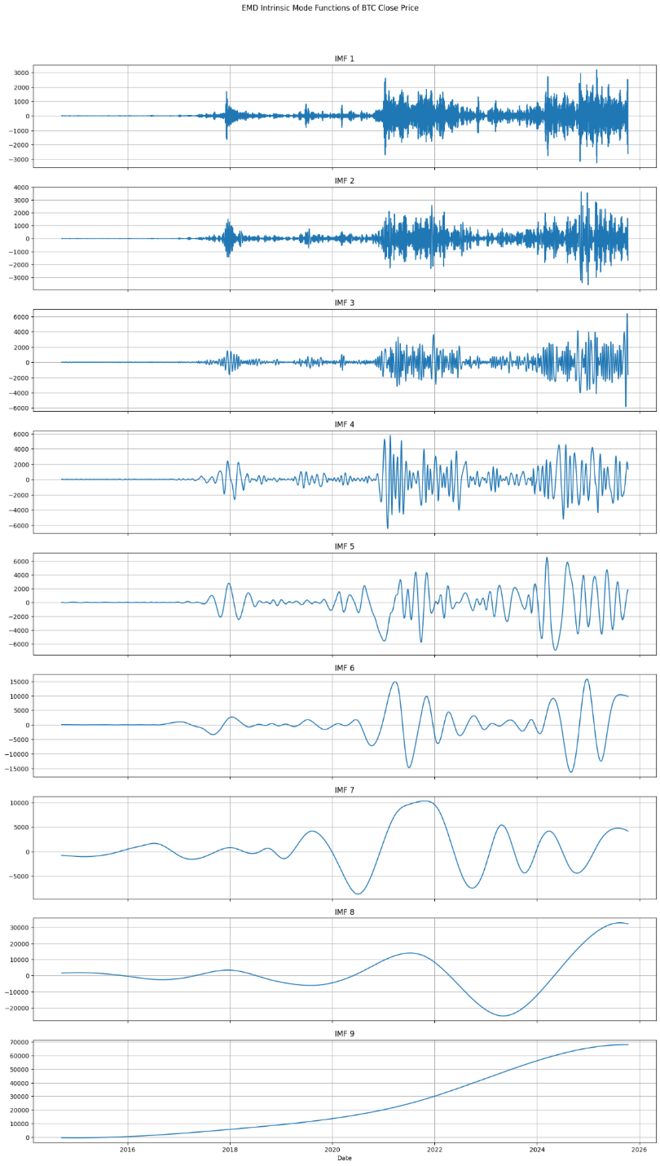
Fig. 4. EMD decomposition of the Bitcoin closing price series into intrinsic mode functions (IMFs)
As illustrated in Fig. 5, the EMD-GRU model tracks the actual Bitcoin price more closely than the baseline GRU model. The GRU model exhibits noticeable lag and deviation during periods of high volatility, whereas the EMD-GRU model captures both short-term fluctuations and long-term trends more accurately. This improvement can be attributed to the decomposition step, which enables the model to learn different temporal patterns separately rather than jointly.

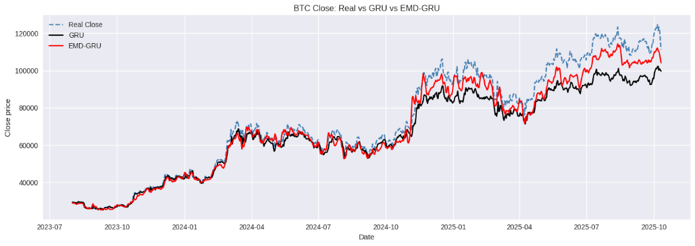
Fig. 5. Comparison of actual Bitcoin prices and predictions from GRU and EMD-GRU models
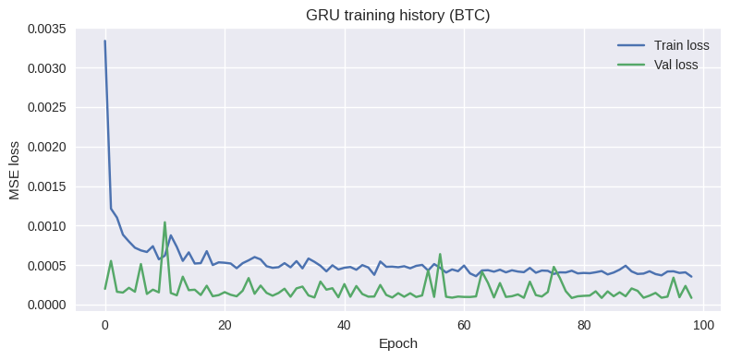
Fig. 6. Training and validation loss curves of the GRU model
The training process of the GRU model is shown in Fig. 6. The training loss decreases rapidly during the initial epochs and gradually stabilizes, while the validation loss remains relatively consistent. The use of early stopping prevents overfitting and ensures that the model retains the best-performing weights.The stable convergence behavior indicates that the training process is well-controlled and that the model generalizes reasonably well to unseen data.
The experimental results highlight the effectiveness of the proposed EMD-GRU framework. The improvement in forecasting performance can be explained by the ability of EMD to decompose the original signal into components with reduced complexity.
By separating high-frequency noise from low-frequency trends, the GRU models can focus on learning more structured and homogeneous patterns. This leads to improved prediction accuracy and enhanced robustness, particularly in volatile market conditions.
Furthermore, the results suggest that decomposition-based approaches are well-suited for financial time series characterized by multi-scale dynamics. The proposed framework can potentially be extended to other assets, such as stocks, commodities, and alternative cryptocurrencies.
5 Conclusion
This study investigated Bitcoin price forecasting under nonlinear and non-stationary conditions through a hybrid EMD-GRU framework. By decomposing the original price series into intrinsic mode functions using Empirical Mode Decomposition and modeling each component separately with GRU networks, the proposed approach was able to capture multi-scale temporal patterns more effectively than a standalone GRU model.
The experimental results obtained from daily Bitcoin price data collected from Yahoo Finance demonstrated clear improvements in predictive performance. In particular, the hybrid model reduced the RMSE from 9519.78 to 5422.74 and the MAE from 6808.97 to 4182.02, while increasing the R² from 0.887 to 0.963. These findings indicate that decomposition-based learning can significantly enhance the capacity of deep neural networks to model complex financial time series and generate more accurate forecasts.
Despite these encouraging results, several limitations should be acknowledged. The analysis was based solely on historical price data and did not consider exogenous factors such as trading volume, macroeconomic conditions, or market sentiment. Moreover, the study focused on a single cryptocurrency, which limits the generalizability of the findings across other financial assets. Future work may therefore incorporate additional explanatory variables, examine broader classes of cryptocurrencies or financial instruments, and evaluate alternative decomposition techniques such as CEEMDAN or variational mode decomposition, as well as more recent deep learning architectures, including Transformer-based models.
References
- Z. Tong, Z. Chen, and C. Zhu, “Nonlinear dynamics analysis of cryptocurrency price fluctuations based on Bitcoin,” Finance Res. Lett., vol. 47, p. 102803, Jun. 2022, doi: 10.1016/j.frl.2022.102803.
- H. Liu and J. Shi, “Applying ARMA–GARCH approaches to forecasting short-term electricity prices,” Energy Econ., vol. 37, pp. 152–166, May 2013, doi: 10.1016/j.eneco.2013.02.006.
- T. Kim, H. Jo, W. Choi, and B.-G. Jang, “Bitcoin Price Direction Forecasting and Market Variables,” J. Futur. Mark., vol. 45, no. 10, pp. 1579–1600, 2025, doi: 10.1002/fut.70010.
- A. A. Adekunle, Issouf. Fofana, P. Picher, E. M. Rodriguez-Celis, O. H. Arroyo-Fernandez, and R. Zemouri, “Optimizing deep learning predictive models: A comprehensive review of RNN and its variant architectures,” Appl. Soft Comput., vol. 185, p. 114015, Dec. 2025, doi: 10.1016/j.asoc.2025.114015.
- H. Jiang et al., “A hybrid EMD-GRU model for pressure prediction in air cyclone centrifugal classifiers,” Adv. Powder Technol., vol. 36, no. 1, p. 104743, Jan. 2025, doi: 10.1016/j.apt.2024.104743.
- J. Zhang et al., “Serial-EMD: Fast empirical mode decomposition method for multi-dimensional signals based on serialization,” Inf. Sci., vol. 581, pp. 215–232, Dec. 2021, doi: 10.1016/j.ins.2021.09.033.
- O. B. Sezer, M. U. Gudelek, and A. M. Ozbayoglu, “Financial time series forecasting with deep learning : A systematic literature review: 2005–2019,” Appl. Soft Comput., vol. 90, p. 106181, May 2020, doi: 10.1016/j.asoc.2020.106181.
- A. M. Khedr, I. Arif, P. R. P V, M. El-Bannany, S. M. Alhashmi, and M. Sreedharan, “Cryptocurrency price prediction using traditional statistical and machine-learning techniques: A survey,” Intell. Syst. Account. Finance Manag., vol. 28, no. 1, pp. 3–34, 2021, doi: 10.1002/isaf.1488.
- S. McNally, “Predicting the price of Bitcoin using Machine Learning”.
- M. Mudassir, S. Bennbaia, D. Unal, and M. Hammoudeh, “Time-series forecasting of Bitcoin prices using high-dimensional features: a machine learning approach,” Neural Comput. Appl., vol. 37, no. 28, pp. 22979–22993, Oct. 2025, doi: 10.1007/s00521-020-05129-6.
- P. Lamothe-Fernández, D. Alaminos, P. Lamothe-López, and M. A. Fernández-Gámez, “Deep Learning Methods for Modeling Bitcoin Price,” Mathematics, 2020, doi: 10.3390/math8081245.
- M. Liu, G. Li, J. Li, X. Zhu, and Y. Yao, “Forecasting the price of Bitcoin using deep learning,” Finance Res. Lett., vol. 40, p. 101755, May 2021, doi: 10.1016/j.frl.2020.101755.
- A. Dutta, S. Kumar, and M. Basu, “A Gated Recurrent Unit Approach to Bitcoin Price Prediction,” J. Risk Financ. Manag., vol. 13, no. 2, Feb. 2020, doi: 10.3390/jrfm13020023.
- S. Hansun, A. Wicaksana, and A. Q. M. Khaliq, “Multivariate cryptocurrency prediction: comparative analysis of three recurrent neural networks approaches,” J. Big Data, vol. 9, no. 1, p. 50, Apr. 2022, doi: 10.1186/s40537-022-00601-7.
- A. Bouteska, M. Z. Abedin, P. Hajek, and K. Yuan, “Cryptocurrency price forecasting – A comparative analysis of ensemble learning and deep learning methods,” Int. Rev. Financ. Anal., vol. 92, p. 103055, Mar. 2024, doi: 10.1016/j.irfa.2023.103055.
- A. A. Oyedele, A. O. Ajayi, L. O. Oyedele, S. A. Bello, and K. O. Jimoh, “Performance evaluation of deep learning and boosted trees for cryptocurrency closing price prediction,” Expert Syst. Appl., vol. 213, p. 119233, Mar. 2023, doi: 10.1016/j.eswa.2022.119233.
- N. E. Huang et al., “The empirical mode decomposition and the Hilbert spectrum for nonlinear and non-stationary time series analysis,” Proc. R. Soc. Math. Phys. Eng. Sci., vol. 454, no. 1971, pp. 903–995, Mar. 1998, doi: 10.1098/rspa.1998.0193.
- “ENSEMBLE EMPIRICAL MODE DECOMPOSITION: A NOISE-ASSISTED DATA ANALYSIS METHOD,” Adv. Adapt. Data Anal., Accessed: Mar. 19, 2026. [Online]. Available: https://www.worldscientific.com/doi/epdf/10.1142/S1793536909000047
- N. Parvini, M. Abdollahi, S. Seifollahi, and D. Ahmadian, “Forecasting Bitcoin returns with long short-term memory networks and wavelet decomposition: A comparison of several market determinants,” Appl. Soft Comput., vol. 121, p. 108707, May 2022, doi: 10.1016/j.asoc.2022.108707.
- T.-J. Chang, T.-S. Lee, C.-T. Yang, and C.-J. Lu, “A ternary-frequency cryptocurrency price prediction scheme by ensemble of clustering and reconstructing intrinsic mode functions based on CEEMDAN,” Expert Syst. Appl., vol. 233, p. 121008, Dec. 2023, doi: 10.1016/j.eswa.2023.121008.
- V. Mizdrakovic et al., “Forecasting bitcoin: Decomposition aided long short-term memory based time series modeling and its explanation with Shapley values,” Knowl.-Based Syst., vol. 299, p. 112026, Sep. 2024, doi: 10.1016/j.knosys.2024.112026.
- E. Koo and G. Kim, “Centralized decomposition approach in LSTM for Bitcoin price prediction,” Expert Syst. Appl., vol. 237, p. 121401, Mar. 2024, doi: 10.1016/j.eswa.2023.121401.
- H. Sebastião and P. Godinho, “Forecasting and trading cryptocurrencies with machine learning under changing market conditions,” Financ. Innov., vol. 7, no. 1, p. 3, Jan. 2021, doi: 10.1186/s40854-020-00217-x.
- Z. Chen, C. Li, and W. Sun, “Bitcoin price prediction using machine learning: An approach to sample dimension engineering,” J. Comput. Appl. Math., vol. 365, p. 112395, Feb. 2020, doi: 10.1016/j.cam.2019.112395.

